**PRACTICAL N0 – 1**

**Aim:** Arima used for acf and pacf

**Code:**

import pandas as pd

import numpy as np

import matplotlib.pyplot as plt

import seaborn as sns

from statsmodels.tsa.stattools import adfuller

from statsmodels.graphics.tsaplots import plot_acf,plot_pacf

from statsmodels.tsa.arima.model import ARIMA

from sklearn.metrics import mean_squared_error

#Load time Series data

#load built-in AirPassengers dataset

url="https://raw.githubusercontent.com/jbrownlee/Datasets/master/airline-passengers.csv"

df=pd.read_csv(url, parse_dates=['Month'],index_col='Month')

df_columns=['Passengers']

df.head()

**Output:**

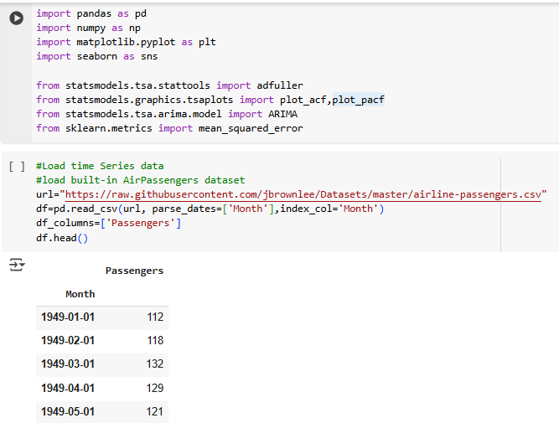

**Code:**

#plot the time series

df.plot(title='Monthly Air Passengers',figsize=(10,4))

plt.ylabel("Number of Passengers")

plt.xlabel("Year")

plt.grid()

plt.show()

**Output:**

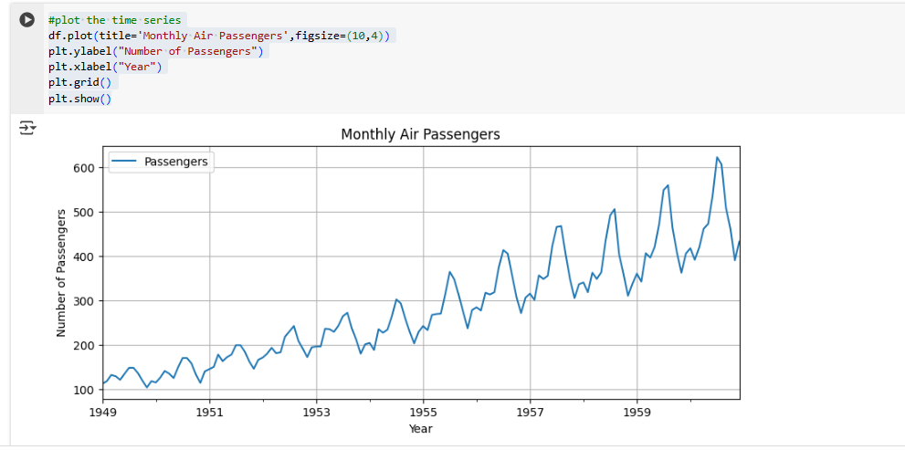

**Code:**

#test for stationary(adf)

def test_stationarity(series):

  result = adfuller(series)

  print(f'ADF statistics: {result[0]:.4f}')

  print(f'p-value: {result[1]:.4f}')

  if result[1] <= 0.05:

    print('Stationary')

  else:

    print('Not Stationary')

test_stationarity(df['Passengers'])

**Output:**

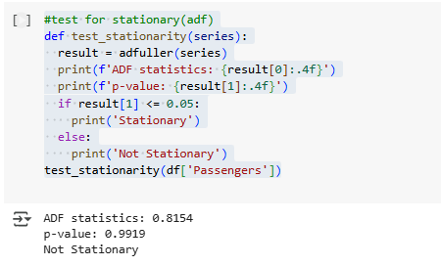

**Code:**

#make stationary (Differencing)

df_diff = df['Passengers'].diff().dropna()

df_diff.plot(title='Differenced Series')

plt.show()

test_stationarity(df_diff)

**Output:**

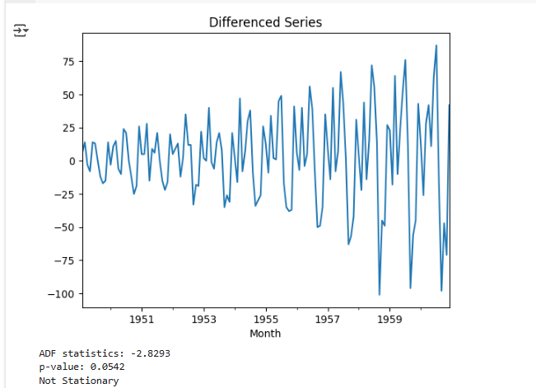

**Code:**

#plot Acf and pacf

plot_acf(df_diff,lags=20)

plt.title("ACF Plot")

plt.show()

plot_pacf(df_diff,lags=20)

plt.title("PACF Plot")

plt.show()

**Output:**

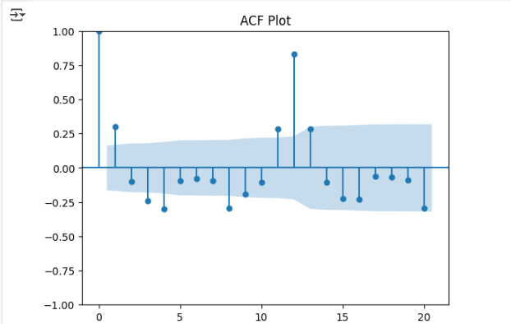

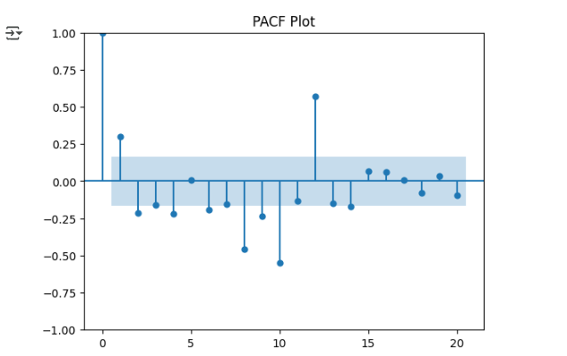

**Code:**

#Arima

model=ARIMA(df['Passengers'],order=(2,1,2))

model_fit=model.fit()

model_fit.summary()

**Output:**

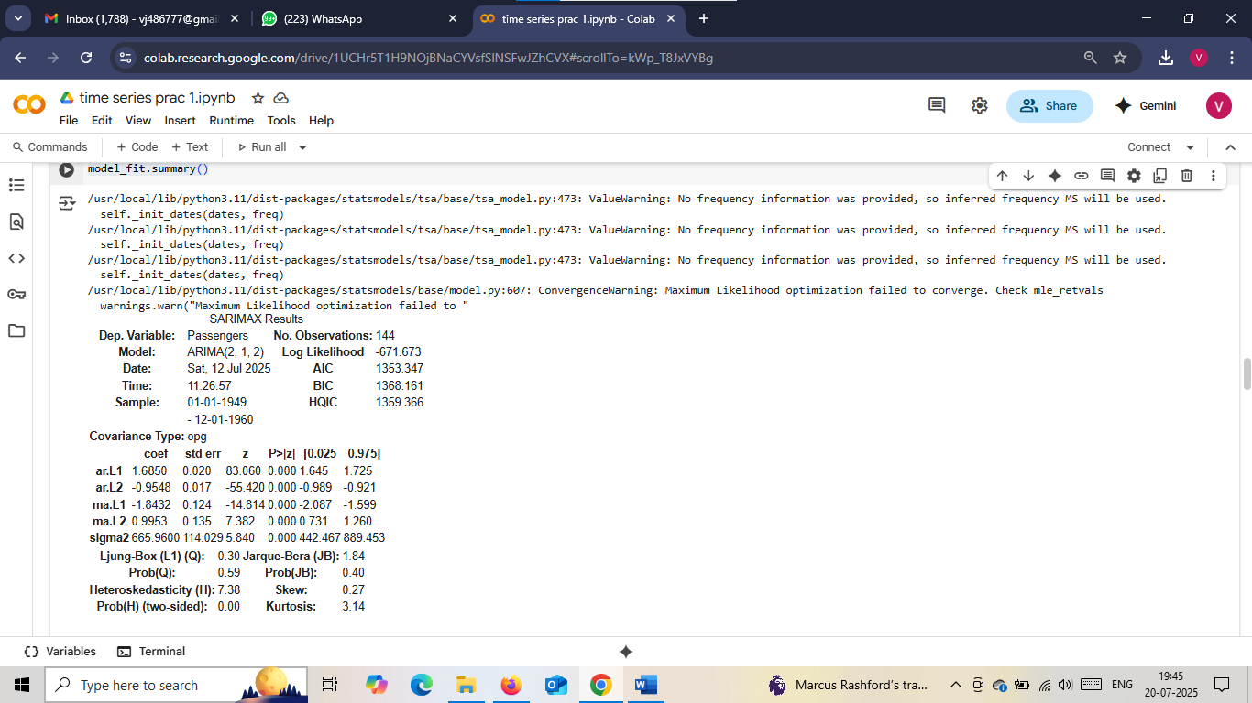

**Code:**

#forecast and plot

forecast = model_fit.forecast(steps=24)

forecast.index =pd.date_range(start=df.index[-1] + pd.DateOffset(months=1), periods=24, freq='MS')

plt.figure(figsize=(10, 4))

plt.plot(df['Passengers'], label='Actual')

plt.plot(forecast, label='Forecast', color='red')

plt.title("forecast using ARIMA(2,1,2)")

plt.legend()

plt.grid()

plt.show()

**Output:**

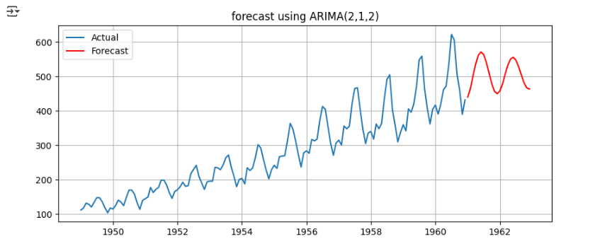

**Code:**

#evaluate forecast(train/test)

#train

train=df['Passengers'][:-24]

test=df['Passengers'][-24:]

model=ARIMA(train,order=(2,1,2))

model_fit=model.fit()

preds = model_fit.forecast(steps=24)

#evaluate

mse=mean_squared_error(test,preds)

print(f'Mean squared error: {mse:.2f}')

**Output:**

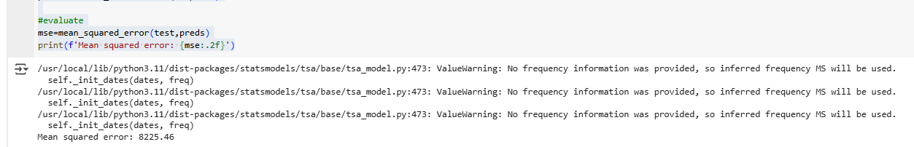

**Code:**

plt.plot(test.index,test.values,label='Actual')

plt.plot(test.index,preds,label='Forecast')

plt.title("ARIMA Model - Prediction vs Actual")

plt.legend()

plt.show()

**Output:**

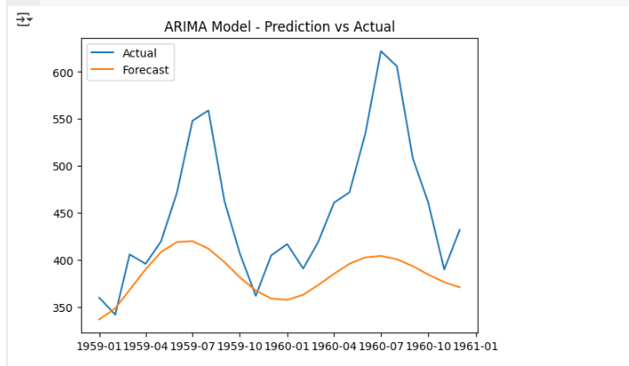

**#Used in r studio**

**Code:**

set.seed(1)

x<-rnorm(100,mean=0,sd=1)

plot(x,type='l',xlab="Time")

**Output:**

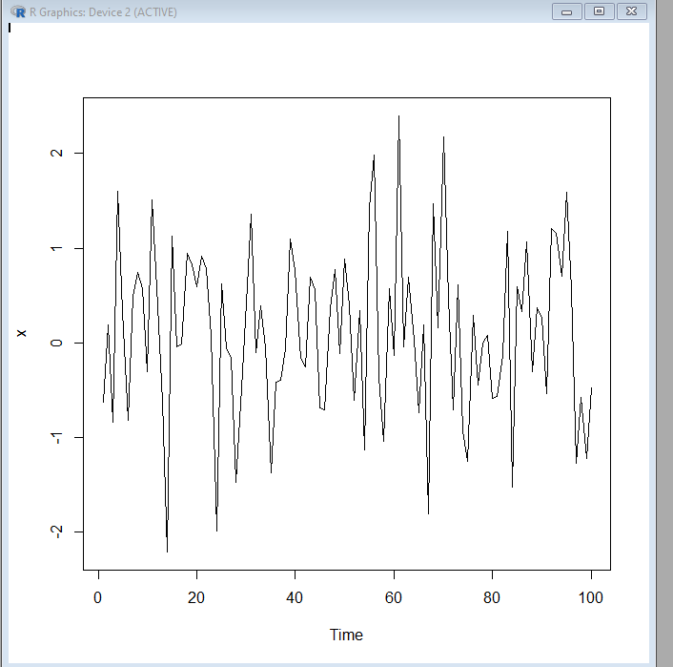

**Code:**

acf(x,main="")

**Output:**

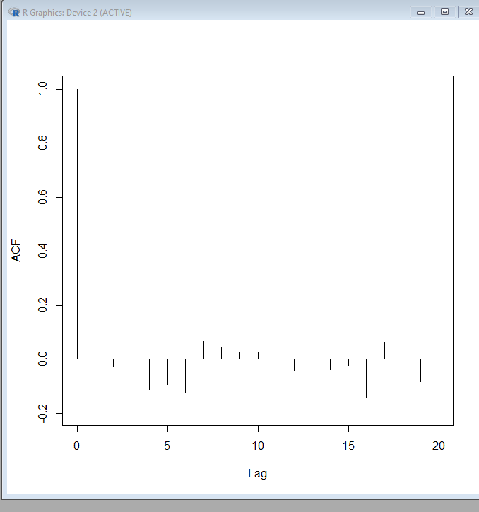

**Code:**

pacf(x,main="")

**Output:**

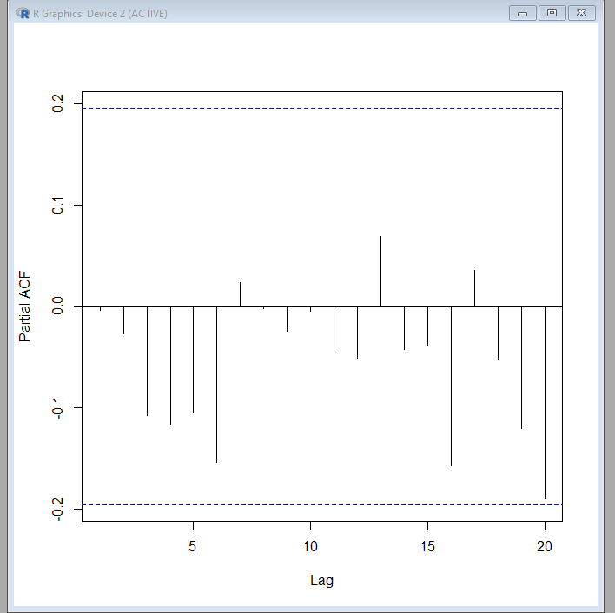

**Code:**

set.seed(1)

x<-w<-rnorm(100,mean=0,sd=1)

for(t in 2:100)x[t]<-x[t-1]+w[t]

plot(x,type='l',xlab="Time")

**Output:**

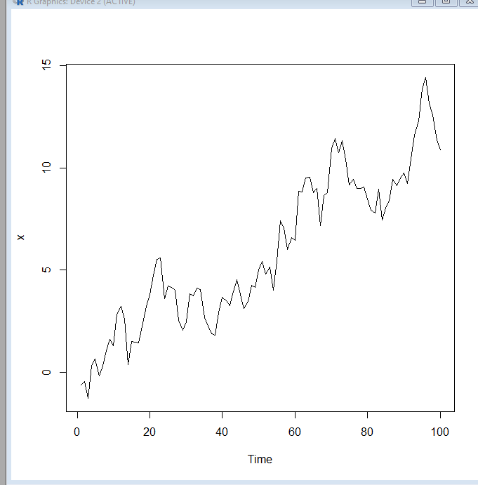

**Code:**

acf(x,main="")

**Output:**

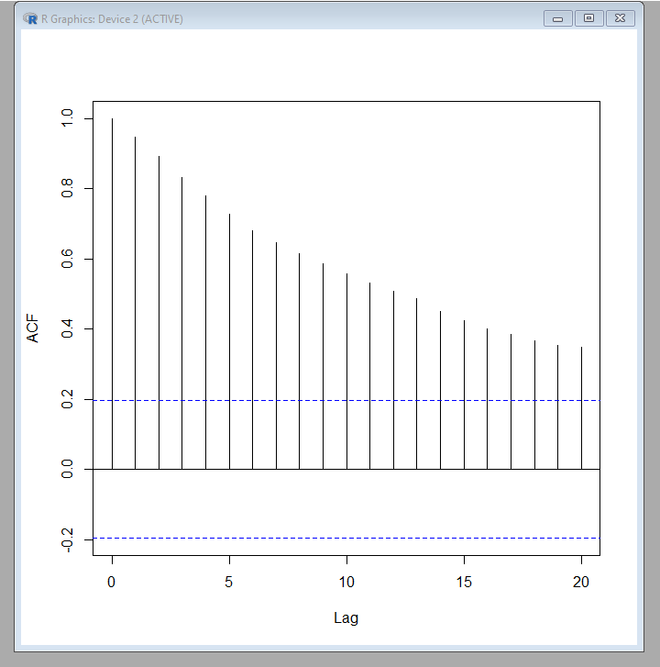

**Code:**

pacf(x,main="")

**Output:**

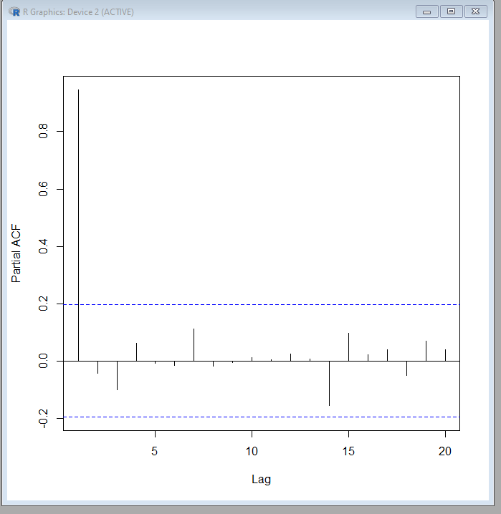

**Code:**

library(datasets)

plot(JohnsonJohnson)

**Output:**

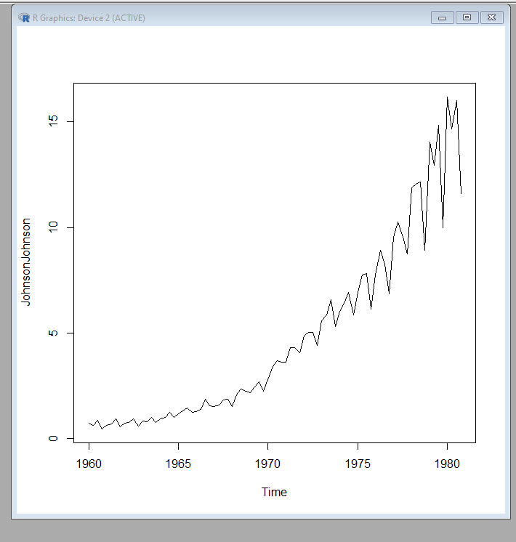

**PRACTICAL N0 – 2**

**Aim:** Linear regression

**Code:**

import numpy as nm

import matplotlib.pyplot as mtp

import pandas as pd

data_set = pd.read_csv('Salary_Data.csv')

print(data_set)

**Output:**

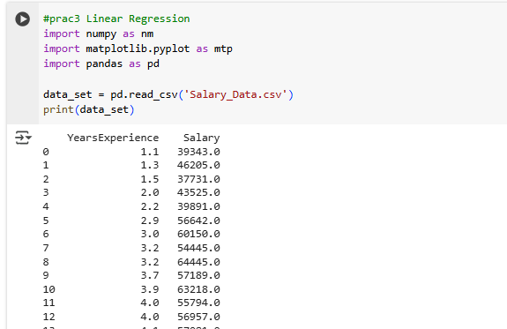

**Code:**

x=data_set.iloc[:,:-1].values

y=data_set.iloc[:,1].values

print(y)

from sklearn.model_selection import train_test_split

x_train,x_test,y_train,y_test=train_test_split(x,y,test_size=1/3,random_state=0)

from sklearn.linear_model import LinearRegression

regressor=LinearRegression()

regressor.fit(x_train,y_train)

**Output:**

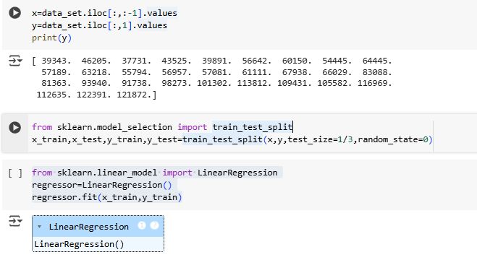

**Code:**

_pred=regressor.predict(x_test)

x_pred=regressor.predict(x_train)

print(y_pred)

print(x_pred)

**Output:**

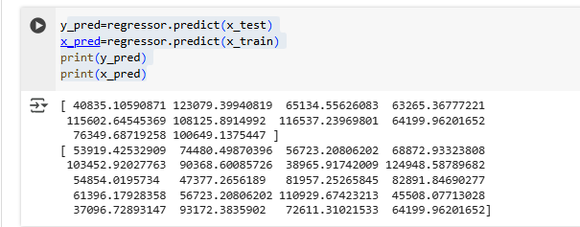

**Code:**

mtp.scatter(x_train,y_train,color="green")

mtp.plot(x_train,x_pred,color="red")

mtp.title("Salary vs Experience(Training DataSet)")

mtp.xlabel("Years of Experience")

mtp.ylabel("Salary(In Rupees)")

mtp.show()

**Output:**

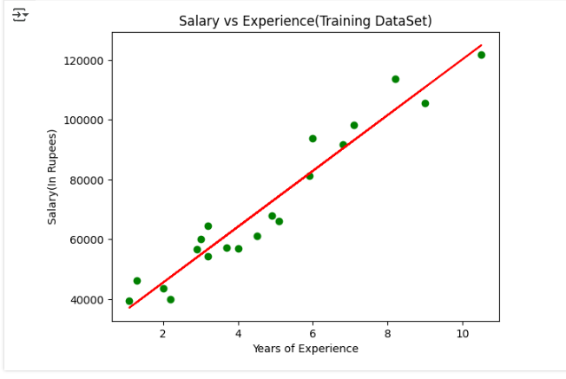

**PRACTICAL N0 – 3**

**Aim:** Exponential Smoothing using fit holt winter additive

**Code:**

import pandas as pd

import numpy as np

import matplotlib.pyplot as plt

from statsmodels.tsa.holtwinters import ExponentialSmoothing

#load or Define data

#load and prepare data

sales=[210,220,230,300,310,305,280,290,295,310,320,330,220,225,235,310,315,310,285,295,300,315,325,335]

dates=pd.date_range(start='2022-01-01',periods=len(sales),freq='MS')

df = pd.Series(sales,index=dates)

df.plot(title='Monthly Retail Sales($)',figsize=(10,4))

plt.ylabel("Sales")

plt.grid()

plt.show()

**Output:**

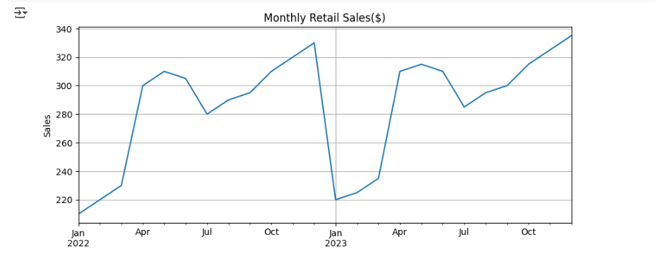

**Code:**

#Create models

#fit holt-winters Additive

model = ExponentialSmoothing(df,trend='add',seasonal='add',seasonal_periods=12)

fit=model.fit()

#forecast next 12 month

forecast=fit.forecast(12)

#plot actucal & forecasted values

#plot actual + forecast

plt.figure(figsize=(10,4))

df.plot(label='Actucal')

forecast.plot(label='Forecast',linestyle='--')

plt.title("Holt-Winters Additive Forecast-Retail Sales")

plt.legend()

plt.grid()

plt.show()

**Output:**

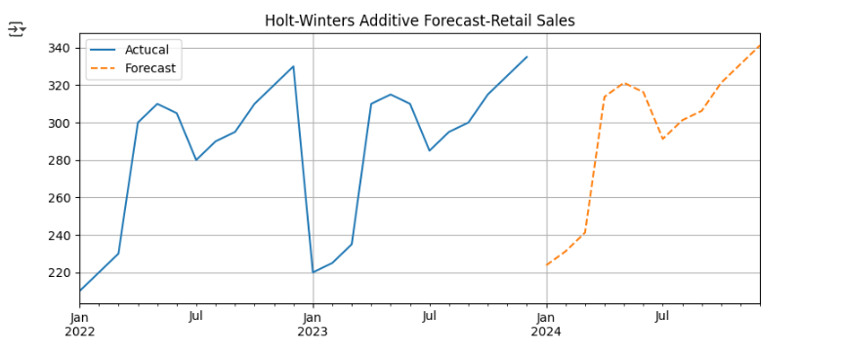

#using different method

**Code:**

import pandas as pd

import numpy as np

import matplotlib.pyplot as plt

from statsmodels.tsa.holtwinters import ExponentialSmoothing

#Simutaled Electronics demand data

#monthly demand over 3 year(36month)

np.random.seed(42)

months=pd.date_range(start='2021-01-01',periods=36,freq='MS')

#Trend+seasonality+noise

demand=(

    500+#base demand

    np.linspace(0,300,36)+ #upward trend

    50*np.sin(2*np.pi*months.month/12)+ #seasonality(1-yearcycle)

    np.random.normal(0,20,36) #random noise

  )

df=pd.Series(demand,index=months)

df.name='Monthly Electronics Demand'

plt.figure(figsize=(10,4))

df.plot()

df=pd.Series(demand,index=months)

df.name = ('Monthly Electronics Demand(units)')

plt.xlabel('Date')

plt.ylabel('Demand')

plt.grid()

plt.show()

**Output:**

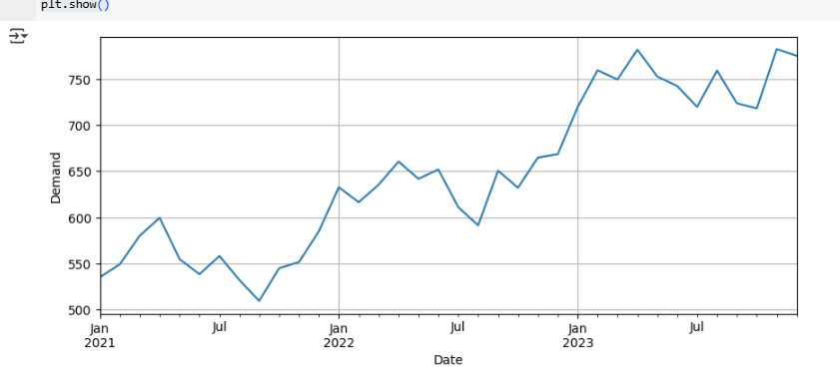

**Code:**

#apply holt-winter forecasting(additive)

model=ExponentialSmoothing(df,trend='add',seasonal='add',seasonal_periods=12)

fit=model.fit()

#forecast for 12 months

forecast=fit.forecast(12)

#plotting actucal and forecasting demand

plt.figure(figsize=(10,4))

df.plot(label='Actual',marker='o')

forecast.plot(label='Forecast',marker='o',linestyle='--',color='red')

plt.title('Electronics Demand forecast (Holt-winters additive)')

plt.xlabel('Date')

plt.ylabel("Units Sold")

plt.legend()

plt.grid()

plt.show()

**Output:**

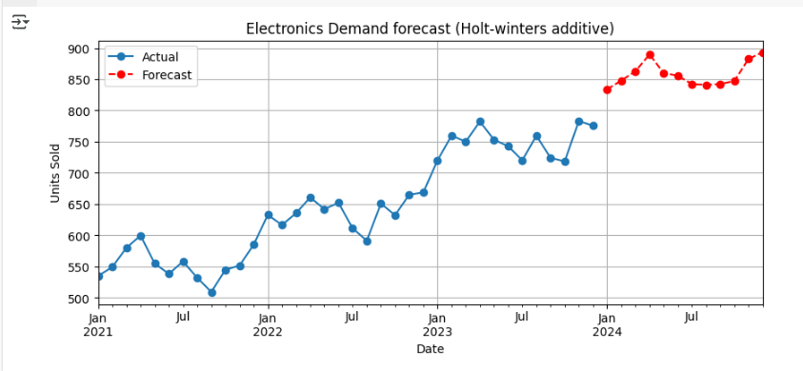

**#using multiplicative**

**Code:**

import pandas as pd

import numpy as np

import matplotlib.pyplot as plt

from statsmodels.tsa.holtwinters import ExponentialSmoothing

#energy consumption(multiplicative)

#predict monthly electricity usage

#synthetic but realistic kwh values for monthly electricity

energy=[310,280,275,260,240,230,220,225,240,280,300,330,325,295,285,270,250,240,230,235,235,290,310,340]

dates=pd.date_range(start='2022-01-01',periods=len(energy),freq='MS')

df2=pd.Series(energy,index=dates)

df2.plot(title='Monthly Electricity Usage(kWh)',figsize=(10,4))

plt.ylabel('kWh')

plt.grid()

plt.show()

**Output:**

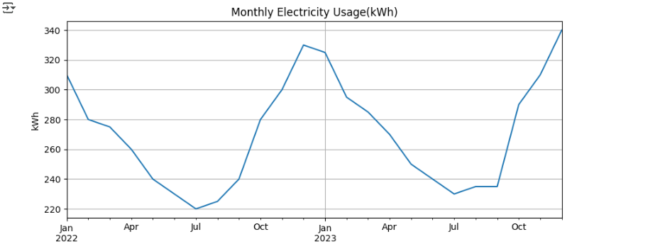

**Code:**

#Holt Winters Multiplicative

model2=ExponentialSmoothing(df2,trend='add',seasonal='mul',seasonal_periods=12)

fit2=model2.fit()

#forecast

forecast2=fit2.forecast(12)

#plot electricity usage

plt.figure(figsize=(10,4))

df2.plot(label='Actual')

forecast2.plot(label='forecast',linestyle='--')

plt.title("Holt-Winters Multiplicative forecast-Electricity")

plt.grid()

plt.legend()

plt.show()

**Output:**

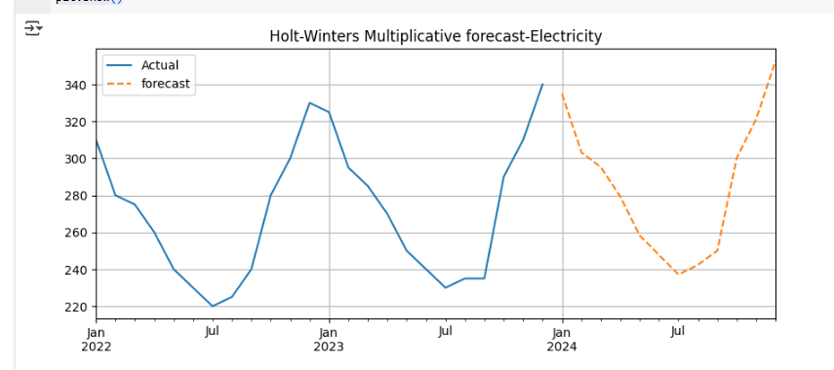

**#using different dataset**

**Code:**

#prac 7

#holt-winter on kashmir Tourism data

import pandas as pd

import numpy as np

import matplotlib.pyplot as plt

from statsmodels.tsa.holtwinters import ExponentialSmoothing

#monthly tourist data

np.random.seed(10)

months=pd.date_range(start='2019-01-01',periods=60,freq='MS')

#base+trend+seasonal variation(e.g high in may-july and dec-jan)

base=10000

trend=np.linspace(0,5000,60)

seasonal_pattern=np.sin(2*np.pi*months.month/12)*2000 #seasonal effect

noise=np.random.normal(0,800,60) #random variation

visitors = base+trend+seasonal_pattern+noise

df = pd.Series(visitors, index=months)

df.name='Monthly Visitors(Kashmir)'

#plot actual data

plt.figure(figsize=(10,4))

df.plot()

plt.title("Monthly Tourist Visitors-Kashmir Valley")

plt.xlabel("Date")

plt.ylabel('Visitors')

plt.grid()

plt.show()

**Output:**

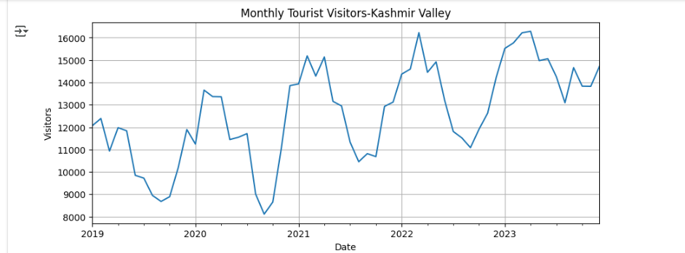

#apply holty-Winters(additive seasonality)

**Code:**

model=ExponentialSmoothing(df,trend='add',seasonal='add',seasonal_periods=12)

#12 months per seasonal cycle

fit=model.fit()

#forecast next 12 months tourist

forecast=fit.forecast(12)

#plot actual vs forecast data

plt.figure(figsize=(10,4))

df.plot(label='Actual',marker='o')

forecast.plot(label='forecast',marker='o',linestyle='--',color='red')

plt.title("Holt-Winters forecast:Kashmir Tourist Visits")

plt.xlabel("Date")

plt.ylabel("Visitors")

plt.grid()

plt.legend()

plt.show()

print("Forecasted Tourist Visits(Next 12 Months):")

print(forecast.round(0).astype(int))

**Output:**

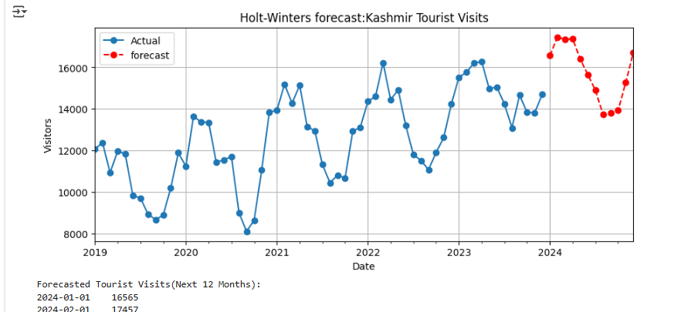

**PRACTICAL N0 – 4**

**Aim:** Simple Exponential Smoothing

**Code:**

import pandas as pd

import matplotlib.pyplot as plt

from statsmodels.tsa.holtwinters import SimpleExpSmoothing,Holt

#create or load dataset

#monthly sales data(in thousand)

sales_data=[200,210,215,220,230,225,235,240,250,255,260,265]

#create a time index

dates=pd.date_range(start='2023-01-01',periods=len(sales_data),freq='M')

#create a time series object

sales_series=pd.Series(sales_data,index=dates)

#apply ses

#create the ses model

model=Holt(sales_series)

#fit the model alpha=0.4,0.3,0.2

fit=model.fit(smoothing_level=0.4,optimized='False')

# forecast for next 6 month

forecast=fit.forecast(6)

#visualize result

#plotting the original data,fitted values and forecast

plt.figure(figsize=(10,5))

plt.plot(sales_series,label='Original Data',marker='o')

plt.plot(fit.fittedvalues,label='Fitted Values',linestyle='--',marker='x')

plt.plot(forecast,label='Forecast',linestyle='--',marker='o',color='red')

plt.title('Simple Exponential Smoothing')

plt.xlabel('Month')

plt.ylabel('Sales(in thousands)')

plt.legend()

plt.grid()

plt.tight_layout()

plt.show()

**Output:**

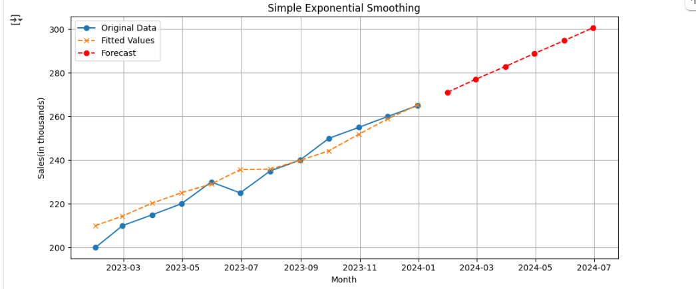

**Code:**

#print forecast values

print("Forecasted sales(next 6 month)")

print(forecast.round(2))

**Output:**

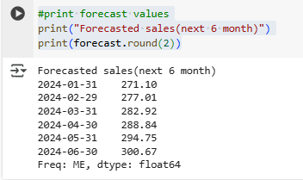

**#using csv file**

**Code:**

#program

#csv files

import pandas as pd

import matplotlib.pyplot as plt

from statsmodels.tsa.holtwinters import SimpleExpSmoothing

#load dataset

df=pd.read_csv('electricity_usage.csv',parse_dates=['Date'],index_col='Date')

print(df.head())

#checking optional values

print(df.isnull().sum())

#create time series object

series =df['Consumption']

#apply ses

model=Holt(series)

fit=model.fit(smoothing_level=0.4,optimized='False')

#forecast next 6 month

forecast=fit.forecast(6)

#print forecast values

print("Next 6 month forecast:")

print(forecast)

**Output:**

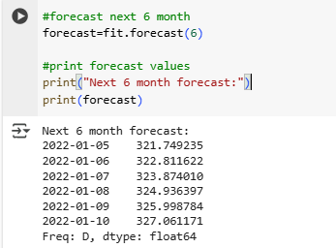

**Code:**

#plot the result

plt.figure(figsize=(10,5))

series.plot(label='Original Data',marker='o')

fit.fittedvalues.plot(label='Fitted Values',linestyle='--',marker='x')

forecast.plot(label='Forecast',linestyle='--',marker='o',color='red')

plt.title('Simple Exponential Smoothing')

plt.xlabel('Month')

plt.ylabel('Electricity Consumption')

plt.legend()

plt.grid()

plt.tight_layout()

plt.show()

**Output:**

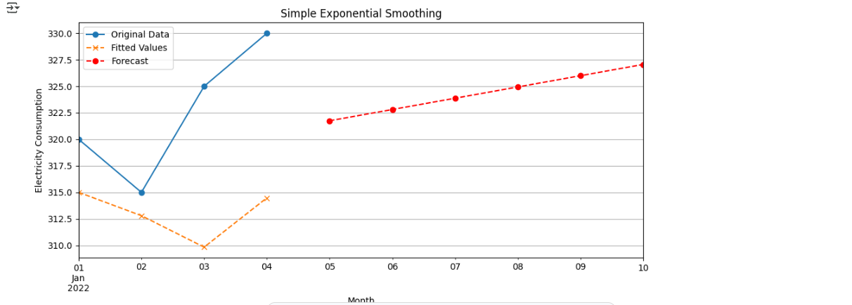

**Code:**

#staionary time series example

#import libraries

import numpy as np

import pandas as pd

import matplotlib.pyplot as plt

from statsmodels.tsa.stattools import adfuller

#set seed for reproducibility

np.random.seed(42)

#build model

data = np.random.normal(loc=0,scale=1,size=100)

dates=pd.date_range(start='2023-01-01',periods=100,freq='D')

series=pd.Series(data,index=dates)

#plot stationary data series

plt.figure(figsize=(10,4))

series.plot(title='Simulated stationary Time Series(White noise)')

plt.xlabel('Date')

plt.ylabel('Value')

plt.grid()

plt.tight_layout()

plt.show()

**Output:**

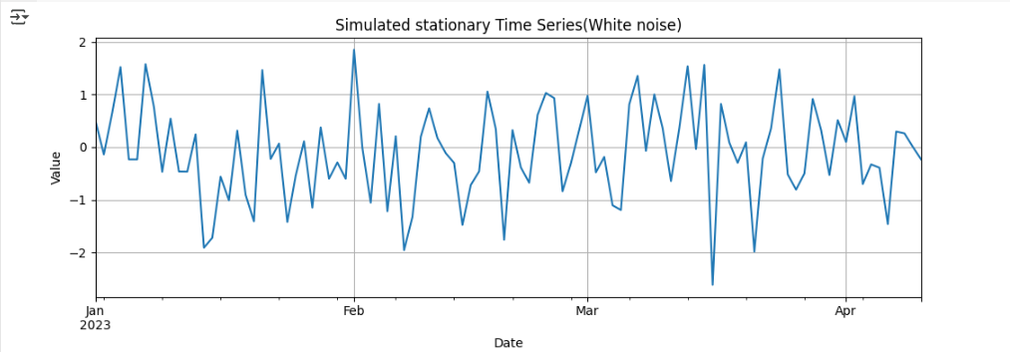

**Code:**

#check whether stationary or non stationary

import pandas as pd

import matplotlib.pyplot as plt

from statsmodels.tsa.stattools import adfuller

df=pd.read_csv('website_traffic.csv',parse_dates=['Date'],index_col='Date')

df['Visits'].plot(figsize=(10,4),title="Daily Website Traffic")

plt.grid()

plt.tight_layout()

plt.show()

**Output:**

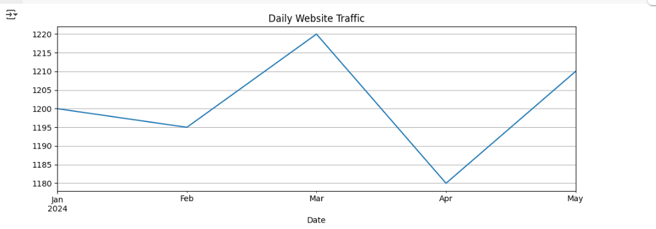

**Code:**

#perform augmented Dickey-Fuller test

result=adfuller(df['Visits'])

print("Augmented Dickey-Fuller Test:",result[0])

print("p-value:",result[1])

**Output:**

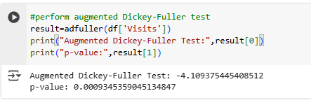

**Code:**

if result[1]<0.05:

  print("The series is stationary")

else:

  print("The series is non-stationary.Applying differencing...")

#first order differencing

df_diff=df['Visits'].diff().dropna()

#plot differenced series

df_diff.plot(figsize=(10,4),title="First-order Differenced Series")

plt.grid()

plt.show()

**Output:**

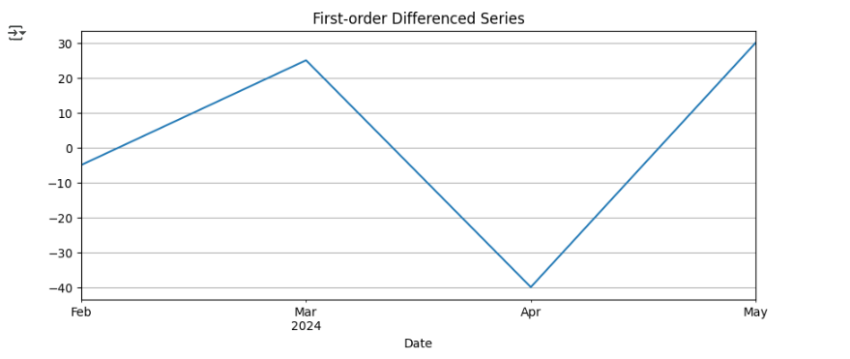

**Code:**

#re-run adf test on differenced series

result_diff= adfuller(df_diff)

print("Augmented Dickey-Fuller Test:",result_diff[0])

print("p-value after decreasing:",result_diff[1])

if result_diff[1]<0.05:

  print("The differenced series is now stationary")

else:

  print("The differenced series is now non-stationary")

**Output:**

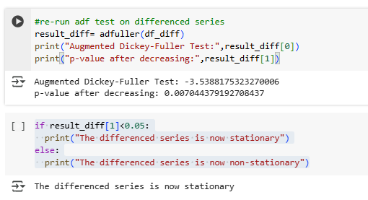

**PRACTICAL N0 – 5**

**Aim:** Simple Exponential Smoothing holt(in rstudio) & Exponential and moving average smoothing-Holts forecasting

**Code:**

install.packages("forecast")

**Output:**

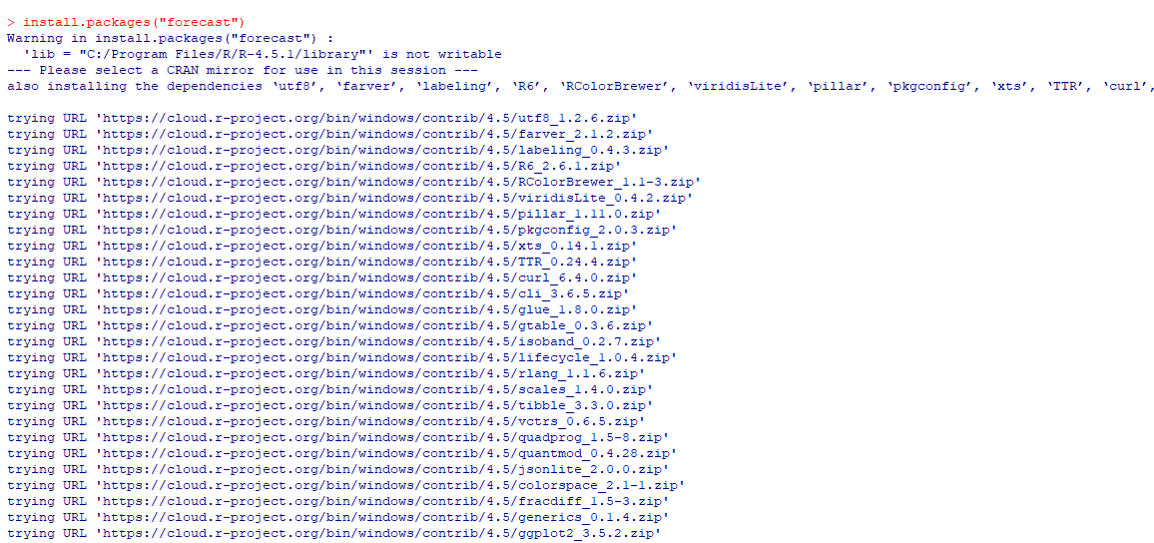

**Code:**

library(forecast)

**Output:**



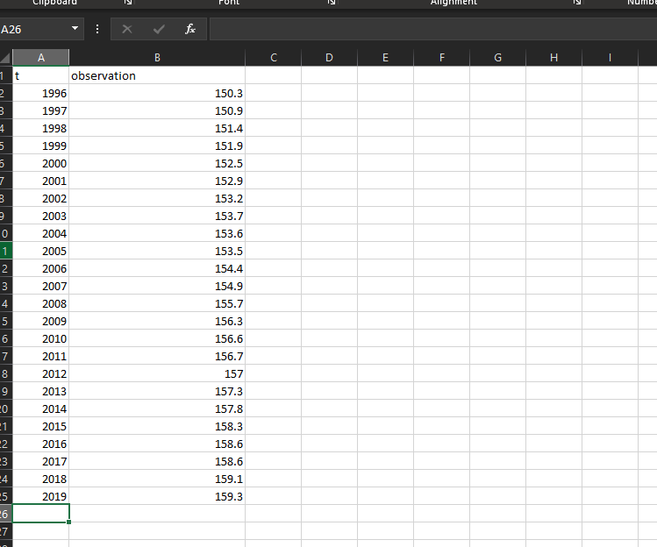

**Code:**

data<-read.csv('C:/Users/Admin/Desktop/Book1.csv')

data

**Output:**

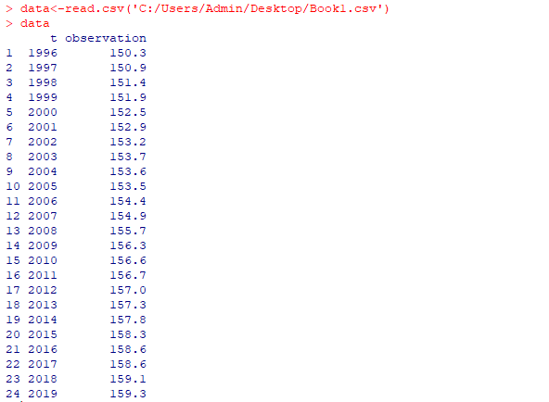

**Code:**

library(ggplot2)

ggplot(data,aes(x=t,y=observation))+

geom_line(color="blue")+

geom_point(color="blue")+

ggtitle("Original Time Series Data")+

xlab("Year")+

ylab("Observation")

**Output:**

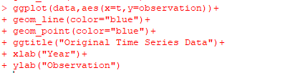

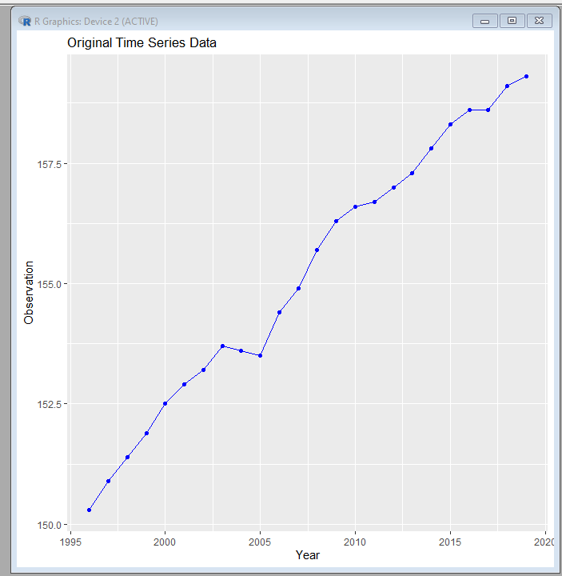

**Code:**

ses_model<-ses(data$observation, alpha=0.3,initial="simple",h=1)

ses_fitted<-fitted(ses_model)

ses_fitted

**Output:**

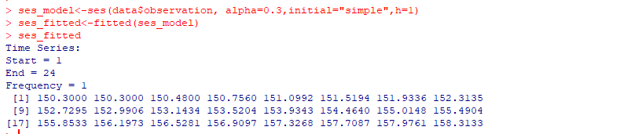

**Code:**

holt_model<-holt(data$observation,aplha=0.3,beta=0.2,initial="simple",h=1)

holt_fitted<-fitted(holt_model)

holt_fitted

**Output:**

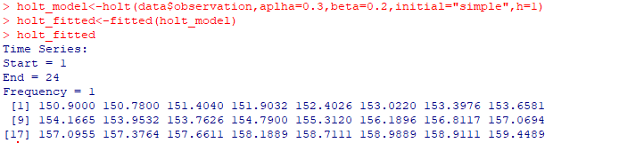

**Code:**

ggplot()+

  geom_line(aes(x=data$t, y=data$observation,color="Original"),size=1)+

geom_line(aes(x=data$t, y=ses_fitted, color="SES(aplha=0.3)"),linetype="dashed",size=1)+

 geom_line(aes(x=data$t, y=holt_fitted,color="Holt's(alpha=0.3,beta=0.2)"),linetype="dotted",size=1)+

 ggtitle("Comparsion of SES and Holt's Method")+

 xlab("Year")+

 ylab("Observation")+

 scale_color_manual(values=c("blue","red","green"))+

 theme_minimal()

**Output:**

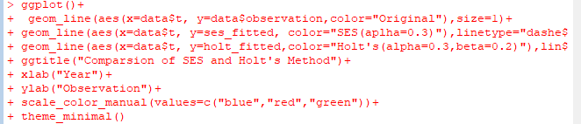

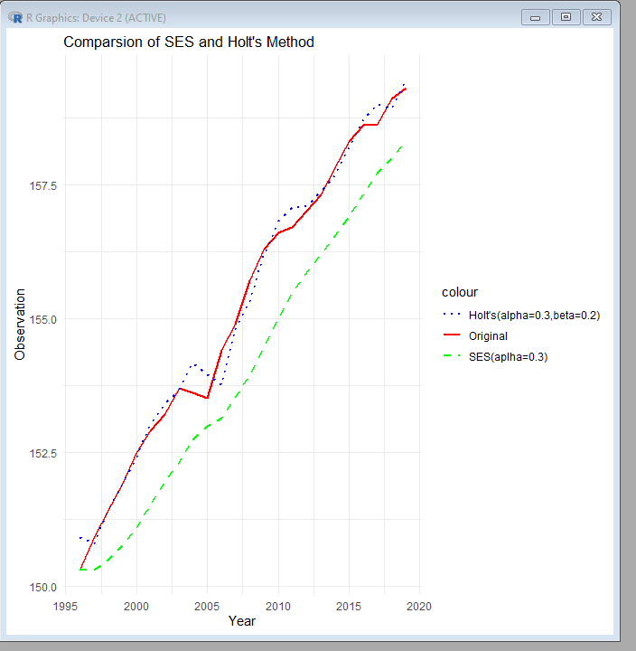

**#Different dataset**

**Code:**

years<-1991:2003

co2_concentration<-c(355.62,356.36,357.1,358.86,360.9,362.58,363.84,366.58,368.3,369.47,371.03,373.61,357.61)

ts_co2<-ts(co2_concentration,start=min(years),frequency=1)

ts_co2

**Output:**

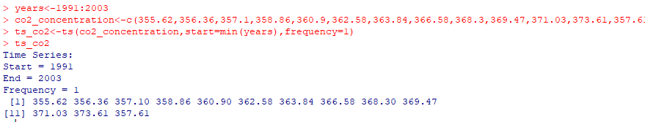

**Code:**

moving_avg_manual<-function(data,window_size){

n<-length(data)

ma<-rep(NA,n)

for(i in seq(window_size,n)){

ma[i]<-mean(data[(i-window_size+1):i])

}

return(ma)

}

window_size<-3

ma_co2<-moving_avg_manual(co2_concentration,window_size)

ma_co2

**Output:**

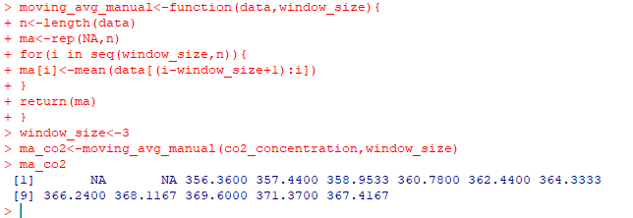

**Code:**

forecast_2004<-tail(ma_co2,1)

cat("Forecasted co2 concentration for 2004 using 3-year Moving Average:",forecast_2004,"\n")

**Output:**



**Code:**

insall.packages("forecast")

library(forecast)

 data("AirPassengers")

plot(AirPassengers,main="AirPassengers Data",ylab="Number of Passengers",xlab="Year")

**Output:**

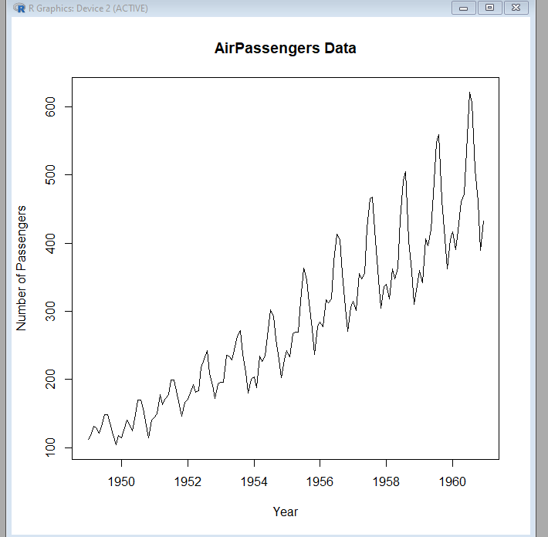

 #Exponential and moving average smoothing-Holts forecasting

**Code:**

 data<-c(150.3,150.9,151.4,151.9,152.5,152.9,153.2,153.7,153.6,153.5,154.4,154.9,155.7,156.3,156.6,156.7,157,157.3,157.8,158.3,158.6,158.6,159.1,159.3)

 time_series_data<-ts(data,start=1996,frequency=1)

 #A)simple exponential smoothing aplha=0.3

 #load necessary package

 library(forecast)

**Output:**

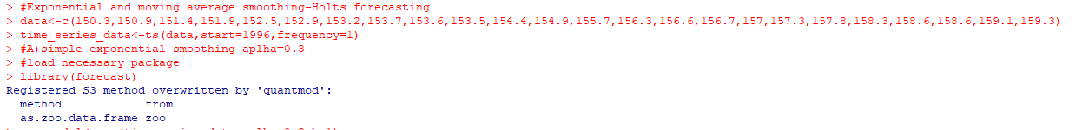

**Code:**

 ses_model<-ses(time_series_data,aplha=0.3,h=1)

 summary(ses_model)

**Output:**

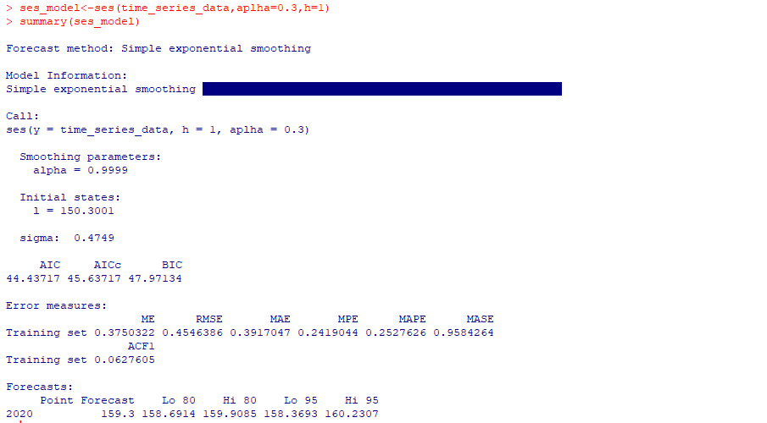

**Code:**

#plot the ses model

 plot(time_series_data,main="Simple Exponential Smoothing(aplha=0.3)",col="blue",lwd=2)

**Output:**

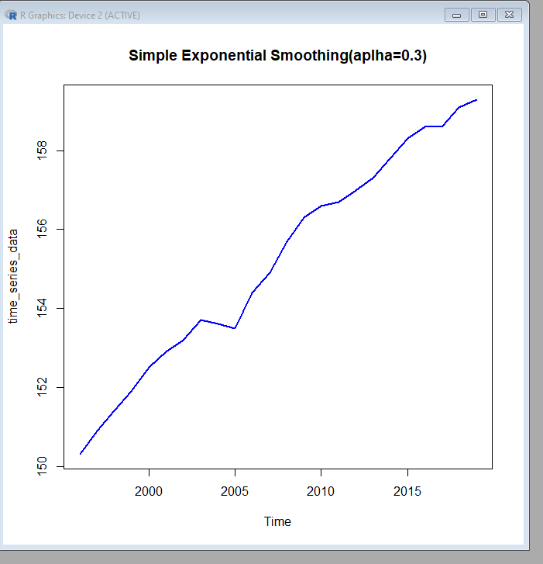

**Code:**

lines(fitted(ses_model),col="red",lty=2,lwd=2)

**Output:**

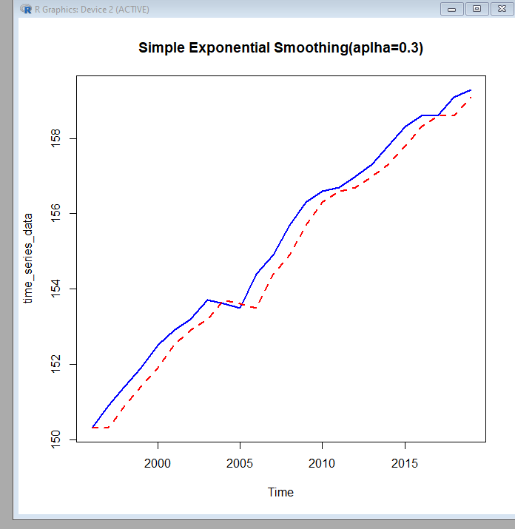

**Code:**

legend("topleft",legend=c("Original Series","SES Fitted"),col=c("blue","red"),lty=1:2)

**Output:**

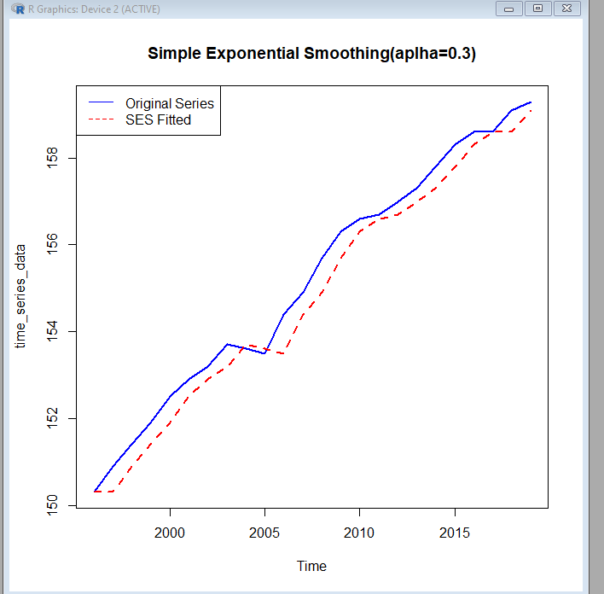

**Code:**

#plot the holt's model

 plot(time_series_data,main="Holt's Exponential Smoothing(alpha=0.3,beta=0.2)",col="blue",lwd=2)

**Output:**

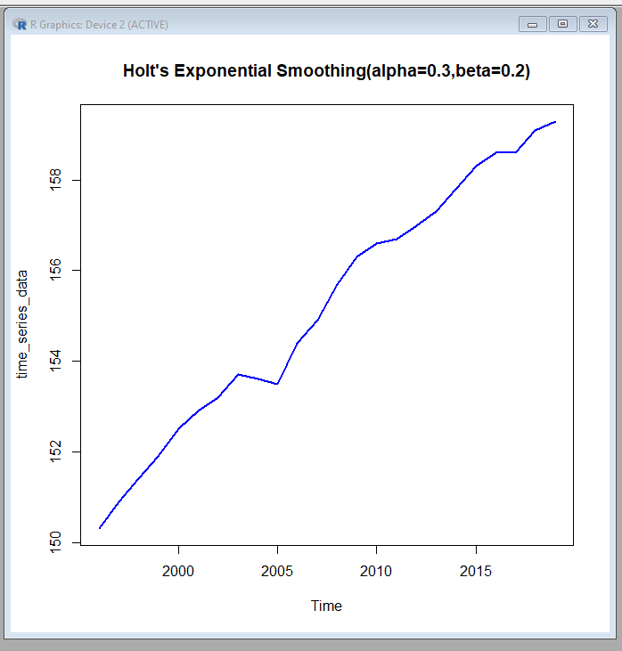

**Code:**

lines(fitted(holt_model),col="green",lty=2,lwd=2)

**Output:**

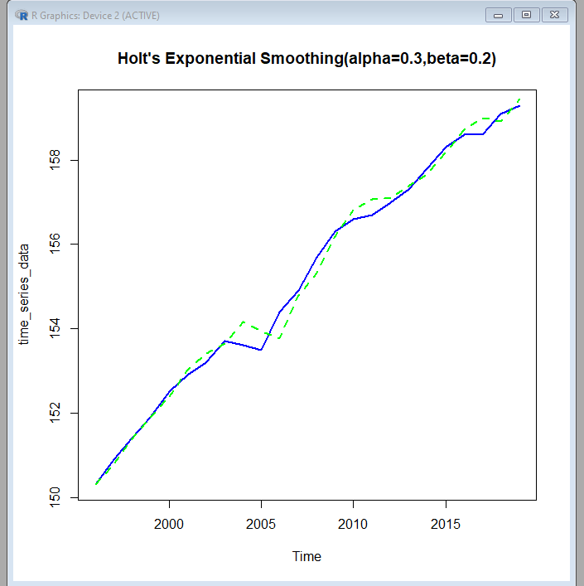

**Code:**

legend("topleft",legend=c("Original Series","Holt's Fitted"),col=c("blue","green"),lty=1:2)

**Output:**

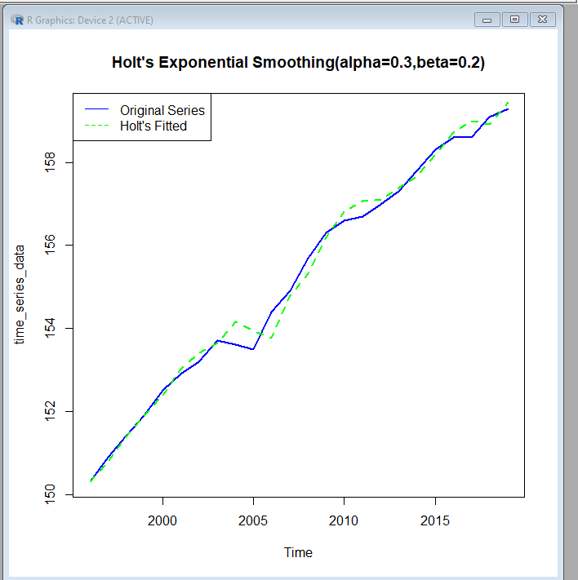

**Code:**

#plotting both model

 plot(time_series_data,main="Comparsion of SES and Holt's Methods",col="blue",lwd=2)

 lines(fitted(ses_model),col="red",lty=2,lwd=2)

lines(fitted(holt_model),col="green",lty=2,lwd=2)

 legend("topleft",legend=c("Original Series","SES Fitted","Holt's Fitted"),col=c("blue","red","green"),lty=1:2)

**Output:**

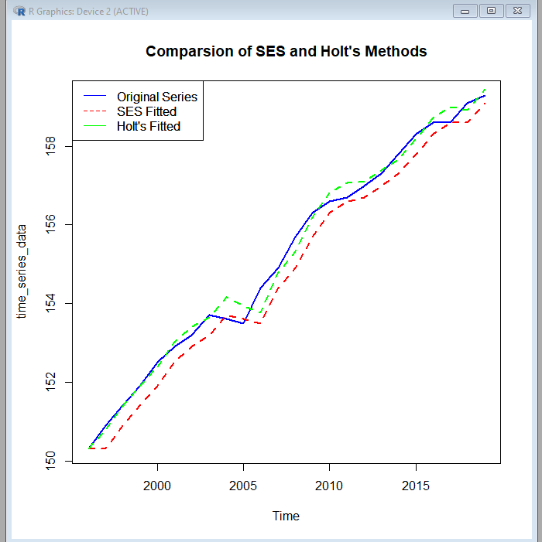

**Code:**

 #Exponential and moving average smoothing 3-years

 #given data

co2_concentration<-c(355.62,356.36,357.1,358.86,360.9,362.58,363.84,366.58,368.3,369.47,371.03,373.61,357.61)

 #create a time series object for the co2 concentration data

 co2_ts<-ts(co2_concentration,start=1991,frequency=1)

 #plotting the time series

 plot(co2_ts,main="Atmospheric CO2 Concentration at Mauna Loa(1991-2003)",xlab="Year",ylab="CO2 Concentration(ppm)",col="blue",lwd=2)

**Output:**

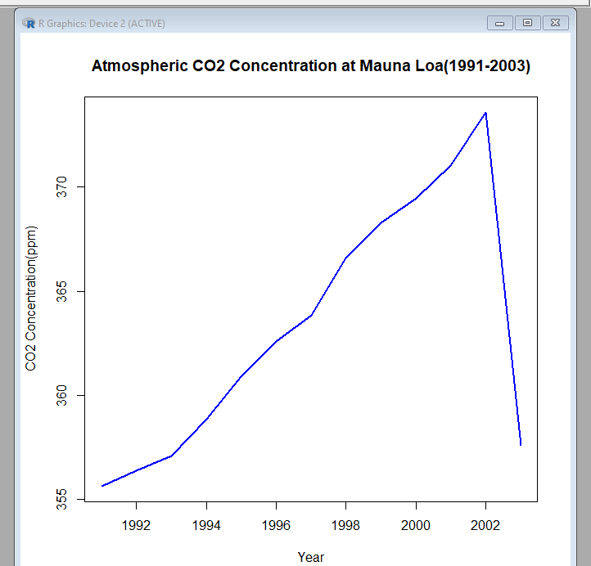

**Code:**

#Calculate 3-year moving average

 moving_average_3<-filter(co2_ts,rep(1/3,3),sides=2)

 #forecast the value for 2004

 #using the last three values(2001,2002,2003)to forecast for 2004

 forecast_2004<-mean(co2_concentration[11:13])

 forecast_2004

**Output:**

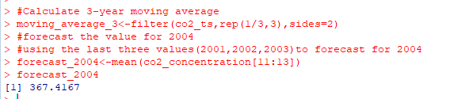

**Code:**

#Exponential and moving average smoothing for holt forecasting

 library(stats)

 data("AirPassengers")

 #plot the time series

 plot(AirPassengers,main="AirPassengers Data",xlab="Year",ylab="Number of Passengers")

**Output:**

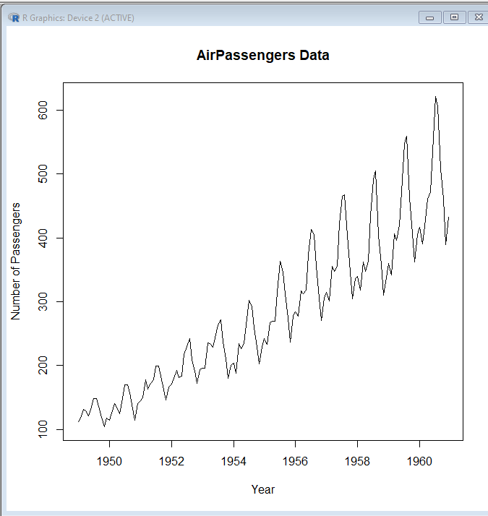

**Code:**

#apply holt-winters model (multiplicative)

 hw_model<-HoltWinters(AirPassengers,seasonal="multiplicative")

#summary

summary(hw_model)

**Output:**

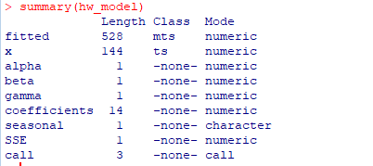

**Code:**

#forecast for the next 12 months

forecast<-predict(hw_model,n.ahead=12)

forecast

**Output:**

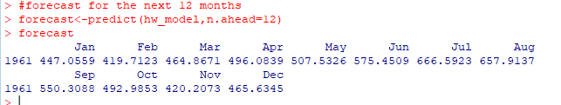

**Code:**

#plot the original series and forecast

 plot(hw_model,forecast,main="Holt-Winters Forecasting")

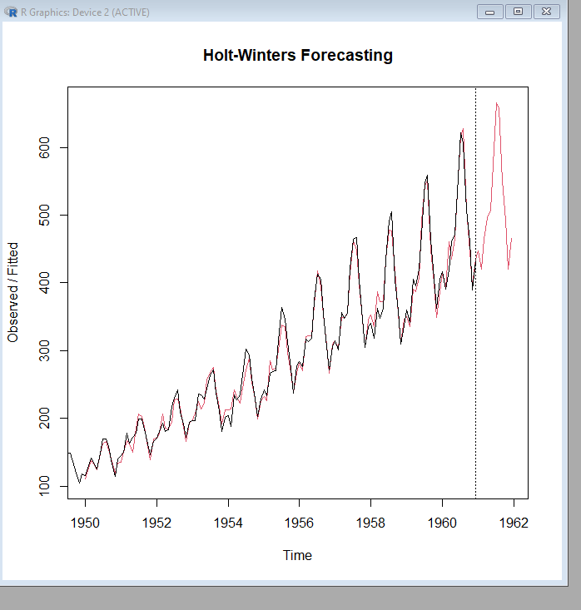

**Code:**

#plot the original series and forecast

residuals<-AirPassengers-fitted(hw_model)

 plot(residuals,main="Residuals of Holt-winters Model")

**Output:**

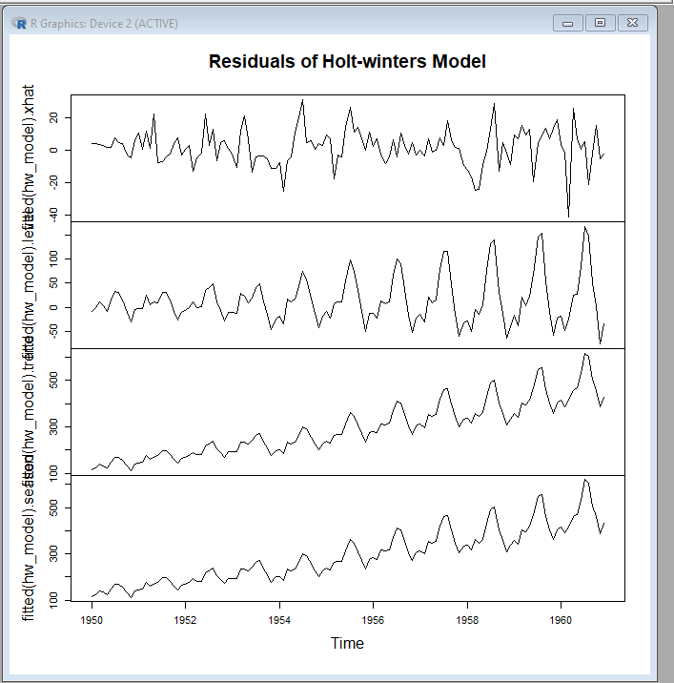

**Code:**

#check for autocorrelation

acf(residuals,main="ACF of Residuals")

**Output:**

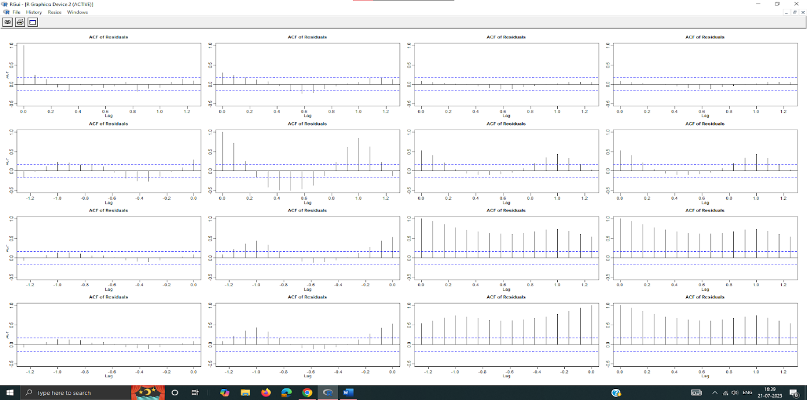

**PRACTICAL N0 – 6**

**Aim:** Autocorrelation & Autoregression using Arima

**Code:**

import pandas as pd

from statsmodels.tsa.arima.model import ARIMA

data=[100,105,102,107,110,112,115,117]

s = pd.Series(data)

#model

model = ARIMA(s,order=(1,0,1))

result = model.fit()

#summary

print(result.summary())

**Output:**

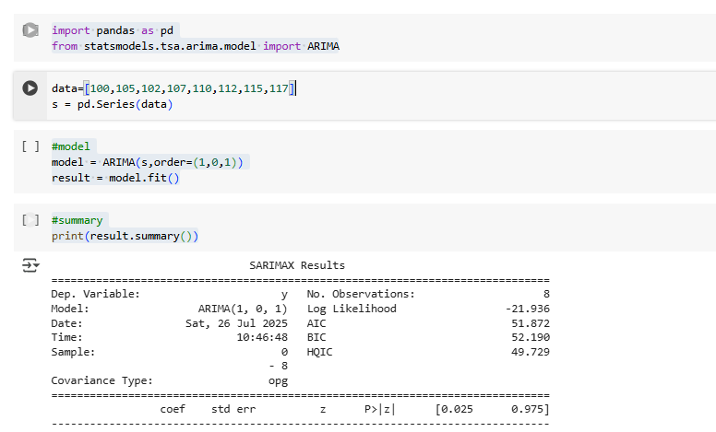

**Code:**

#forecacst

future=result.forecast(steps=3)

print("Next 3 prediction:",future.tolist())

**Output:**

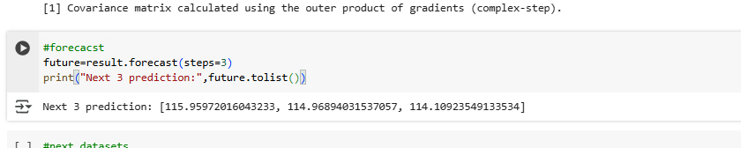

**#Using different dataset**

**Code:**

#next datasets

import matplotlib.pyplot as plt

from statsmodels.tsa.arima.model import ARIMA

from statsmodels.graphics.tsaplots import plot_acf, plot_pacf

#load data

data=[200,202,198,203,207,210,212,215,214,217]

series=pd.Series(data)

#plot time series

plt.figure(figsize=(8,4))

plt.plot(series,marker='o')

plt.title("Weekly Sales Data")

plt.xlabel("Week")

plt.ylabel("Sales Units")

plt.grid()

plt.show()

**Output:**

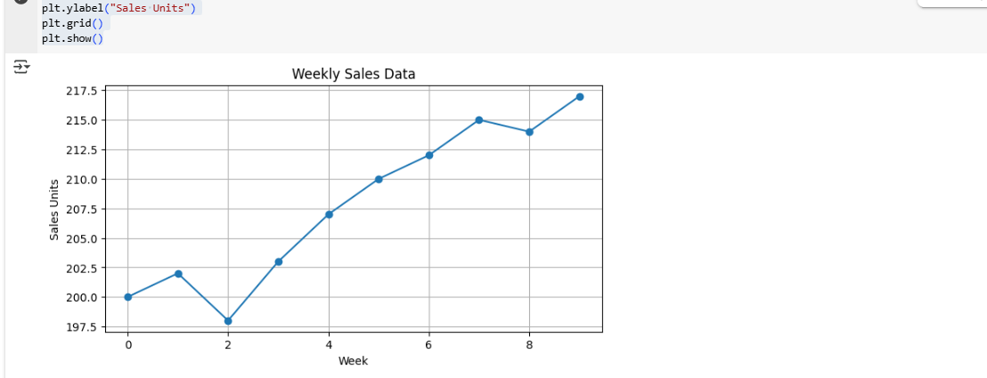

**Code:**

#ACF & PACF

plot_acf(series,lags=5)

plt.show()

plot_pacf(series,lags=5)

plt.show()

**Output:**

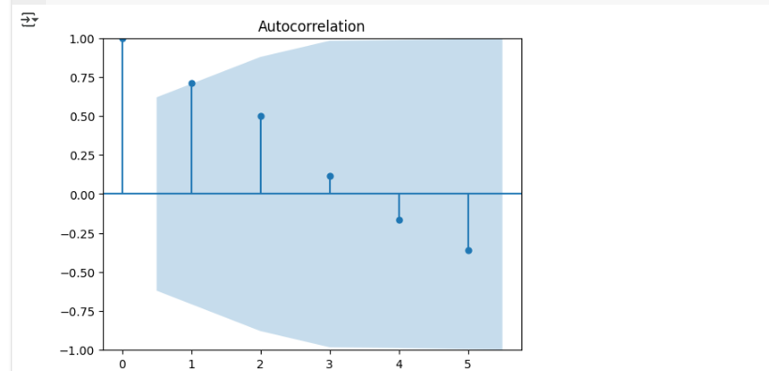

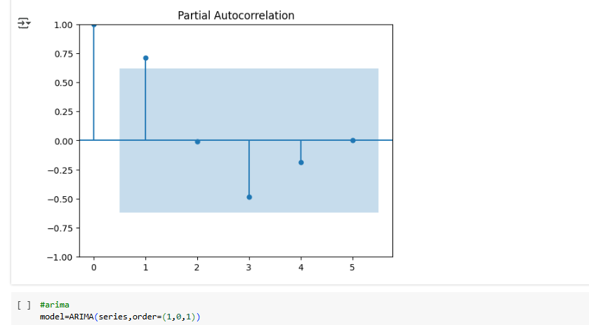

**Code:**

#arima

model=ARIMA(series,order=(1,0,1))

result=model.fit()

print(result.summary())

**Output:**

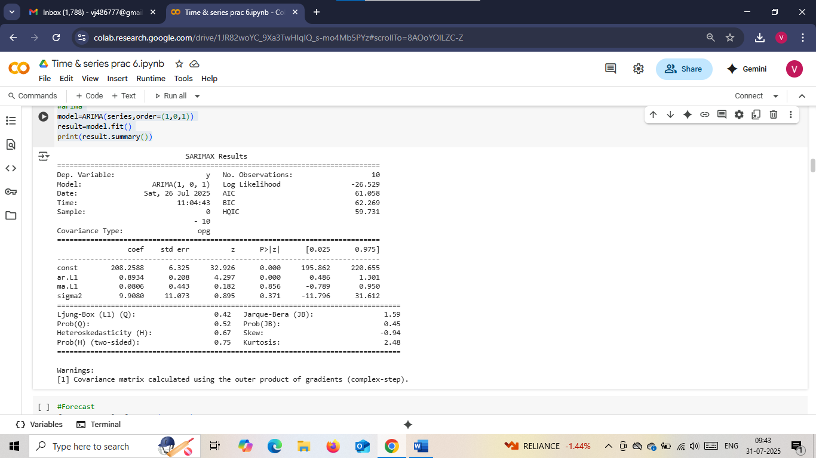

**Code:**

#Forecast

forecast=result.forecast(steps=3)

print("\nForecast for next 3 weeks:")

print(forecast)

**Output:**

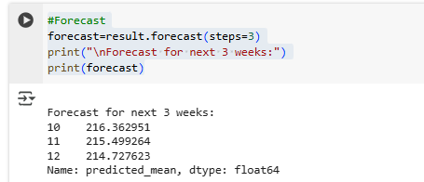

**Code:**

#plot forecast

plt.plot(series,label='Original',marker='o')

forecast_index=range(len(series),len(series)+3)

plt.plot(forecast_index,forecast,label='Forecast',marker='x',linestyle='--',color='red')

plt.legend()

plt.title("Forecast using ARIMA(1,1)")

plt.grid()

plt.show()

print(result.summary())

**Output:**

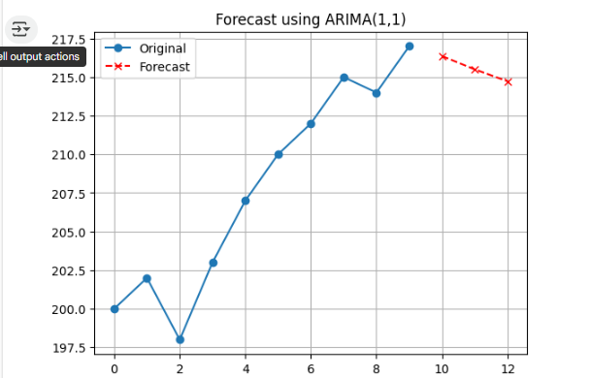

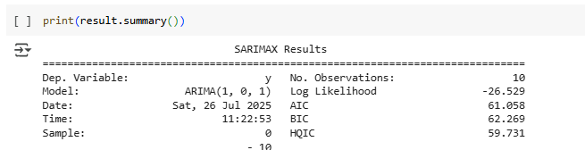

**#next dataset from csv file**

**Code:**

##next dataset from csv file

import pandas as pd

import matplotlib.pyplot as plt

import numpy as np

from statsmodels.tsa.ar_model import AutoReg

from statsmodels.tsa.stattools import acf

#load dataset

df=pd.read_csv("temperature_data.csv",parse_dates=['Date'],index_col='Date')

#visualize the data

df['Temperature'].plot(title='Daily Temperature Time Series',figsize=(10,4))

plt.grid()

plt.show()

**Output:**

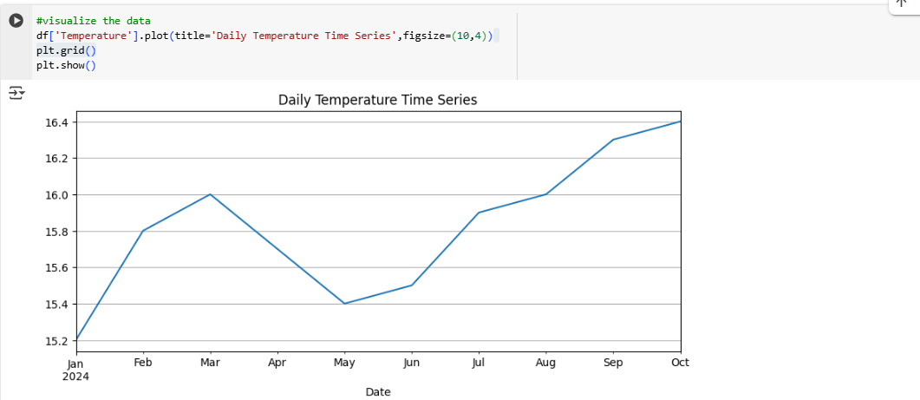

**Code:**

#calculate and plot autocovariance manually

def autocovariance(x,lag):

  x_mean=np.mean(x)

  n=len(x)

  return np.sum((x[:n-lag]-x_mean)*(x[lag:]-x_mean))/n

#print autocovariance for lags 1 to 5

for lag in range(1,6):

  cov=autocovariance(df['Temperature'].values,lag)

  print(f"Autocovariance for lag {lag}: {cov:4f}")

**Output:**

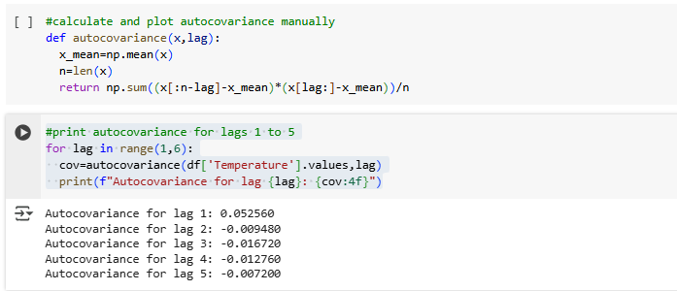

**Code:**

#plot autocorrelation function (ACF)

from statsmodels.graphics.tsaplots import plot_acf

#ACF

plot_acf(df['Temperature'],lags=5)

plt.title("Autocorrelation(ACF)Plot")

plt.show()

**Output:**

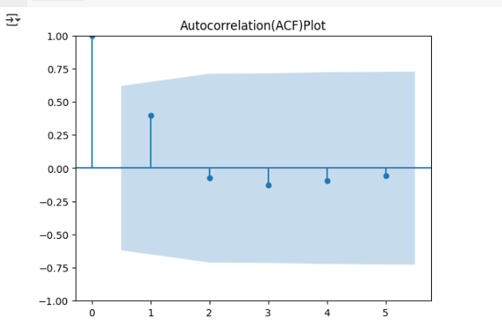

**Code:**

#build and train on autoregression model

ar_model=AutoReg(df['Temperature'],lags=3)

ar_result=ar_model.fit()

#View coefficients

print(ar_result.summary())

**Output:**

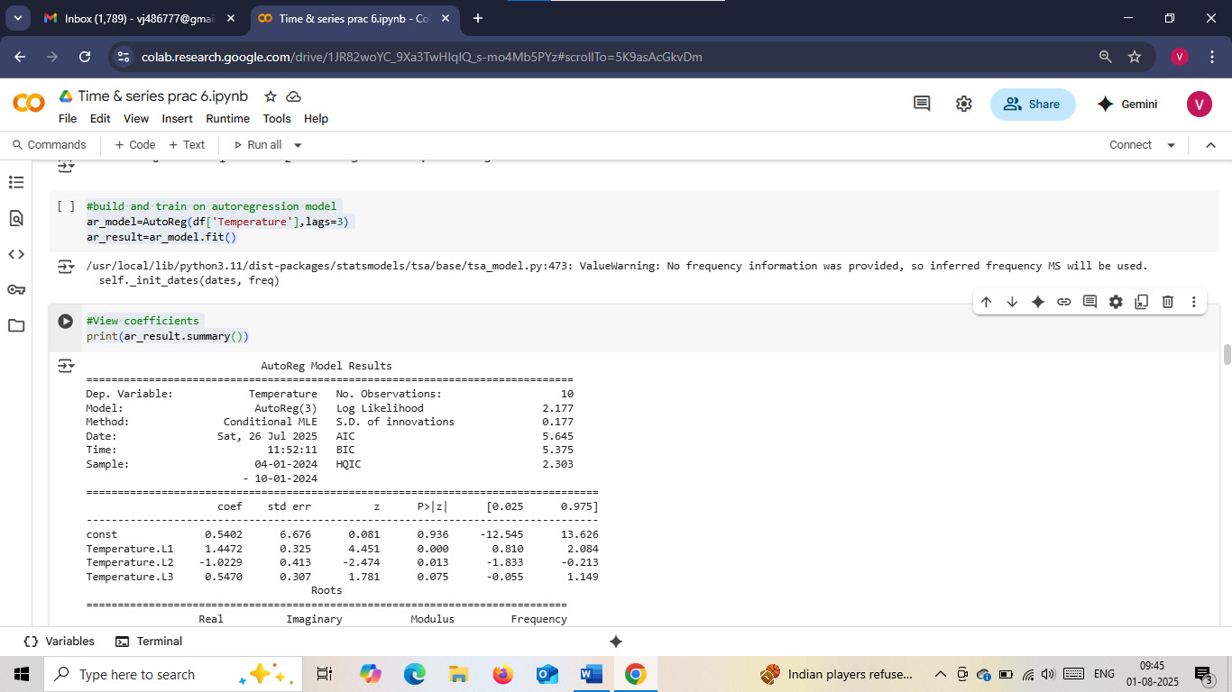

**Code:**

#make prediction and plot

#for next 10 values

forecast=ar_result.predict(start=len(df),end=len(df)+9,dynamic=False)

print(forecast)

**Output:**

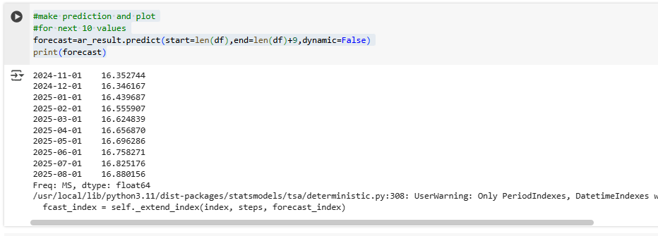

**Code:**

#plot original data and forecast

plt.figure(figsize=(10,4))

plt.plot(df['Temperature'],label='Original')

forecast.plot(label='Forecast',linestyle='--',color='red')

plt.title('Autoregression Forecast(Next 10 Days)')

plt.legend()

plt.grid()

plt.show()

**Output:**

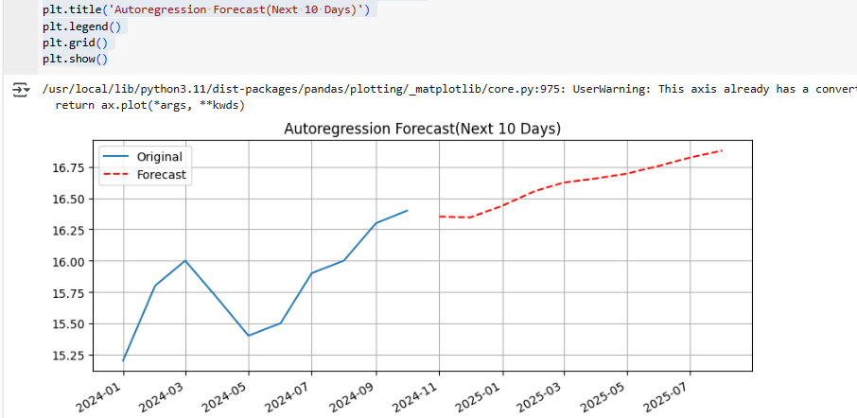

#program 1 project next2 years big billon days sales of flipkart using ARMA(1)

**Code:**

#Hypothetical dataset(2014-2023)

import pandas as pd

import numpy as np

import matplotlib.pyplot as plt

from statsmodels.tsa.arima.model import ARIMA

from statsmodels.graphics.tsaplots import plot_acf, plot_pacf

#load data

df=pd.read_csv("Hypodataset.csv")

#Create time series

sales = df['BBD Sales(in Crores)']

years = df['Year']

sales_series=pd.Series(data=sales.values,index=years)

print("Sales Data:\n",sales_series)

**Output:**

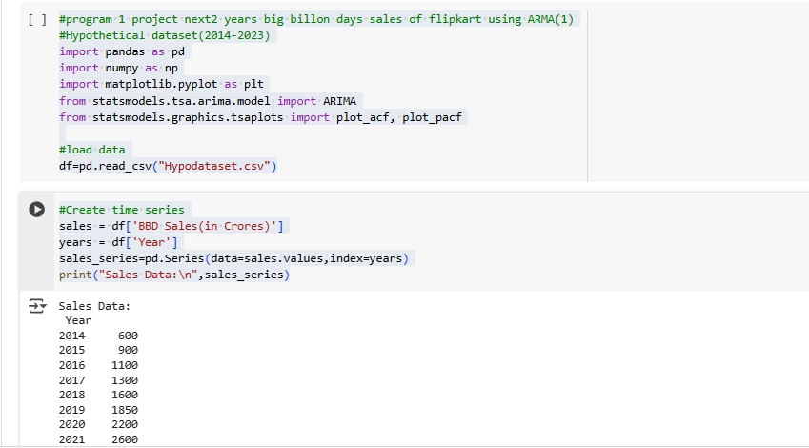

**Code:**

#plot the time series

sales_series.plot(marker='o',title='Flipkart BBD Sales(2014-2023)',ylabel='Sales(in Crores)')

plt.grid()

plt.show()

**Output:**

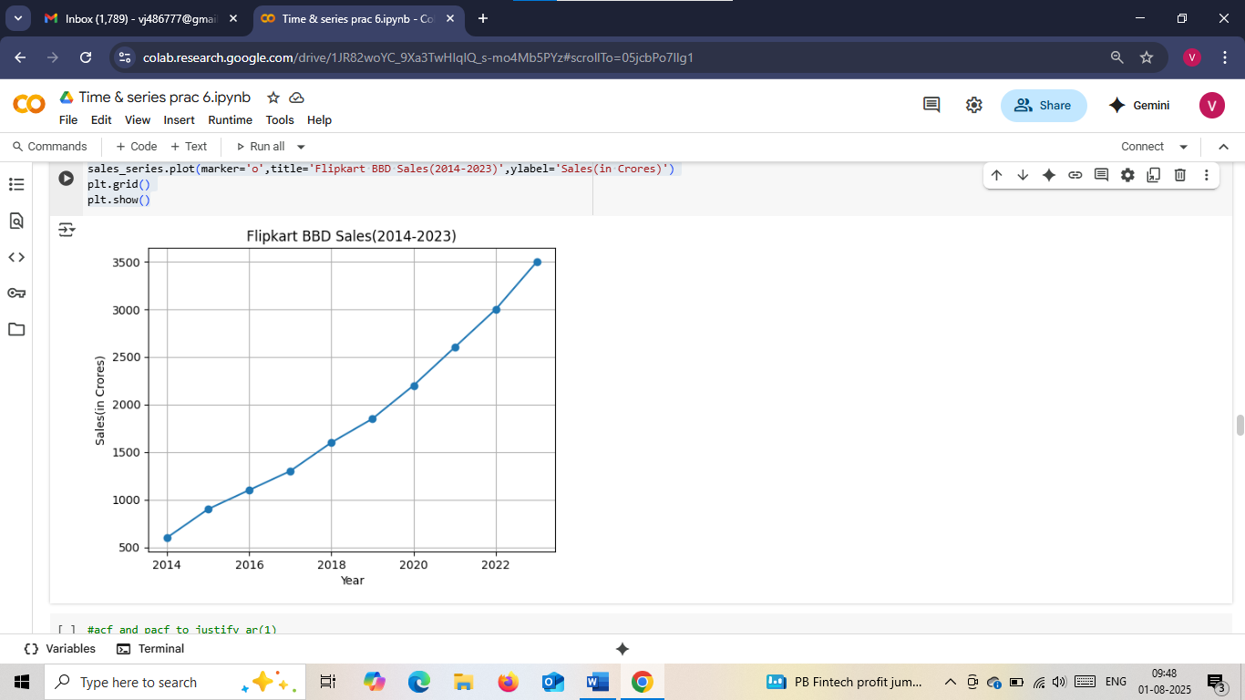

**Code:**

#acf and pacf to justify ar(1)

plot_acf(sales_series)

plt.show()

plot_pacf(sales_series)

plt.show()

**Output:**

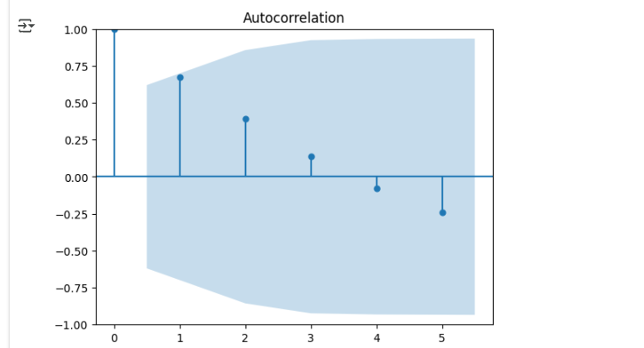

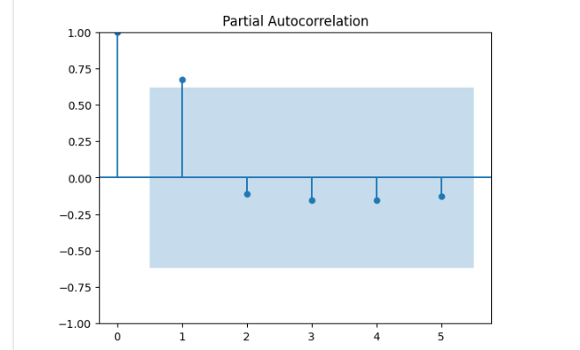

**Code:**

#fit arima(1,0)(Arima with d=0, ma=0)

model=ARIMA(sales_series,order=(1,0,0))

result=model.fit()

#model summary

print(result.summary())

**Output:**

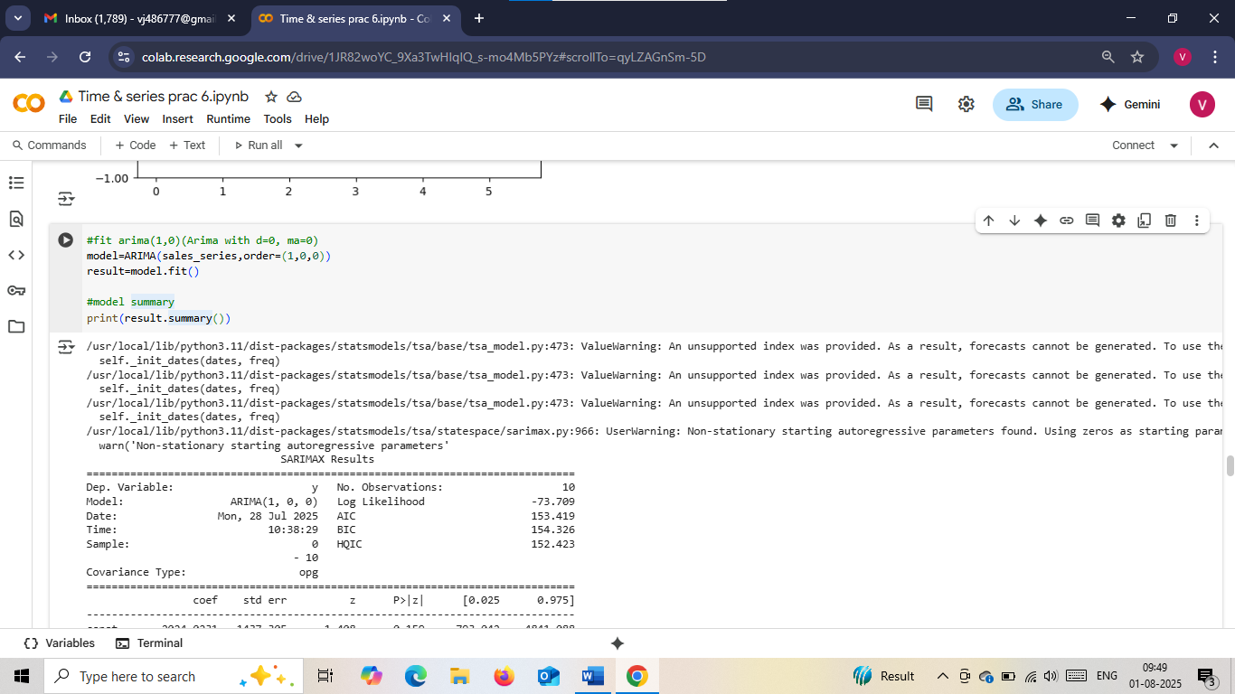

**Code:**

forecast=result.forecast(steps=2)

forecast_years=pd.date_range(start='2024',periods=2,freq='YE')

plt.plot(sales_series,label='Historical')

plt.plot(forecast_years,forecast,label='Forecast',marker='x',linestyle='--',color='orange')

plt.title('Forecast of flipkart(ARMA(1))')

plt.ylabel('Sales(in Crores)')

plt.xlabel('Year')

plt.legend()

plt.grid()

plt.show()

print("Forecasted Sales for 2024:", forecast.iloc[0])

print("Forecasted Sales for 2025:", forecast.iloc[1])

**Output:**

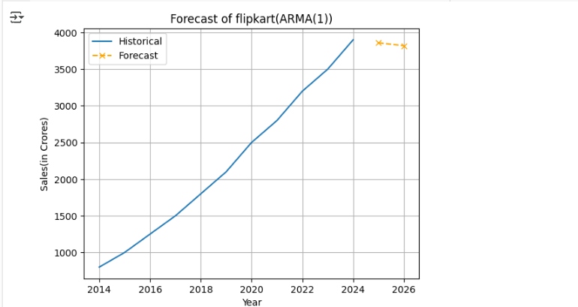

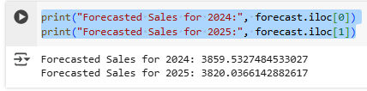

**#Next dataset**

**Code:**

#next dataset

import pandas as pd

import numpy as np

import matplotlib.pyplot as plt

from statsmodels.tsa.arima.model import ARIMA

from statsmodels.graphics.tsaplots import plot_acf, plot_pacf

#create the time series

years=pd.date_range(start='2013',periods=11,freq='Y')

sales=[800,1000,1250,1500,1800,2100,2500,2800,3200,3500,3900]

sales_series=pd.Series(data=sales,index=years)

print("Sales Data:\n",sales_series)

**Output:**

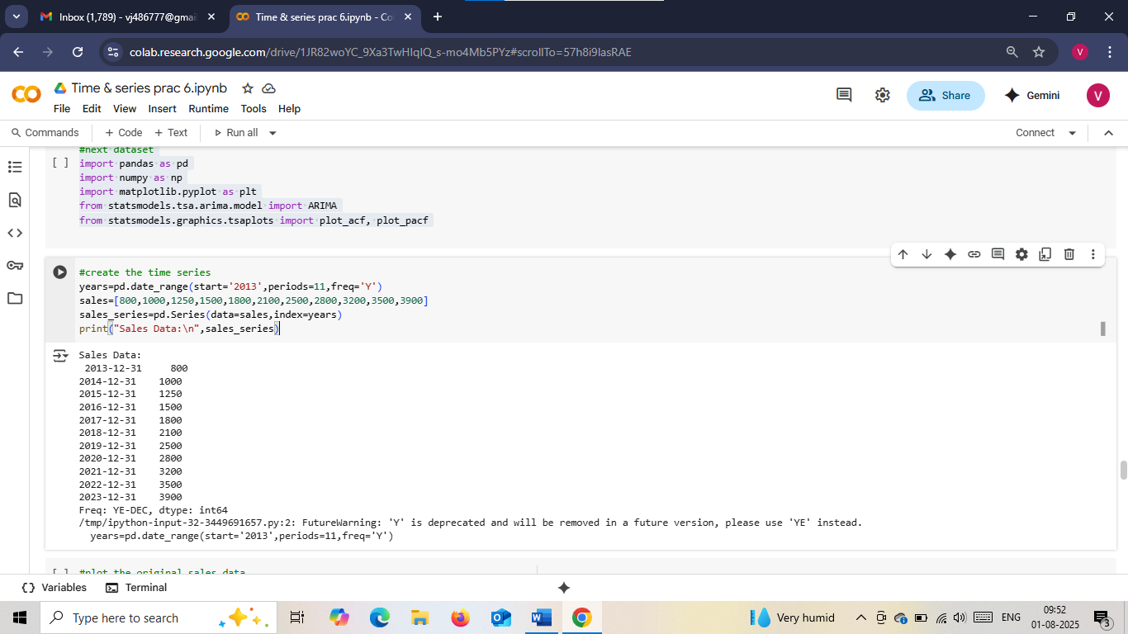

**Code:**

#plot the original sales data

sales_series.plot(marker='o',title='Amazon Diwali Sales(2013-2023)',ylabel='Sales(in Crores)')

plt.grid()

plt.show()

**Output:**

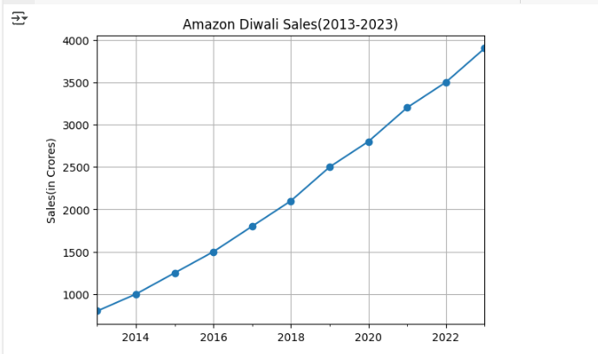

**Code:**

#acf and pacf

plot_acf(sales_series)

plot_pacf(sales_series)

plt.show()

**Output:**

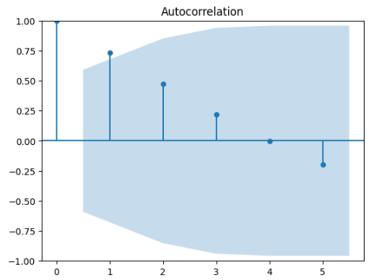

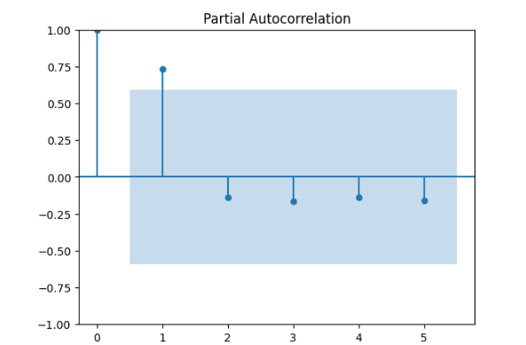

**Code:**

#fit arma(1,0)

model=ARIMA(sales_series,order=(1,0,0))

result=model.fit()

#model summary

print(result.summary())

**Output:**

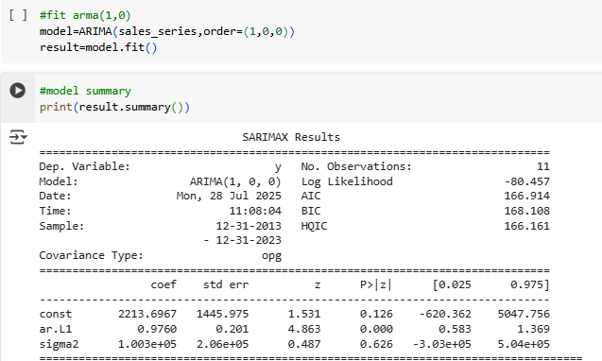

**Code:**

#forecast nest 2 years

forecast=result.forecast(steps=2)

forecast_years=pd.date_range(start='2024',periods=2,freq='YE')

#plot historical and forecasted values

plt.plot(sales_series,label='Historical')

plt.plot(forecast_years,forecast,label='Forecast',marker='x',linestyle='--',color='orange')

plt.title('Forecast of Amazon Diwali Sales(ARMA(1))')

plt.ylabel('Sales(in Crores)')

plt.xlabel('Year')

plt.legend()

plt.grid()

plt.show()

print("Forecasted Amazon Diwali Sales:")

for year,value in zip(forecast_years,forecast):

  print(f"{year}: {value:.2f}Crores")

**Output:**

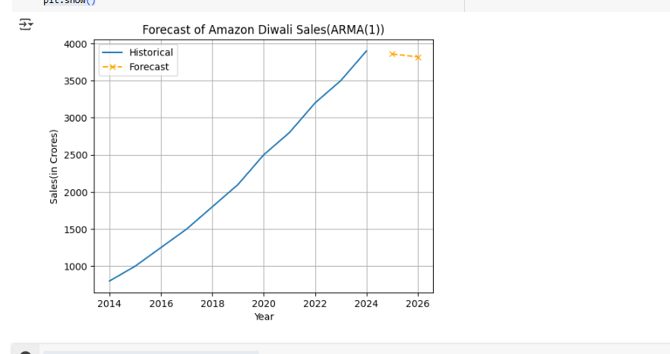

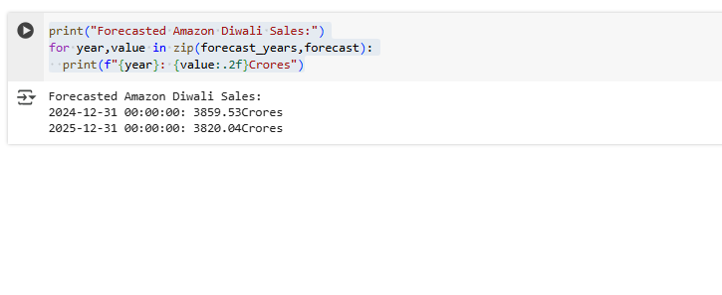

**#Same program in r-studio**

**Code:**

#load required libraries in r

library(forecast)

library(tseries)

#create time series object(from 2013,frequency=1 sice yearly data)

sales_ts<-ts(c(750,1000,1300,1650,1900,2200,2550,2900,3300,3700,4100),start=2013,frequency=1)

#plot the time series

plot(sales_ts,main="Amazon Great Indian Festival Sales(2013-2023)",ylab="Sales(Crores)",xlab="Year",type="o",col="blue")

**Output:**

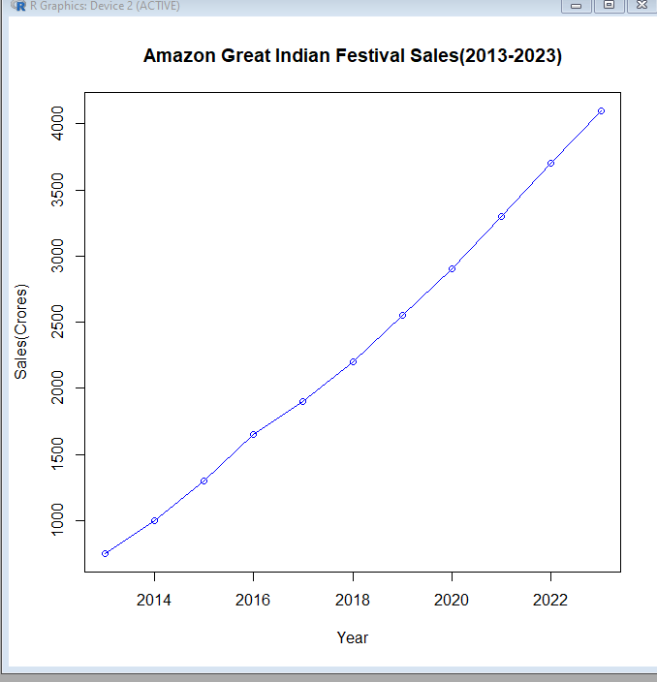

**Code:**

#check acf and pacf

acf(sales_ts,main="ACF of Sales")

**Output:**

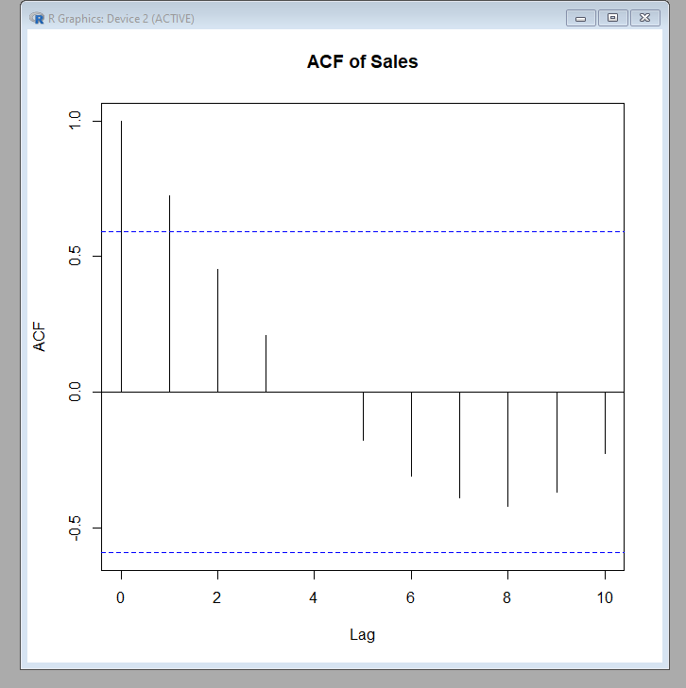

**Code:**

pacf(sales_ts,main="PACF of Sales")

**Output:**

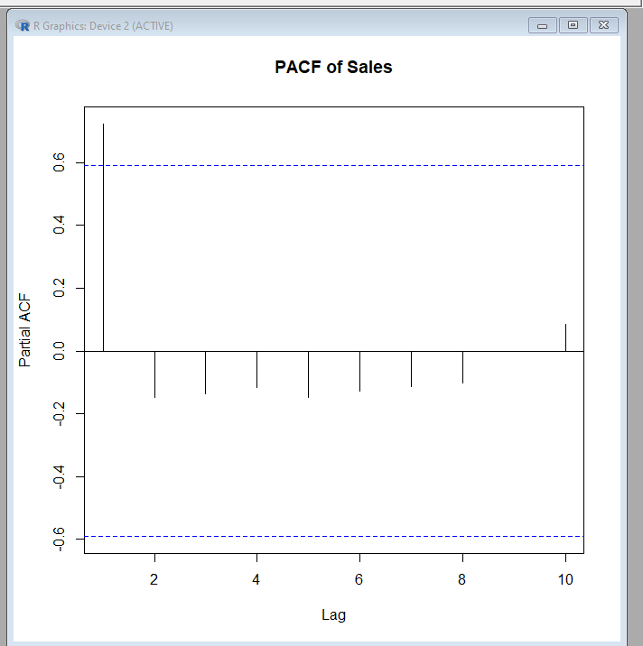

**Code:**

arma_model<-Arima(sales_ts,order=c(1,0,1))

summary(arma_model)

**Output:**

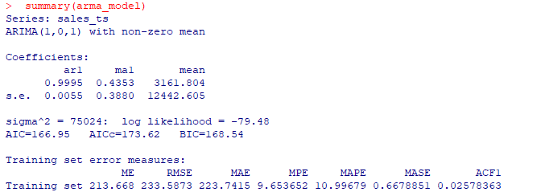

**Code:**

forecast_result<-forecast(arma_model,h=2)

#plot the forecast

plot(forecast_result,main="forecast:Amazon GIF sales(2024&2025)",xlab="Year",ylab="sales(crores)" ,col="darkgreen")

**Output:**

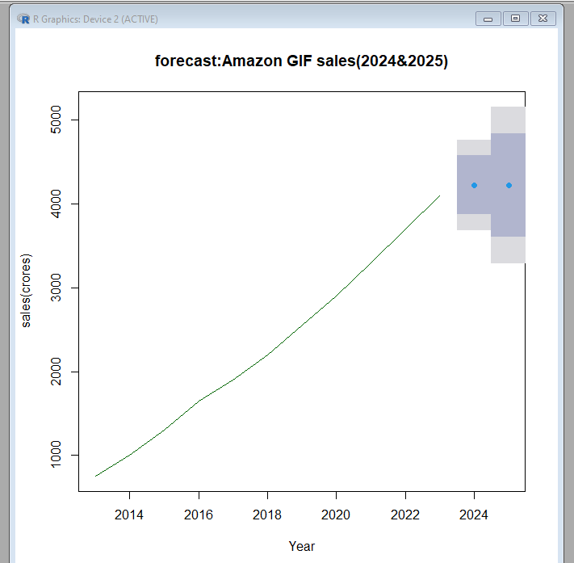

**Code:**

print(forecast_result)

**Output:**

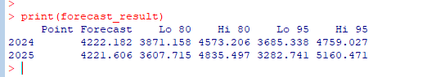

**PRACTICAL N0 –7**

**Aim:** Using Arima for forecasting

**Code:**

import pandas as pd

import numpy as np

import matplotlib.pyplot as plt

from statsmodels.tsa.stattools import adfuller

from statsmodels.graphics.tsaplots import plot_acf,plot_pacf

from statsmodels.tsa.arima.model import ARIMA

#load dataset

#monthly sales

data=pd.DataFrame({'Month':pd.date_range(start='2018-01',periods=24,freq='ME'),'Sales':[200,220,230,250,270,300,310,320,340,350,370,400,410,420,450,470,500,520,540,560,580,600,620,650]})

data.set_index('Month',inplace=True)

#plot data

plt.figure(figsize=(10,5))

plt.plot(data['Sales'],marker='o')

plt.title("Monthly Sales Data")

plt.show()

**Output:**

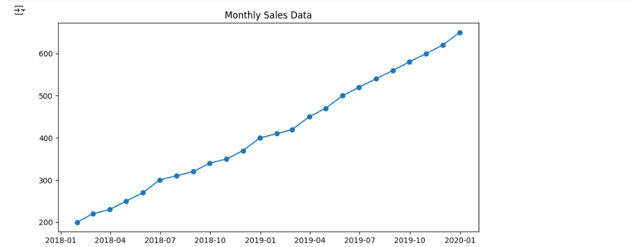

**Code:**

#Check Stationary(ADF test)

def check_stationarity(series):

    result=adfuller(series)

    print("ADF Statistic:", result[0])

    print("p-value:",result[1])

    if result[1]<=0.05:

      print("Stationary")

    else:

      print("Non-Stationary")

check_stationarity(data['Sales'])

**Output:**

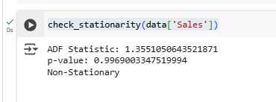

**Code:**

#Difference to stationarity

data_diff=data['Sales'].diff().dropna()

check_stationarity(data_diff)

**Output:**

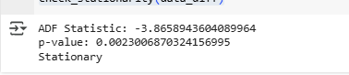

**Code:**

plot_acf(data_diff,lags=10)   #ARIMA(1,1,1) fromacf and pacf

plot_pacf(data_diff,lags=10)

plt.show()

**Output:**

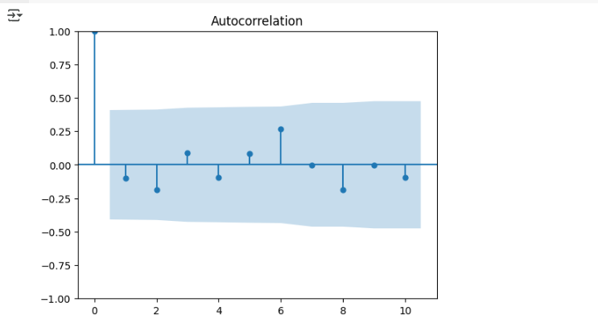

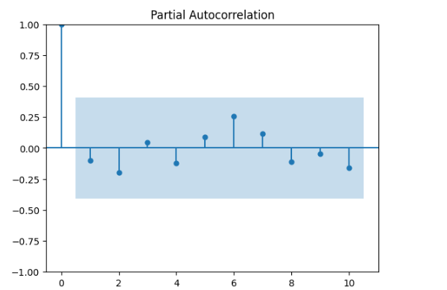

**Code:**

#fit ARIMA Model

model=ARIMA(data['Sales'],order=(1,1,1))

model_fit=model.fit()

print(model_fit.summary())

**Output:**

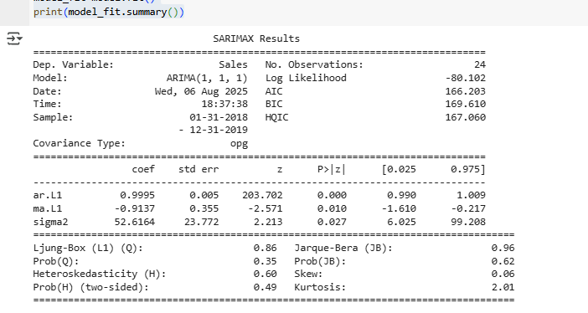

**Code:**

#forecast future Sales

forecast = model_fit.forecast(steps=12)

future_index=pd.date_range(start=data.index[-1],periods=12,freq='ME')

forecast_df=pd.DataFrame({'Forecast':forecast},index=future_index)

plt.figure(figsize=(12,5))

plt.plot(data['Sales'],label='Actual Sales')

plt.plot(forecast_df['Forecast'],label='Forecast',color='red',linestyle='--')

plt.title("ARIMA(1,1,1)Sales Forecast")

plt.legend()

plt.show()

**Output:**

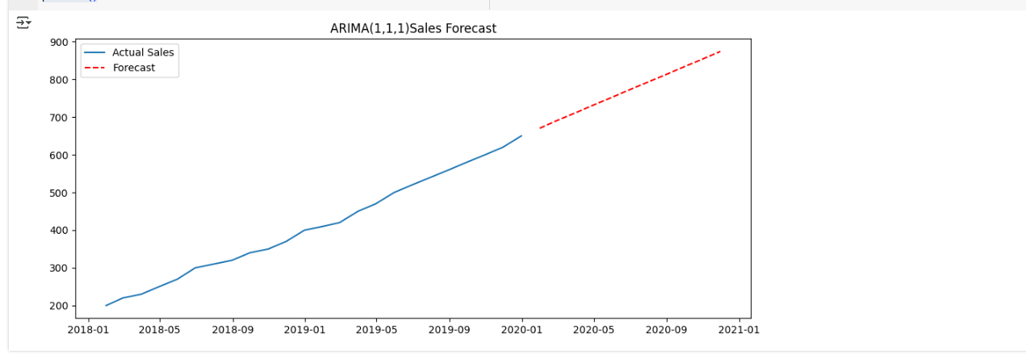

**Code:**

#forecast Airline Passengers

url="https://raw.githubusercontent.com/jbrownlee/Datasets/master/airline-passengers.csv"

df=pd.read_csv(url, parse_dates=['Month'], index_col='Month')

df.head()

**Output:**

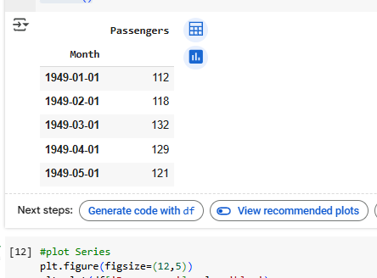

**Code:**

#plot Series

plt.figure(figsize=(12,5))

plt.plot(df['Passengers'],color='blue')

plt.title("Airline Passengers Data")

plt.show()

**Output:**

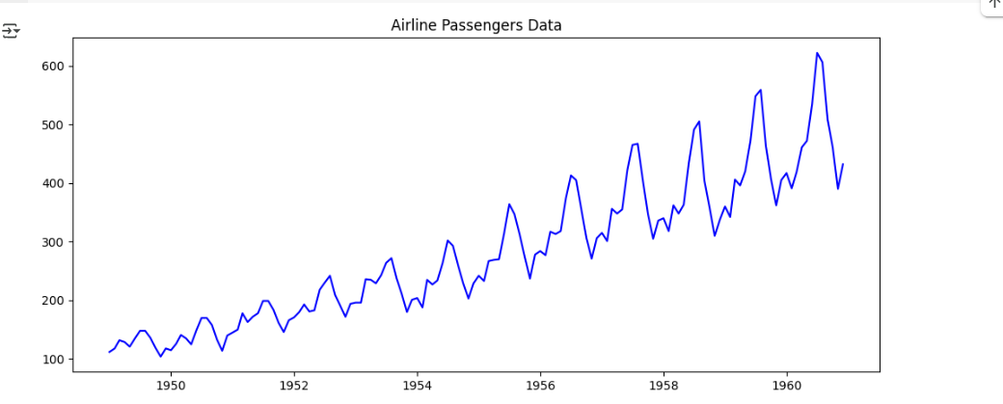

**Code:**

#fit Arima model

model=ARIMA(df['Passengers'],order=(2,1,2))

model_fit=model.fit()

print(model_fit.summary())

**Output:**

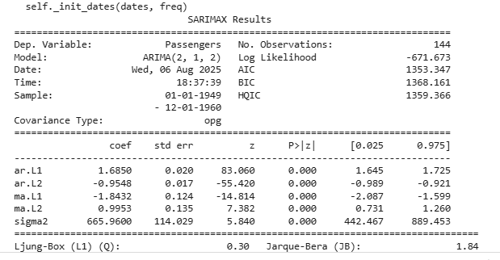

**Code:**

#forecast

forecast = model_fit.forecast(steps=24)

future_index=pd.date_range(start=df.index[-1],periods=24,freq='MS')

forecast_df=pd.DataFrame({'Forecast':forecast},index=future_index)

plt.figure(figsize=(12,5))

plt.plot(df['Passengers'],label='Actual ')

plt.plot(forecast_df['Forecast'],label='Forecast',color='red',linestyle='--')

plt.title("ARIMA(2,1,2) Airline Passengers Forecast")

plt.legend()

plt.show()

**Output:**

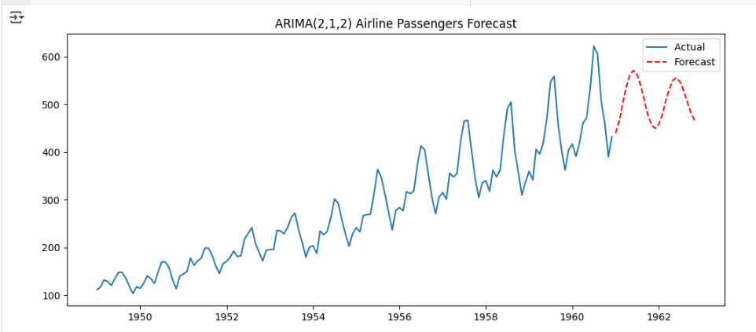

**#ARMA**

**Code:**

#ARMA model forecast (2,0)

import pandas as pd

import matplotlib.pyplot as plt

from statsmodels.tsa.arima.model import ARIMA

from statsmodels.graphics.tsaplots import plot_acf, plot_pacf

#load series

data=[100,104,107,111,115,118,120,124,127,130]

series=pd.Series(data)

#ACF and PACF plots

plot_acf(series,lags=5)

plt.show()

plot_pacf(series,lags=5)

plt.show()

**Output:**

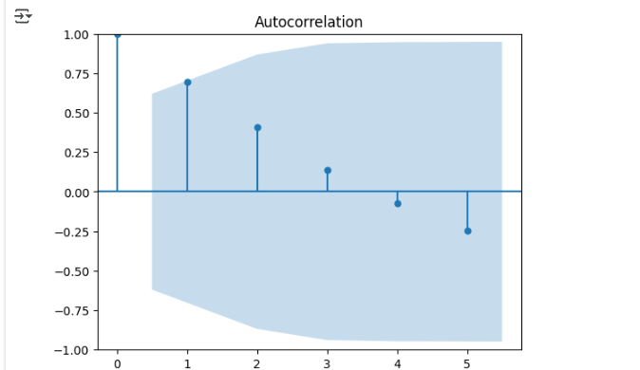

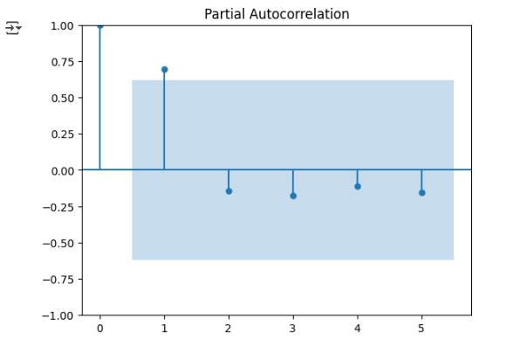

**Code:**

#fit ARMA(2,0) model

model=ARIMA(series,order=(2,0,0))

model_fit=model.fit()

print(model_fit.summary())

**Output:**

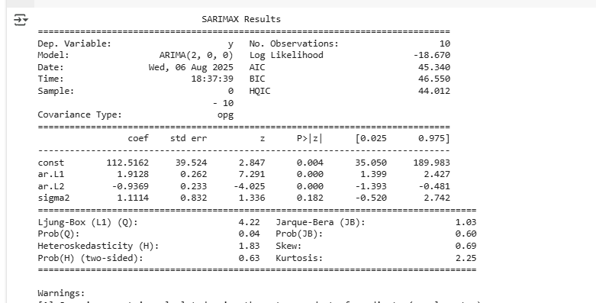

**Code:**

#forecast next 3 values

forecast=model_fit.forecast(steps=3)

print("\nforecast for next 3 days:",forecast.tolist())

**Output:**

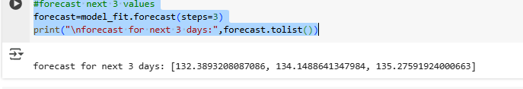

**Code:**

#plot

plt.plot(series,label="Actual",marker='o')

plt.plot(range(len(series),len(series)+3),forecast,label="Forecast",marker='x',linestyle='--')

plt.title("ARIMA(2,0)forecast")

plt.legend()

plt.grid()

plt.show()

**Output:**

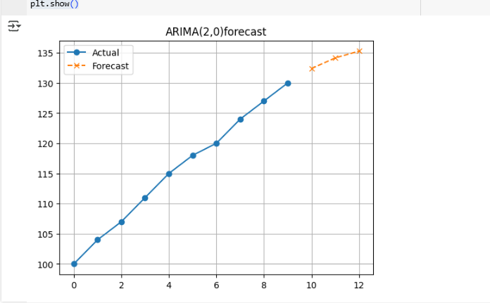

**Code:**

pip install pandas numpy matplotlib statsmodels pmdarima

#import libraries

import numpy as np

import pandas as pd

import matplotlib.pyplot as plt

from statsmodels.tsa.stattools import adfuller

from statsmodels.tsa.arima.model import ARIMA

#from pmdarima import auto_arima

#create

np.random.seed(42)

months=pd.date_range(start='2018-01-01',periods=60,freq='ME')

sales=200+np.arange(60)*2+np.random.normal(0,10,60) #upward trend + noise

data=pd.DataFrame({'Month':months,'Sales':sales})

data.set_index('Month',inplace=True)

print(data.head())

**Output:**

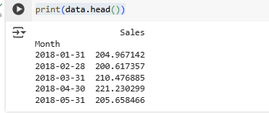

**Code:**

#visualize the data

plt.figure(figsize=(10,4))

plt.plot(data['Sales'],label='Monthly Sales')

plt.title("Monthly Sales Time Series")

plt.xlabel("Months")

plt.ylabel("Sales")

plt.legend()

plt.show()

**Output:**

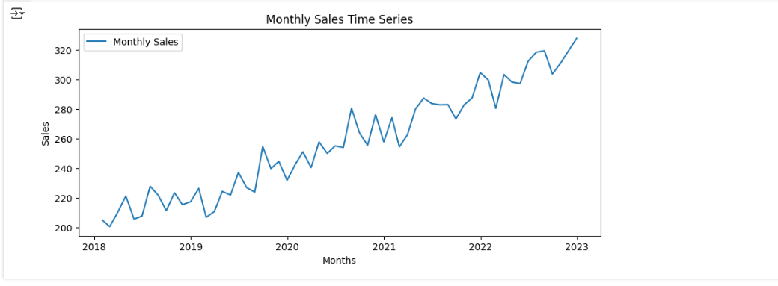

**Code:**

#check stationarity

result=adfuller(data['Sales'])

print("ADF Statistic:",result[0])

print("p-value:",result[1])

if result[1]<=0.05:

  print("Data is Stationary")

else:

  print("Data is Non-Stationary")

model=ARIMA(data['Sales'],order=(1,1,1))

model_fit=model.fit()

print(model_fit.summary())

model_fit.plot_diagnostics(figsize=(12,6))

plt.show()

**Output:**

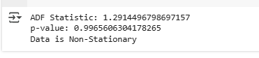

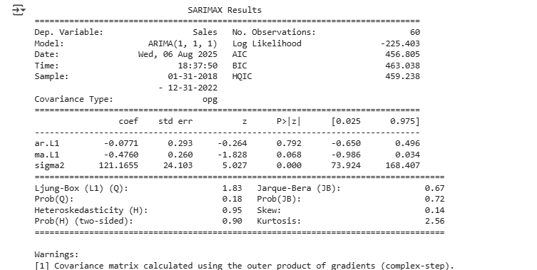

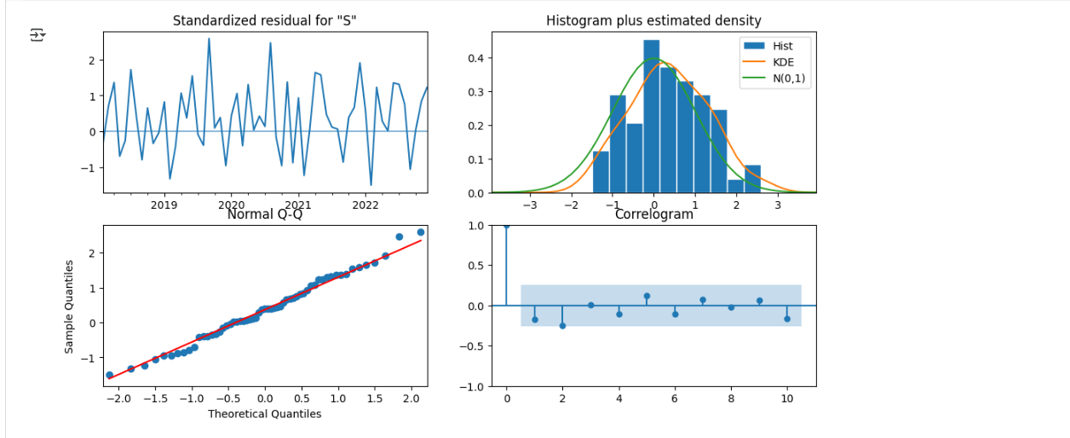

**Code:**

forecast = model_fit.get_forecast(steps=12)

forecast_df=forecast.summary_frame()

#plot

plt.figure(figsize=(12,5))

plt.plot(data['Sales'],label='Observed')

plt.plot(forecast_df['mean'],label='Forecast')

plt.fill_between(forecast_df.index,forecast_df['mean_ci_lower'],forecast_df['mean_ci_upper'],color='red',alpha=0.3)

plt.title("ARIMA Forecast for next 12 Months")

plt.legend()

plt.show()

**Output:**

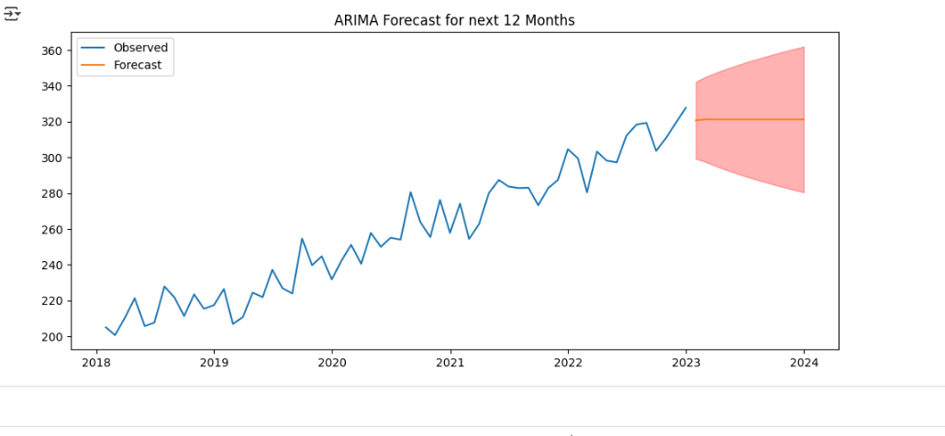

**#R-studio code**

**Code:**

#forecast monthly sales usingg arima model

install.packages("forecast")

install.packages("tseries")

library(forecast)

library(tseries)

#create or load forecast

sales<-c(200,220,230,250,270,300,310,320,340,350,370,400,410,420,450,470,500,520,540,560,580,600,620,650)

#convert numeric vector to time series

sales_ts<-ts(sales,start=c(2022,1),frequency=12)

**Output:**

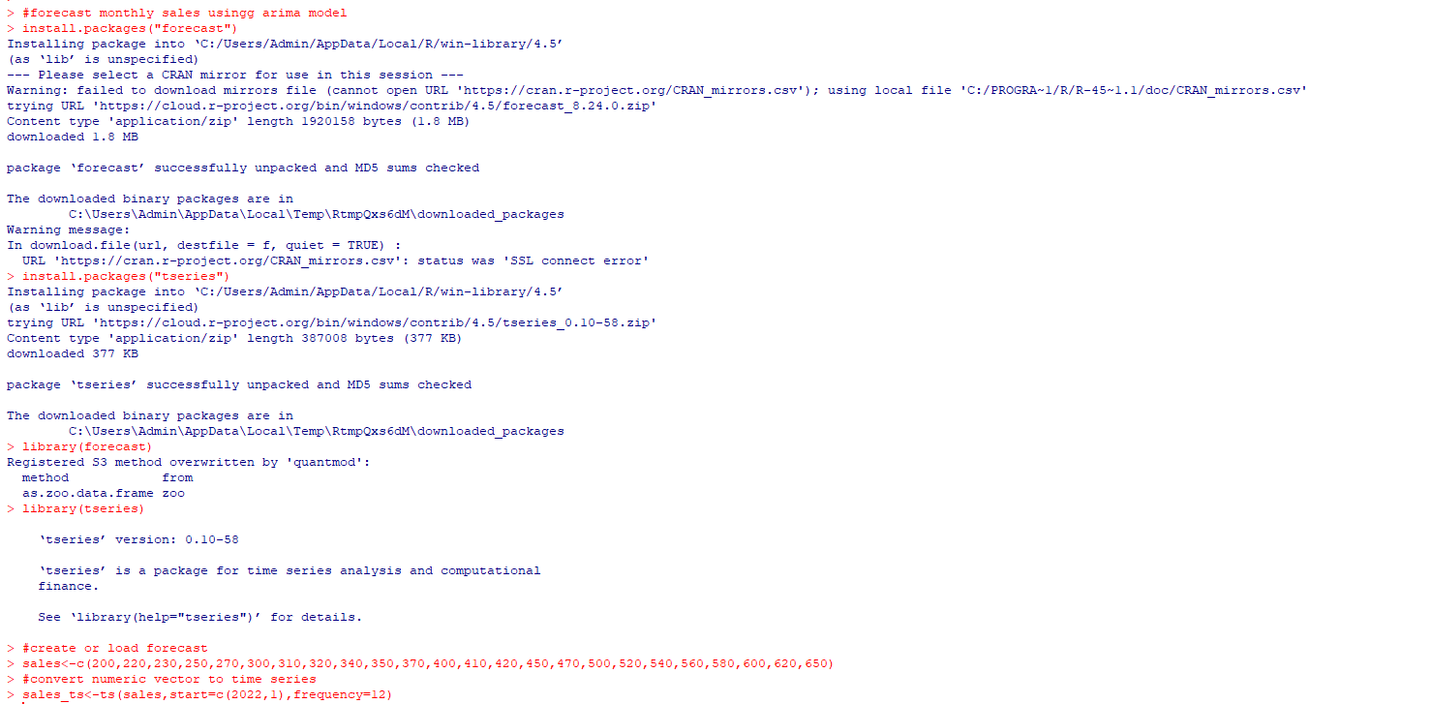

**Code:**

#display the first value

print(sales_ts)

**Output:**

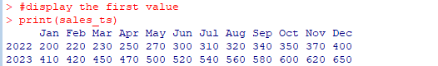

**Code:**

#plot the series

plot(sales_ts,main="Monthly Sales Data",xlab="Year",ylab="Sales",col="blue")

**Output:**

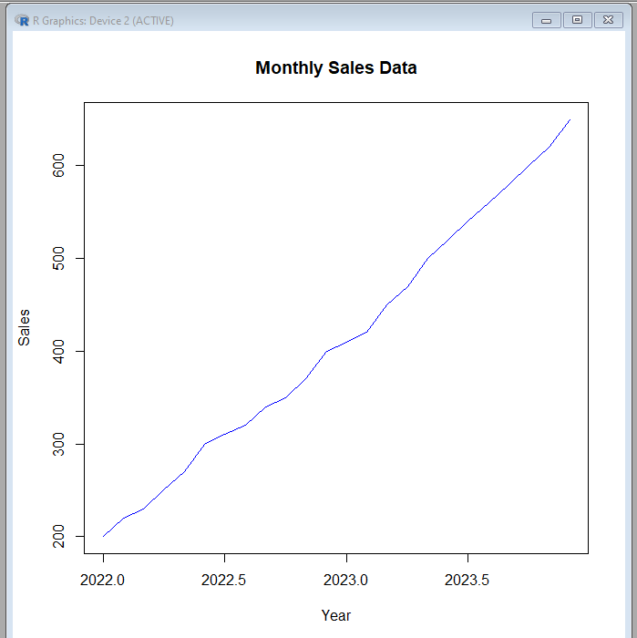

**Code:**

#adf

adf.test(sales_ts)

**Output:**

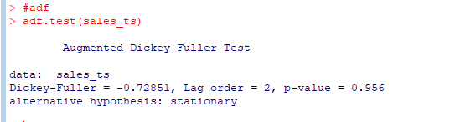

**Code:**

best_model<-auto.arima(sales_ts)

print(best_model)

**Output:**

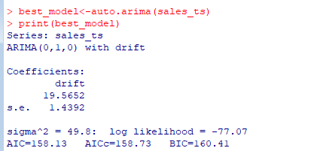

**Code:**

#forecast for next 12 months

forecast_sales<-forecast(best_model,h=12)

print(forecast_sales)

**Output:**

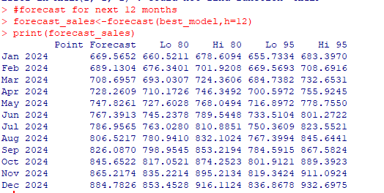

**Code:**

#plot forecast

plot(forecast_sales,main="ARIMA Sales Forecast",col="blue")

**Output:**

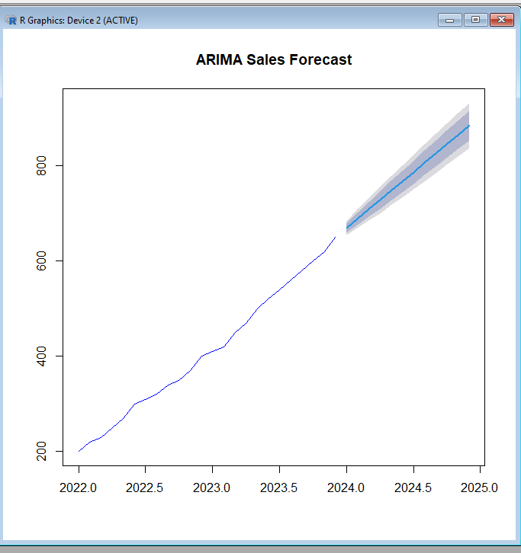

**Code:**

#Arima on real dataset(Airline Passenger)

library(forecast)

library(tseries)

#load dataset

url<-<https://raw.githubusercontent.com/jbrownlee/Datasets/master/airline-passengers.csv>

df<-read.csv(url)

head(df)

**Output:**

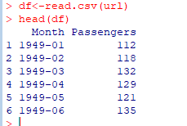

**Code:**

#step 2 convert to time series

air_ts<-ts(df$Passengers,start=c(1949,1),frequency=12)

#plot the data

plot(air_ts,main="Airline Passengers",ylab="Passengers(Thousands)",col="blue")

**Output:**

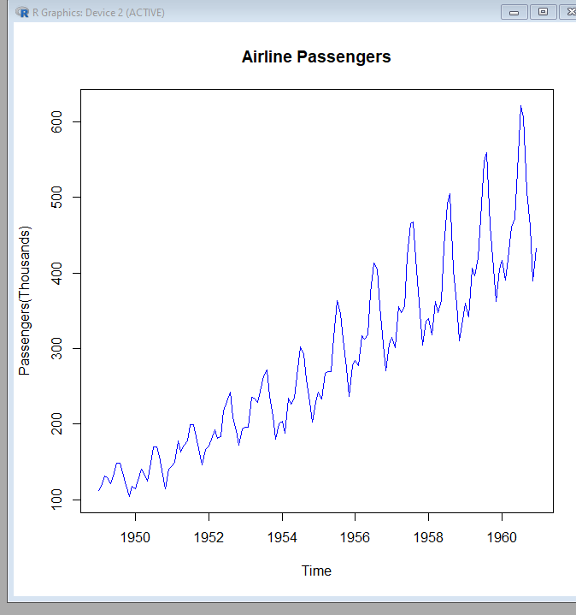

**Code:**

#check stationarity

adf.test(air_ts)

**Output:**

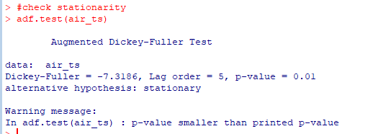

**Code:**

#fit arima model

model_air<-auto.arima(air_ts)

summary(model_air)

**Output:**

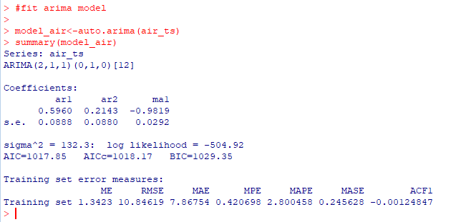

**Code:**

#forecast next 24 months

forecast_air<-forecast(model_air,h=24)

print(forecast_air)

**Output:**

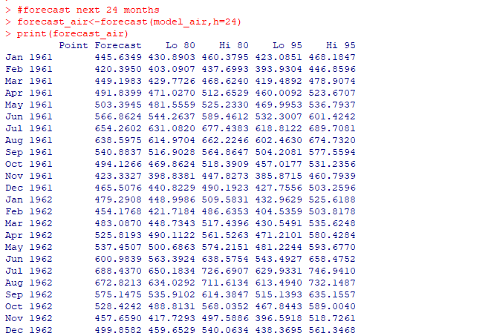

**Code:**

plot(forecast_air,main="Airline Passenger Forecast",col="red")

**Output:**

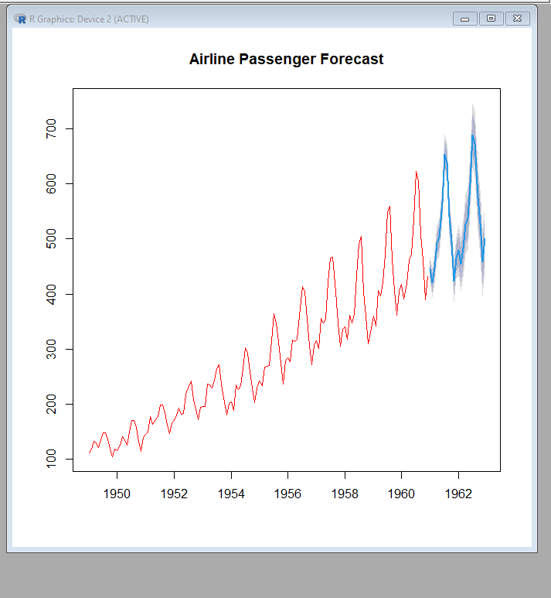

**Code:**

#example 3

#Arima on daily temperature(synthetic data)

#create dataset

set.seed(42)

days<-seq(as.Date("2022-01-01"),by="day",length.out=100)

temperature<-25+cumsum(rnorm(100,0,0.5))#random noise

#create time series

temp_ts<-ts(temperature,frequency=365)

#plot

plot(temp_ts,main="Daily Temperature",ylab="Temperature(c)",col="orange")

**Output:**

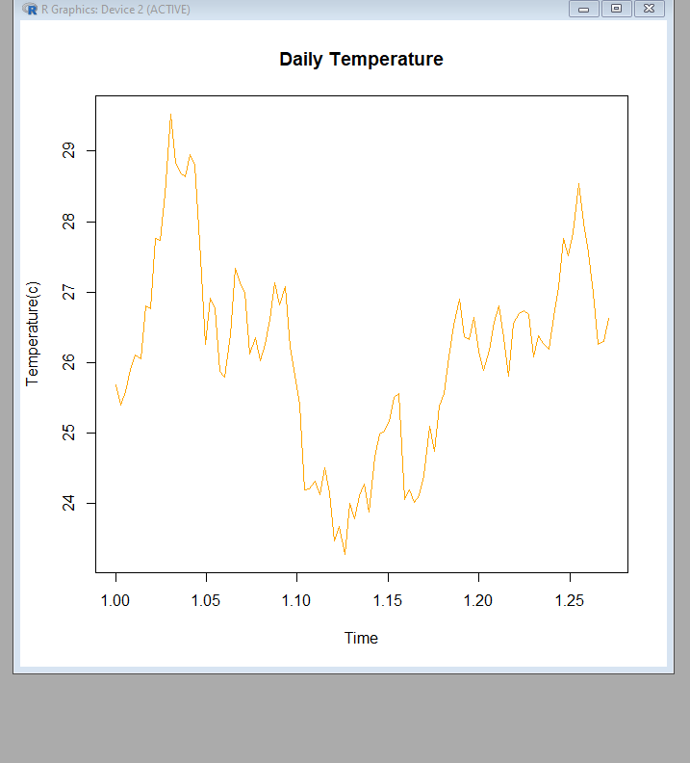

**Code:**

#fit arima model

model_temp<-auto.arima(temp_ts)

summary(model_temp)

**Output:**

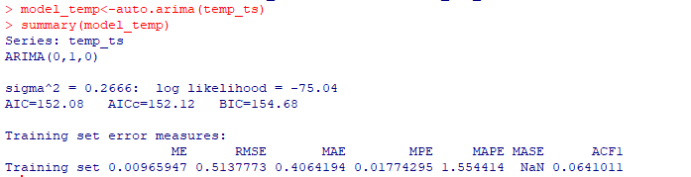

**Code:**

#forecast for next 30 days

forecast_temp<-forecast(model_temp,h=30)

print(forecast_temp)

**Output:**

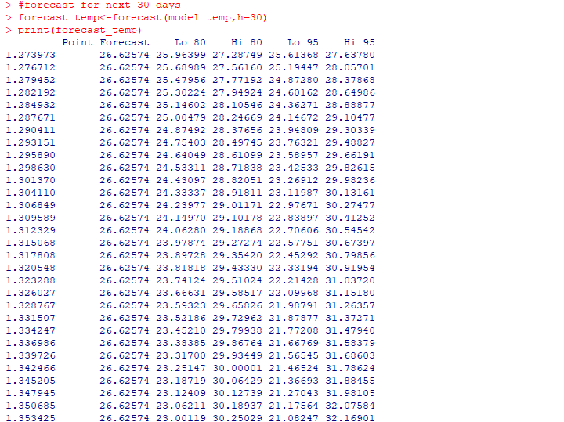

**Code:**

#plot

plot(forecast_temp,main="Temperature Forecast(ARIMA)",col="purple")

**Output:**

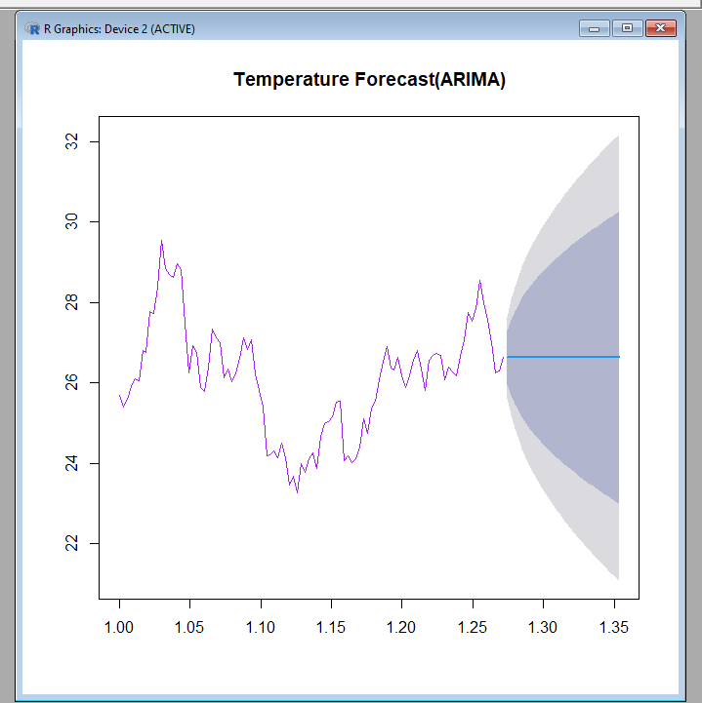

**PRACTICAL N0 –8**

**Aim:** Using Sarima for forecasting

**Code:**

#SARIMA with clear seasonal pattern and upward trenf

import numpy as np

import pandas as pd

import matplotlib.pyplot as plt

from statsmodels.tsa.statespace.sarimax import SARIMAX

#generate data

#Generate data

np.random.seed(0)

date_range=pd.date_range(start='2020-01-01',periods=48,freq='M')

trend=np.linspace(100,200,48)

seasonality=20*np.sin(2*np.pi*date_range.month/12)

noise=np.random.normal(0,5,48)

data=trend+seasonality+noise

df=pd.DataFrame({'Sales':data},index=date_range)

df

**Output:**

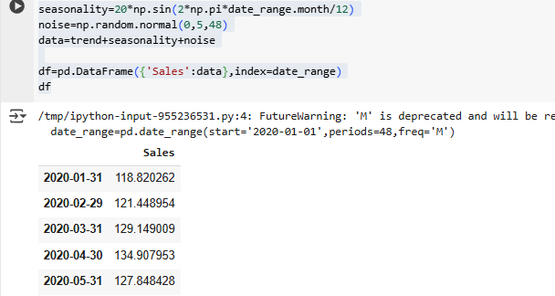

**Code:**

#plot

df.plot(title='Hypothetical Data:Seasonal+Trend')

plt.show()

**Output:**

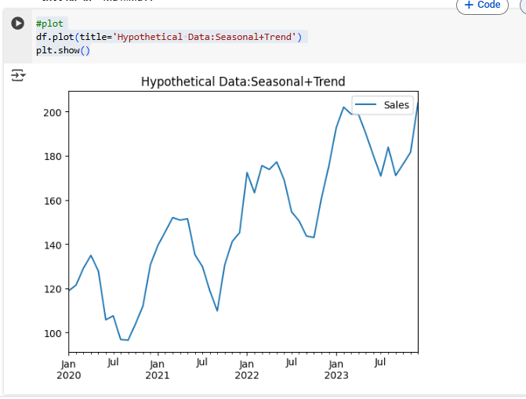

**Code:**

#fit sarima

model=SARIMAX(df['Sales'],order=(1,1,1),seasonal_order=(1,1,1,12))

result=model.fit()

#forecast

forecast=result.get_forecast(steps=12)

forecast_df=forecast.summary_frame()

plt.plot(df,label='Observed')

plt.plot(forecast_df['mean'],label='Forecast')

plt.fill_between(forecast_df.index,forecast_df['mean_ci_lower'],forecast_df['mean_ci_upper'],alpha=0.3)

plt.title('SARIMA Forecast(Seasonal+Trend)')

plt.legend()

plt.show()

**Output:**

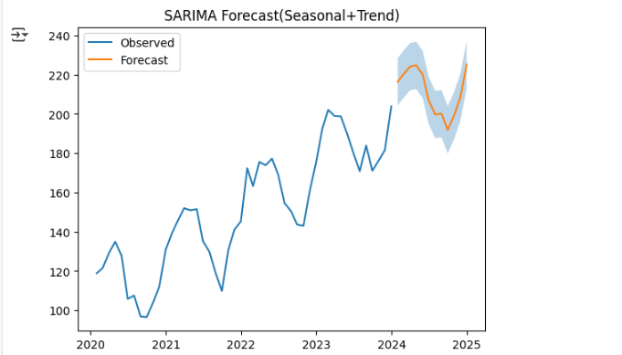

**Code:**

#example2 with high seasonality trend sysnthic data no trend

np.random.seed(1)

dates=pd.date_range(start='2020-01-01',periods=36,freq='M')

seasonality=30+15*np.sin(2*np.pi*dates.month/12)

noise=np.random.normal(0,3,36)

values=seasonality+noise

df=pd.DataFrame({'Values':values},index=dates)

df

#fit Sarima

model=SARIMAX(df['Values'],order=(1,0,0),seasonal_order=(1,1,0,12))

res=model.fit()

#forecast

fcast=res.get_forecast(steps=12)

fcast_df=fcast.summary_frame()

plt.plot(df,label='Observed')

plt.plot(fcast_df['mean'],label='Forecast')

plt.fill_between(fcast_df.index,fcast_df['mean_ci_lower'],fcast_df['mean_ci_upper'],alpha=0.3)

plt.title('SARIMA Forecast(High Seasonal)')

plt.legend()

plt.show()

**Output:**

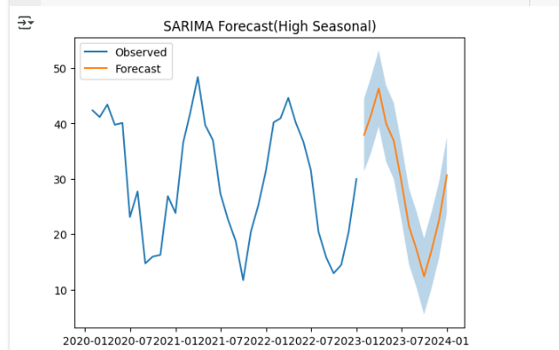

**Code:**

#example 3 Sarima with multiplicative seasonality and weak trend

np.random.seed(2)

months=pd.date_range(start='2019-01',periods=60,freq='M')

trend=np.linspace(80,120,60)

seasonal_factor=1+0.4*np.sin(2*np.pi*months.month/12)

noise=np.random.normal(0,2,60)

values=trend*seasonal_factor+noise

df=pd.DataFrame({'Value':values},index=months)

#fit sarima

model=SARIMAX(df['Value'],order=(1,1,1),seasonal_order=(1,1,1,12))

res=model.fit()

#forecast

pred=res.get_forecast(steps=12)

pred_df=pred.summary_frame()

#plot

plt.plot(df,label='Observed')

plt.plot(fcast_df['mean'],label='Forecast')

plt.fill_between(pred_df.index,pred_df['mean_ci_lower'],pred_df['mean_ci_upper'],alpha=0.3)

plt.title('SARIMA Forecast(Multiplicative Seasonal)')

plt.legend()

plt.show()

**Output:**

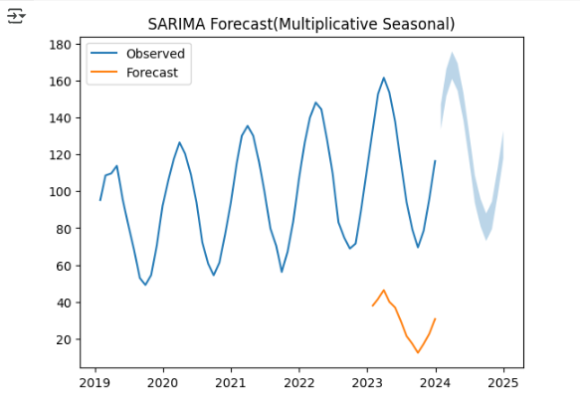

**Code:**

#example 4  SARIMA with irregular Seasonal Pattern

np.random.seed(3)

months=pd.date_range(start='2020-01',periods=48,freq='M')

pattern=np.random.choice([10,20,30],size=12,replace=True)

seasonality=np.tile(pattern,4)

trend=0.5*np.arange(48)

noise=np.random.normal(0,5,48)

values=trend+seasonality+noise

df=pd.DataFrame({'Value':values},index=months)

#fit sarima

model=SARIMAX(df['Value'],order=(1,1,1),seasonal_order=(2,1,0,12))

res=model.fit()

#forecast

future=res.get_forecast(steps=12)

future_df=future.summary_frame()

plt.plot(df,label='Observed')

plt.plot(future_df['mean'],label='Forecast')

plt.fill_between(future_df.index,future_df['mean_ci_lower'],future_df['mean_ci_upper'],alpha=0.3)

plt.title('SARIMA Forecast(Irregular Seasonal)')

plt.legend()

plt.show()

**Output:**

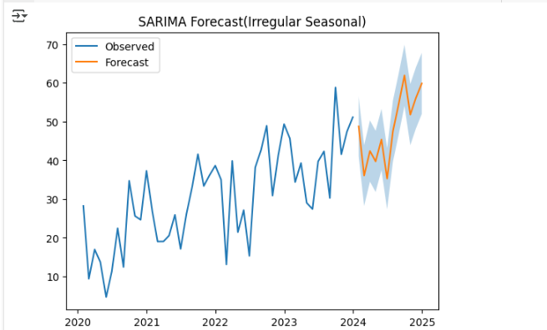

**Code:**

#example 5: Sarima with weak seasonality and strong noise

np.random.seed(4)

months=pd.date_range(start='2021-01',periods=48,freq='M')

seasonal=5*np.sin(2*np.pi*months.month/12)

noise=np.random.normal(0,10,48)

values=50+seasonal+noise

df=pd.DataFrame({'Value':values},index=months)

#fit sarima

model=SARIMAX(df['Value'],order=(0,1,1),seasonal_order=(1,1,1,12))

res=model.fit()

#forecast

forecast=res.get_forecast(steps=12)

forecast_df=forecast.summary_frame()

plt.plot(df,label='Observed')

plt.plot(forecast_df['mean'],label='Forecast')

plt.fill_between(forecast_df.index,forecast_df['mean_ci_lower'],forecast_df['mean_ci_upper'],alpha=0.3)

plt.title('SARIMA Forecast(Noisy Seasonal)')

plt.legend()

plt.show()

**Output:**

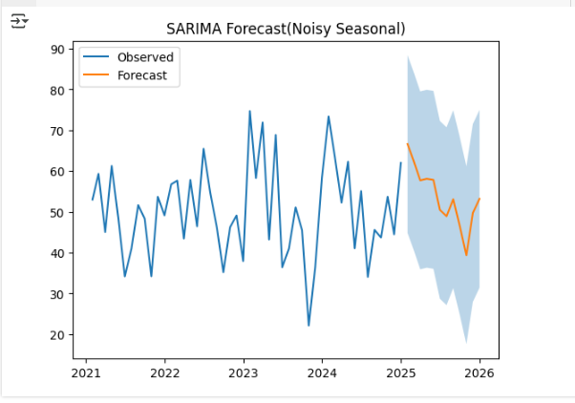

**Code:**

#example 6

#SARIMA on airline passengers dataset(seasonal monthly data)

import pandas as pd

from matplotlib import pyplot as plt

from statsmodels.tsa.statespace.sarimax import SARIMAX

#from pmdarima import auto_arima

from statsmodels.tsa.stattools import adfuller

#load dataset

url='https://raw.githubusercontent.com/jbrownlee/Datasets/master/airline-passengers.csv'

data=pd.read_csv(url,parse_dates=['Month'],index_col='Month')

data.columns=['Passengers']

#plot

data.plot(title='Airline Passengers')

plt.show()

#adf

result =adfuller(data['Passengers'])

print("ADF p-value:",result[1])

#fit Sarima

sarima=SARIMAX(data['Passengers'],order=(1,1,1),seasonal_order=(1,1,1,12))

sarima_fit=sarima.fit()

print(sarima_fit.summary())

#forecast

forecast=sarima_fit.get_forecast(steps=12)

forecast_df=forecast.summary_frame()

plt.plot(data,label='Observed')

plt.plot(forecast_df['mean'],label='Forecast')

plt.fill_between(forecast_df.index,forecast_df['mean_ci_lower'],forecast_df['mean_ci_upper'],color='r',alpha=0.3)

plt.title('SARIMA Forecast')

plt.legend()

plt.show()

**Output:**

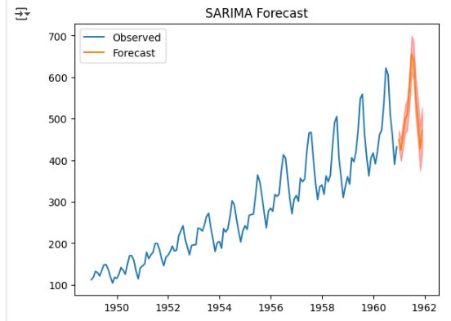

**Code:**

#example 7 Sarima on synthetic Seasonal sales data

import numpy as np

import pandas as pd

import matplotlib.pyplot as plt

from statsmodels.tsa.statespace.sarimax import SARIMAX

#create synthetic data

np.random.seed(0)

months=pd.date_range(start='2015-01',periods=72,freq='M')

seasonal=10*np.sin(2*np.pi*months.month/12)

trend=np.linspace(100,200,72)

noise=np.random.normal(0,5,72)

sales=trend+seasonal+noise

df=pd.DataFrame({'Sales':sales},index=months)

df

#plot

df.plot(title='Synthetic Seasonal Data')

plt.show()

#sarima model

model=SARIMAX(df['Sales'],order=(1,1,1),seasonal_order=(1,1,1,12))

result=model.fit()

#Forecast

#forecast

forecast=result.get_forecast(steps=12)

forecast_df=forecast.summary_frame()

#plot

plt.plot(df,label='Observed')

plt.plot(forecast_df['mean'],label='Forecast')

plt.fill_between(forecast_df.index,forecast_df['mean_ci_lower'],forecast_df['mean_ci_upper'],color='r',alpha=0.3)

plt.title('SARIMA Forecast(synthetic data)')

plt.legend()

plt.show()

**Output:**

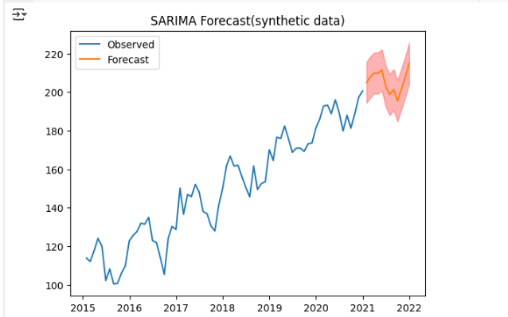

**Code:**

#sarima with multiplicative Seasonal component synthetic

#multiplicative seasonality

months=pd.date_range(start='2020-01',periods=60,freq='M')

seasonal=1+0.3*np.sin(2*np.pi*months.month/12)

trend=np.linspace(50,150,60)

noise=np.random.normal(0,5,60)

sales=trend*seasonal+noise

df=pd.DataFrame({'Sales':sales},index=months)

df

#plot

df.plot(title='Synthetic  Multiplicative Seasonal Data')

plt.show()

#sarima model

model=SARIMAX(df['Sales'],order=(1,1,1),seasonal_order=(1,1,1,12))

result=model.fit()

#forecast

forecast=result.get_forecast(steps=12)

forecast_df=forecast.summary_frame()

#plot

plt.plot(df,label='Observed')

plt.plot(forecast_df['mean'],label='Forecast')

plt.fill_between(forecast_df.index,forecast_df['mean_ci_lower'],forecast_df['mean_ci_upper'],color='r',alpha=0.3)

plt.title('SARIMA Forecast(synthetic data)')

plt.legend()

plt.show()

**Output:**

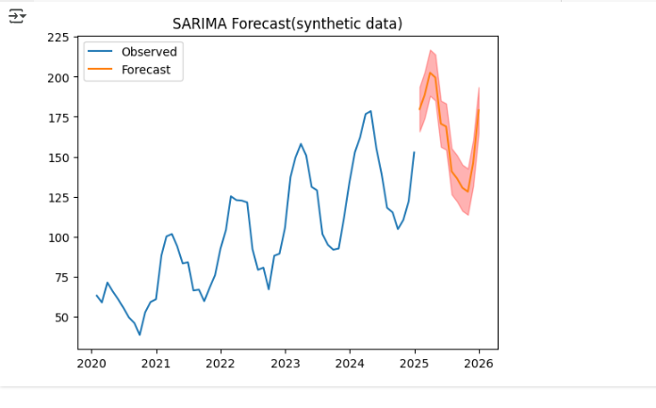

**PRACTICAL N0 –9**

**Aim:** Aic, Bic & Fpe

**Code:**

from inspect import modulesbyfile

#example diwali sales aic,bic,fpe

#step1:generate dataset6

import numpy as np

import pandas as pd

import matplotlib.pyplot as plt

np.random.seed(42)

months=pd.date_range(start='2018-01-01',periods=60,freq='M')

#base trend=noise

sales=200+np.arange(60)*3+np.random.normal(0,15,60)

#add diwali effect:higher sales in oct-nov

for i,m in enumerate(months):

  if m.month in [10,11]:

    sales[i]+=100+np.random.randint(50,100)

data=pd.DataFrame({'Month':months,'Sales':sales})

data.set_index('Month',inplace=True)

#plot dataset

plt.figure(figsize=(12,4))

plt.plot(data['Sales'],marker='o',label="Monthly Sales")

plt.title("Synthetic Diwali Sales Data(2018-20522)")

plt.xlabel("Month")

plt.ylabel("Sales")

plt.legend()

plt.show()

#unity function for aic, bic,fpe

from statsmodels.tsa.arima.model import ARIMA

def evaluate_arima(series,order):

  model=ARIMA(series,order=order)

  fit=model.fit()

  n_obs=fit.nobs

  sigma2=fit.mse

  k=fit.df_model+1

  fpe=sigma2*(n_obs+k)/(n_obs-k)

  return{"Order":order,"AIC":fit.aic,"BIC":fit.bic,"FPE":fpe}

#case1: ARIMA(1,1,1)

result1=evaluate_arima(data['Sales'],(1,1,1))

print("case1:",result1)

#case2: ARIMA(2,1,2)

result2=evaluate_arima(data['Sales'],(2,1,2))

print("case2:",result2)

#case3: ARIMA(3,1,2)

result3=evaluate_arima(data['Sales'],(3,1,2))

print("case3:",result3)

#case4: ARIMA(2,0,2)

result4=evaluate_arima(data['Sales'],(2,0,2))

print("case4:",result4)

#case5: ARIMA(1,1,2)

result5=evaluate_arima(data['Sales'],(1,1,2))

print("case5:",result5)

#compare all results

results=pd.DataFrame([result1,result2,result3,result4,result5])

print("\nComparsion of Model (AIC,BIC,FPE):")

print(results.sort_values(by="AIC"))

**Output:**

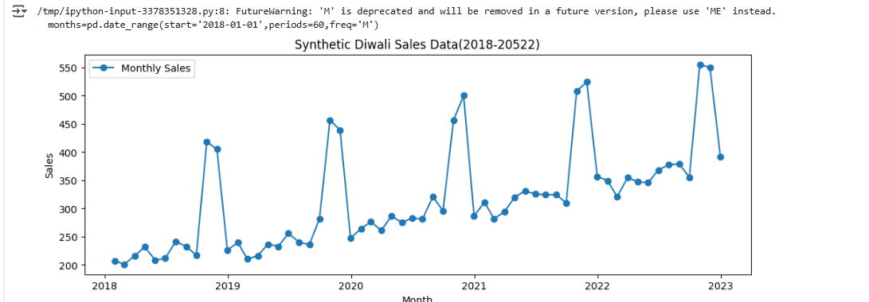

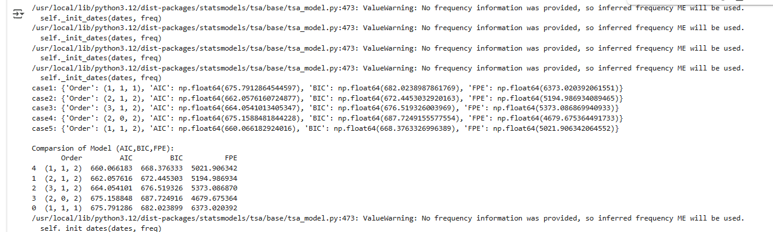

**Code:**

#example2

import numpy as np

import pandas as pd

import matplotlib.pyplot as plt

np.random.seed(42)

#years from 2010 to 2022

years=pd.date_range(start='2010-12-01',end='2022-12-01',freq="12M")

#simulated automobile sales with upward trend+noise

sales=5000+(np.arange(len(years))*300)+np.random.normal(0,500,len(years))

data=pd.DataFrame ({"Year":years,"Auto_Sales":sales})

data.set_index("Year",inplace=True)

#plot the dataset

plt.figure(figsize=(10,4))

plt.plot(data.index,data["Auto_Sales"],marker='o',label="Automobile Sales(Dec)")

plt.title("Automobile Sales Data(2010-2022)")

plt.xlabel("Year")

plt.ylabel("Sales")

plt.legend()

plt.show()

#define function

from statsmodels.tsa.arima.model import ARIMA

def evaluate_arima(series,order):

  model=ARIMA(series,order=order)

  fit=model.fit()

  n_obs=fit.nobs

  sigma2=fit.mse

  k=fit.df_model+1

  fpe=sigma2*(n_obs+k)/(n_obs-k)

  return{"Order":order,"AIC":fit.aic,"BIC":fit.bic,"FPE":fpe}

#case1: ARIMA(1,1,1)

result1=evaluate_arima(data['Auto_Sales'],(1,1,1))

print("case1:",result1)

#case2: ARIMA(2,1,1)

result2=evaluate_arima(data['Auto_Sales'],(2,1,1))

print("case2:",result2)

#case3: ARIMA(2,1,2)

result3=evaluate_arima(data['Auto_Sales'],(2,1,2))

print("case3:",result3)

#case4: ARIMA(3,1,2)

result4=evaluate_arima(data['Auto_Sales'],(3,1,2))

print("case4:",result4)

#case5: ARIMA(1,1,2)

result5=evaluate_arima(data['Auto_Sales'],(1,1,2))

print("case5:",result5)

#compare all results

results=pd.DataFrame([result1,result2,result3,result4,result5])

print("\nComparsion of Model (AIC,BIC,FPE):")

print(results.sort_values(by="AIC"))

**Output:**

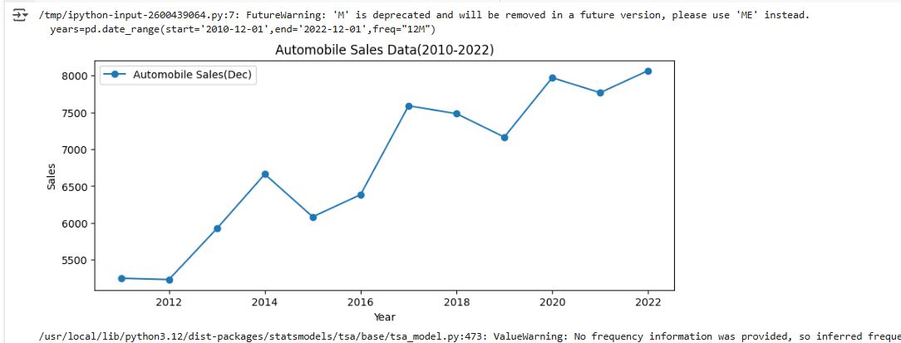

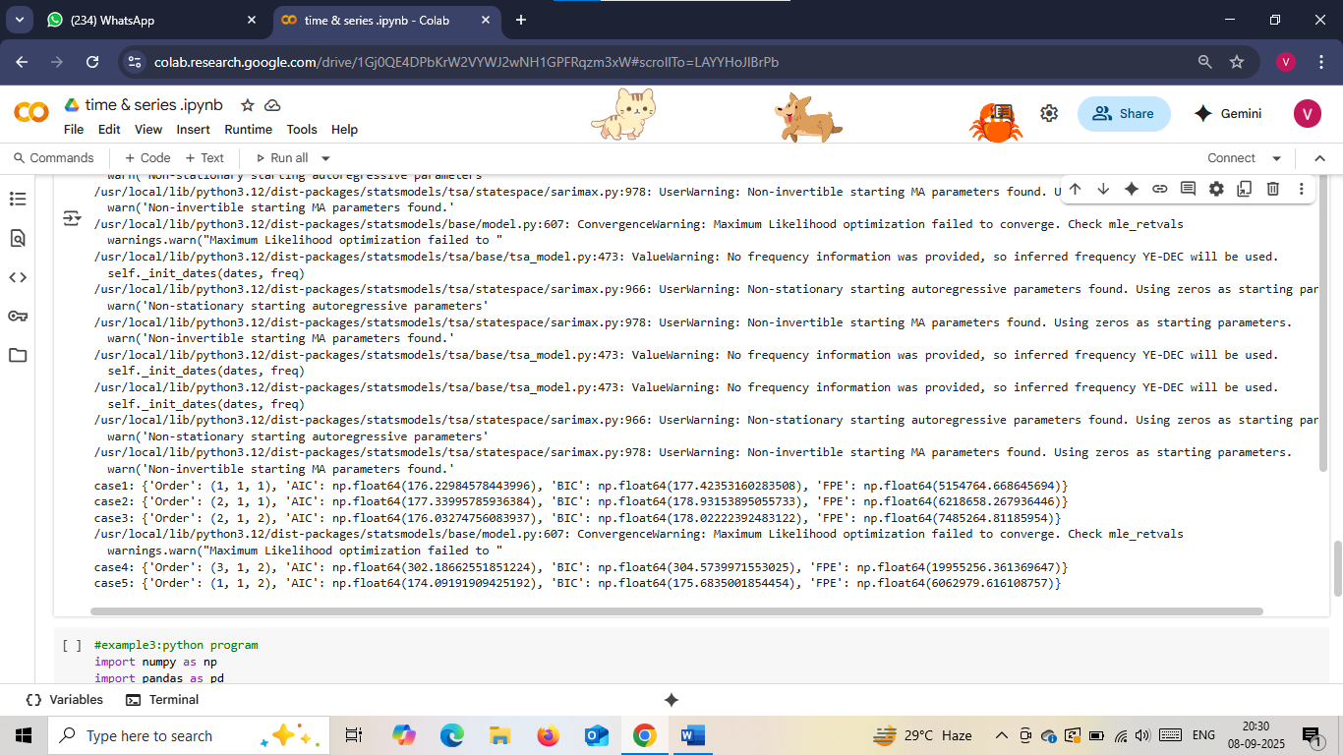

**Code:**

#example3:python program

import numpy as np

import pandas as pd

from statsmodels.tsa.arima.model import ARIMA

#synthetic data

np.random.seed(0)

n = 80

data=pd.Series(50+0.5*np.arange(n)+np.random.normal(0,2,n))

#fit arima

model=ARIMA(data,order=(2,1,2))

fit=model.fit()

#compute FPE

n_obs=fit.nobs

sigma2=fit.mse

k=fit.df_model+1

fpe=sigma2*(n_obs+k)/(n_obs-k)

print("AIC",fit.aic)

print("BIC",fit.bic)

print("FPE",fpe)

**Output:**

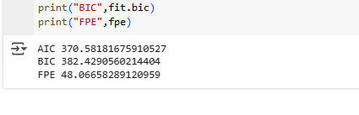

**Code:**

#Synthetic time series

import numpy as np

import pandas as pd

from statsmodels.tsa.arima.model import ARIMA

#generate synthetic trend data

np.random.seed(42)

n = 80

series = pd.Series(100+0.5*np.arange(n)+np.random.normal(0,2,n))

#fit arima(2,1,2)

model=ARIMA(series,order=(2,1,2))

fit=model.fit()

#compute FPE

n_obs=fit.nobs

sigma2=fit.mse

k=fit.df_model+1

fpe=sigma2*(n_obs+k)/(n_obs-k)

print("Synthetic Example")

print("AIC:",fit.aic)

print("BIC:",fit.bic)

print("FPE:",fpe)

**Output:**

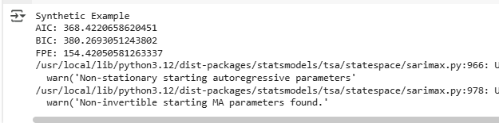

**Code:**

import statsmodels.api as sm

data=pd.read_csv('AirPassengers.csv')

data['Month']=pd.to_datetime(data['Month'])

data.set_index('Month',inplace=True)

#fit arima

model=ARIMA(data['#Passengers'],order=(2,1,1))

fit=model.fit()

#compute fpe

n_obs=fit.nobs

print("\nAirline Passengers Example")

print("AIC:",fit.aic)

print("BIC:",fit.bic)

print("FPE:",fpe)

**Output:**

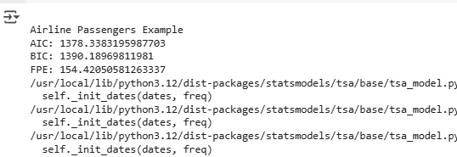

**Code:**

#Alternate method for mutliple orders

orders=[(1,1,1),(2,1,1),(3,1,2)]

results=[]

for order in orders:

    model=ARIMA(data['#Passengers'],order=order)

    fit=model.fit()

    n_obs=fit.nobs

    sigma2=fit.mse

    k=fit.df_model+1

    fpe=sigma2*(n_obs+k)/(n_obs-k)

    results.append((order,fit.aic,fit.bic,fpe))

import pandas as pd

df=pd.DataFrame(results,columns=["Order(p,q,d)","AIC","BIC","FPE"])

print(df)

**Output:**

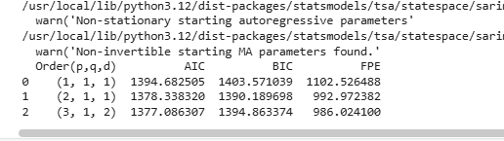

**Code:**

#example 4

#generate data

np.random.seed(0)

n=100

steps=np.random.normal(0,1,n)

series=pd.Series(np.cumsum(steps))

#fit arima

model=ARIMA(series,order=(1,1,1))

fit=model.fit()

#compute FPE

n_obs=fit.nobs

sigma2=fit.mse

k=fit.df_model+1

fpe=sigma2*(n_obs+k)/(n_obs-k)

print("Synthetic Example")

print("AIC:",fit.aic)

print("BIC:",fit.bic)

print("FPE:",fpe)

**Output:**

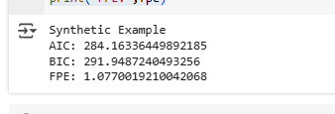

**Code:**

#Example 5

np.random.seed(10)

n=120

time=np.arange(n)

series=50+10*np.sin(2*np.pi*time/12)+np.random.normal(0,2,n)

series=pd.Series(series)

#fit arima

model=ARIMA(series,order=(1,1,1))

fit=model.fit()

#compute FPE

n_obs=fit.nobs

sigma2=fit.mse

k=fit.df_model+1

fpe=sigma2*(n_obs+k)/(n_obs-k)

print("\n Synthetic stock prices Example 5")

print("AIC:",fit.aic)

print("BIC:",fit.bic)

print("FPE:",fpe)

model=ARIMA(series,order=(1,1,2))

fit=model.fit()

#compute FPE

n_obs=fit.nobs

sigma2=fit.mse

k=fit.df_model+1

fpe=sigma2*(n_obs+k)/(n_obs-k)

print("\n Synthetic stock prices Example 5")

print("AIC:",fit.aic)

print("BIC:",fit.bic)

print("FPE:",fpe)

model=ARIMA(series,order=(2,1,2))

fit=model.fit()

#compute FPE

n_obs=fit.nobs

sigma2=fit.mse

k=fit.df_model+1

fpe=sigma2*(n_obs+k)/(n_obs-k)

print("\n Synthetic stock prices Example 5")

print("AIC:",fit.aic)

print("BIC:",fit.bic)

print("FPE:",fpe)

model=ARIMA(series,order=(3,1,2))

fit=model.fit()

#compute FPE

n_obs=fit.nobs

sigma2=fit.mse

k=fit.df_model+1

fpe=sigma2*(n_obs+k)/(n_obs-k)

print("\n Synthetic stock prices Example 5")

print("AIC:",fit.aic)

print("BIC:",fit.bic)

print("FPE:",fpe)

model=ARIMA(series,order=(2,0,2))

fit=model.fit()

#compute FPE

n_obs=fit.nobs

sigma2=fit.mse

k=fit.df_model+1

fpe=sigma2*(n_obs+k)/(n_obs-k)

print("\n Synthetic stock prices Example 5")

print("AIC:",fit.aic)

print("BIC:",fit.bic)

print("FPE:",fpe)

**Output:**

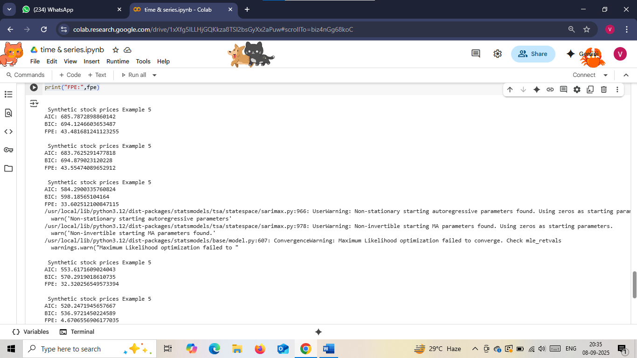

**PRACTICAL N0 –10**

**Aim:** ARCH & GARCH

**Code:**

pip install yfinance

pip install arch

 #example1ARCH(1):Model on S & P 500 Returns

 #step 1

 import yfinance as yf

 import pandas as pd

 import numpy as np

 import matplotlib.pyplot as plt

 from arch import arch_model

 #step2

 #load S&P 500 daily data

 data=yf.download("^GSPC",start="2020-01-01",end="2025-01-01")

 returns=100*data['Close'].pct_change().dropna()

#step 3:Fit arch(1)model

model=arch_model(returns,vol='ARCH',p=1)

results=model.fit(disp='off')

print("Examole 1 - ARCH(1) on S&P 500 Returns")

print(results.summary())

**Output:**

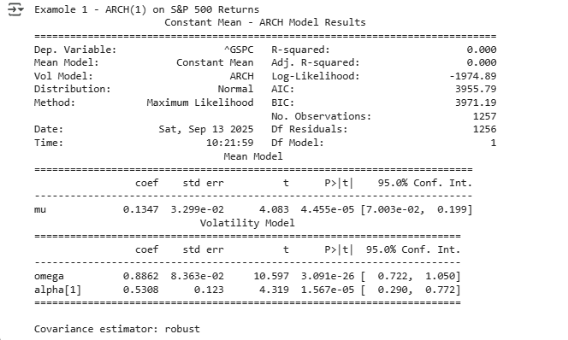

**Code:**

#step 5: plot conditional volatility

plt.figure(figsize=(10,4))

plt.plot(results.conditional_volatility,label='Conditional Volatility')

plt.title('ARCH(1)Conditional Volatility of S&P 500 Returns')

plt.legend()

plt.show()

**Output:**

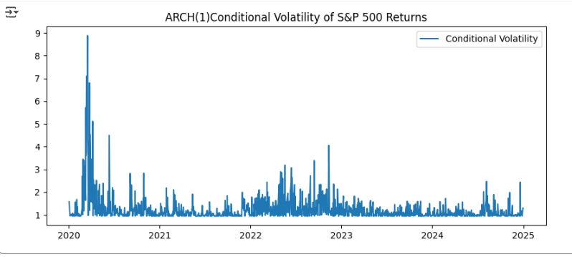

**Code:**

#example2:GARCH(1,1) model on S&P 500 returns

#step 1: fit garch(1,1) model

model=arch_model(returns,vol='GARCH',p=1,q=1)

results=model.fit(disp='off')

print("\nExample 2 - GARCH(1,1) on S&P 500 Returns")

print(results.summary())

#step 2: plot volatility

plt.figure(figsize=(10,4))

plt.plot(results.conditional_volatility,color='red')

plt.title('GARCH(1,1) Conditional Volatility of S&P 500 Returns')

plt.show()

**Output:**

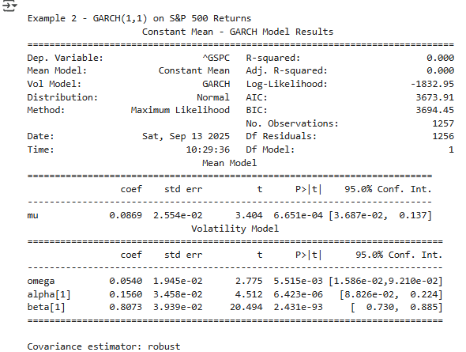

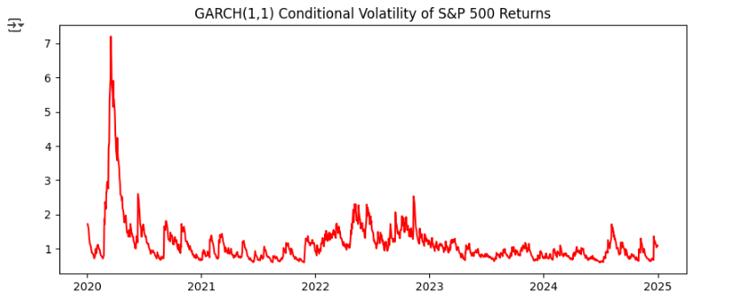

**Code:**

#Example 3: GARCH(1,1) on gold prices

#Step 1: Download gold prices data(GLD ETF)

gold=yf.download('GLD',start='2020-01-01',end='2025-01-01')

gold_returns=100*gold['Close'].pct_change().dropna()

#Step 2: Fit GARCH(1,1) model

model=arch_model(gold_returns,vol='GARCH',p=1,q=1)

results=model.fit(disp='off')

print("\nExample 3 - GARCH(1,1) on Gold Returns")

print(results.summary())

#step 3

plt.figure(figsize=(10,4))

plt.plot(results.conditional_volatility,color='orange')

plt.title('GARCH(1,1) Conditional Volatility Gold')

plt.legend()

plt.show()

**Output:**

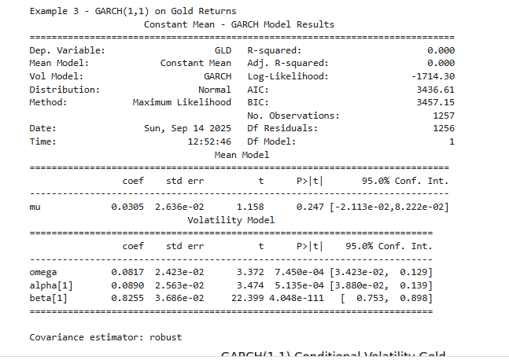

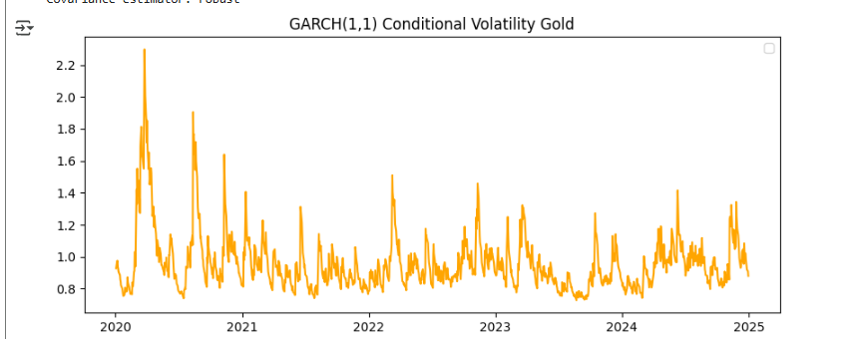

**Code:**

#Example 4: GARCH with AR(1) Mean(ARIMA + GARCH)

#step1 :fit AR(1)-GARCH(1,1)

model=arch_model(returns,mean='AR',lags=1,vol='GARCH',p=1,q=1)

results=model.fit(disp='off')

print("\nExample 4 - AR(1)-GARCH(1,1) on S&P 500 Returns")

print(results.summary())

#step 2:

plt.figure(figsize=(10,4))

plt.plot(results.conditional_volatility,label='Volability')

plt.title('AR(1)-GARCH(1,1) Conditional Volatility of S&P 500 Returns')

plt.legend()

plt.show()

**Output:**

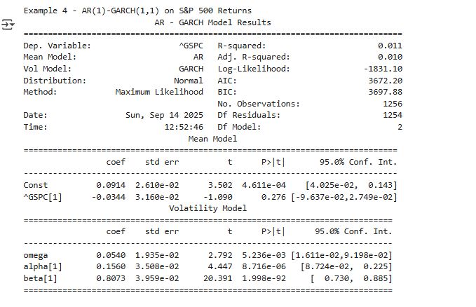

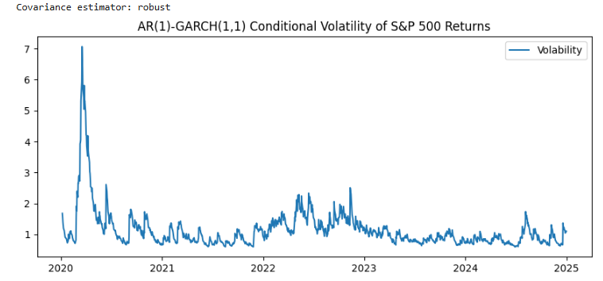

**Code:**

#example 5: comparing GARCH(1,1) vs GARCH(2,1)

#step 1:

models=[(1,1),(2,1)]

results=[]

#step2:

for p,q in models:

  model=arch_model(returns,vol='GARCH',p=p,q=q)

  fit = model.fit(disp='off')

  results.append({"Model":f"GARCH({p},{q})",

                 "AIC":fit.aic,

                 "BIC":fit.bic,

                 "LogLik":fit.loglikelihood})

#step 3:

df=pd.DataFrame(results)

print("\nExample 5 - Model Comparsion")

print(df)

**Output:**

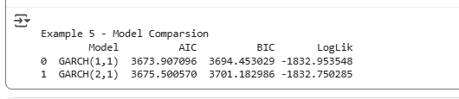

**Code:**

#program 6:Simulate & fit ARCH(1)Model

import numpy as np

import pandas as pd

import matplotlib.pyplot as plt

from arch import arch_model

#step 1: simulate synthetic data(volatility Clustering)

np.random.seed(42)

n= 500

eps = np.random.normal(size=n)

vol=np.zeros(n)

ret=np.zeros(n)

alpha0,alpha1 = 0.1,0.8 #ARCH(1) parameters

for t in range(1,n):

  vol[t]=np.sqrt(alpha0+alpha1*ret[t-1]**2)

  ret[t]=vol[t]*eps[t]

series=pd.Series(ret)

#step2:fit arch(1) model

arch_fit=arch_model(series,vol='ARCH',p=1).fit(disp='off')

print("\nExample 6 - ARCH(1) Synthetic Data")

print(arch_fit.summary())

#step 3: plot volability

plt.figure(figsize=(10,4))

plt.plot(arch_fit.conditional_volatility,label='ARCH(1) Conditional Volatility')

plt.legend()

plt.show()

**Output:**

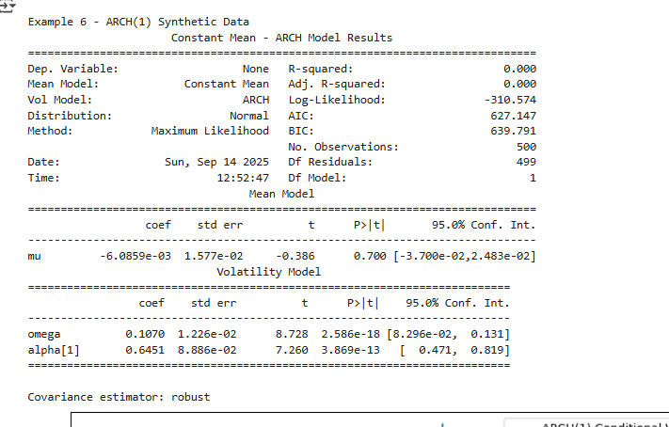 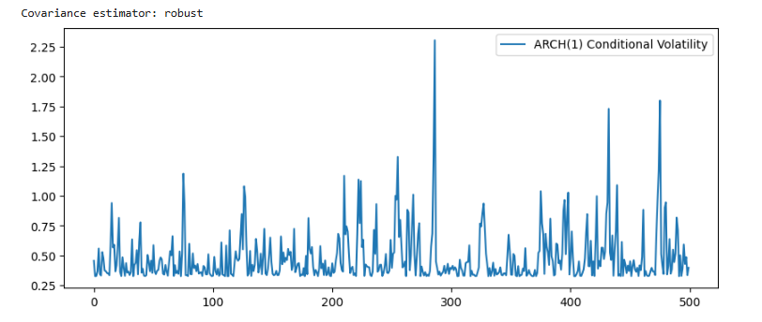

**Code:**

#program 7:Simulate & fit GARCH(1,1) model

#step 1:

np.random.seed(123)

n= 500

eps = np.random.normal(size=n)

ret=np.zeros(n)

vol=np.zeros(n)

omega,alpha,beta=0.05,0.1,0.85 #GARCH(1,1)

for t in range(1,n):

    vol[t]=np.sqrt(omega+alpha*ret[t-1]**2+beta*vol[t-1]**2)

    ret[t]=vol[t]*eps[t]

series = pd.Series(ret)

#step2 fit garch(1,1)

garch_fit=arch_model(series,vol='GARCH',p=1,q=1).fit(disp='off')

print("\nExample 7 - GARCH(1,1) Synthetic Data")

print(garch_fit.summary())

plt.figure(figsize=(10,4))

plt.plot(garch_fit.conditional_volatility,label='GARCH(1,1) Conditional Volatility')

plt.legend()

plt.show()

**Output:**

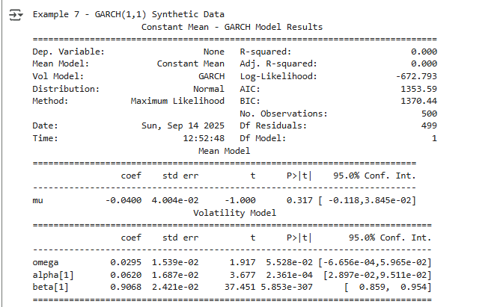

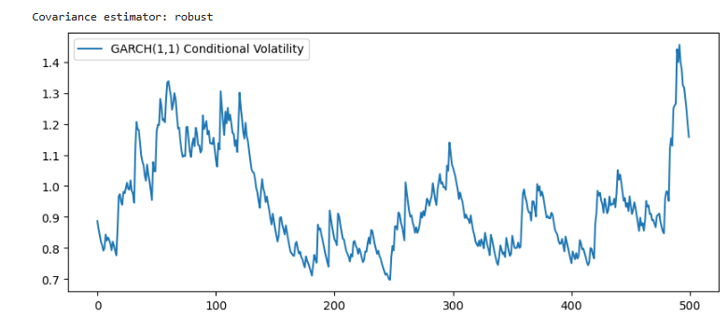

**Code:**

#example 8 Compare arch(1) vs garch(1,1)

#step1: fit arch(1)

arch_fit=arch_model(series,vol='ARCH',p=1).fit(disp='off')

#step2: compare aic/bic

print("\nProgram 3- Model Comparsion on Same Synthetic Data")

print("ARCH(1)-AIC:",arch_fit.aic,"BIC:",arch_fit.bic)

print("GARCH(1,1)-AIC:",garch_fit.aic,"BIC:",garch_fit.bic)

**Output:**



**Code:**

#program9:AR(1)-GARCH(1,1)(Mean+volatility)

np.random.seed(99)

n= 500

eps = np.random.normal(size=n)

ret=np.zeros(n)

vol=np.zeros(n)

phi=0.3 # AR(1) parameter

omega,alpha,beta=0.05,0.1,0.85 # GARCH(1,1) parameters: omega, alpha_1, beta_1

for t in range(1,n):

  vol[t]=np.sqrt(omega+alpha*ret[t-1]**2+beta*vol[t-1]**2)

  ret[t]=phi*ret[t-1]+vol[t]*eps[t]

series=pd.Series(ret)

#step2: fit ar(1) - garch(1,1)

ar_garch_fit=arch_model(series,mean='AR',lags=1,vol='GARCH',p=1,q=1).fit(disp='off')

print("\nExample 8 - AR(1)-GARCH(1,1) on Synthetic Data")

print(ar_garch_fit.summary())

**Output:**

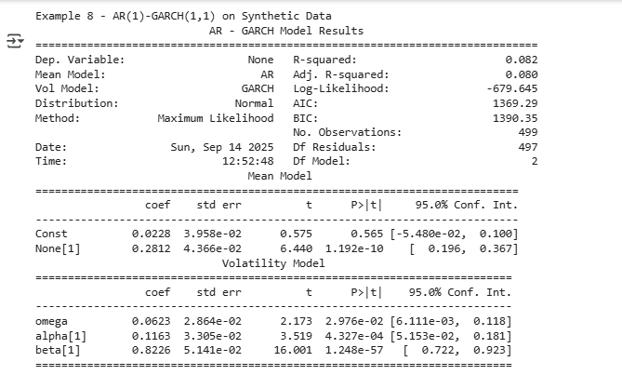

**Code:**

#program 1:Innovation from ar(1)model(Sunspots)

import matplotlib.pyplot as plt

from statsmodels.datasets import sunspots

from statsmodels.tsa.arima.model import ARIMA

#LOAD data

data = sunspots.load_pandas().data['SUNACTIVITY']

#fit ar(1)

model=ARIMA(data,order=(1,0,0)).fit()

innovations=model.resid

print("===Program 1 Output ===")

print(model.summary())

print("\nFirst 10 innovations:\n",innovations.head(10))

#plot

plt.figure(figsize=(10,4))

plt.plot(innovations)

plt.axhline(0,linestyle='--',color='black')

plt.title('Sunspots Innovation')

plt.show()

**Output:**

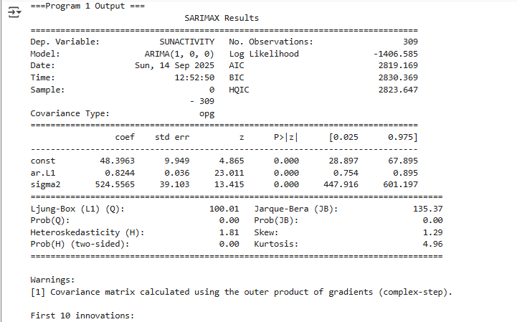

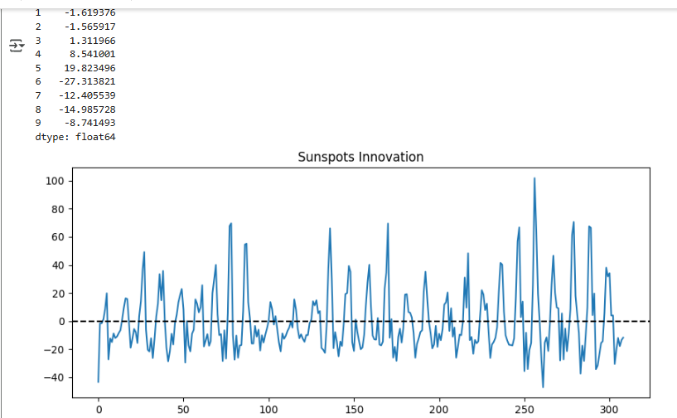

**Code:**

!pip install arch

import numpy as np

import pandas as pd

import yfinance as yf

from statsmodels.tsa.arima.model import ARIMA

from arch import arch_model

from typing_extensions import dataclass_transform

import matplotlib.pyplot as plt

#Step1: load data

ticker="AAPL"

data=yf.download(ticker,start="2015-01-01",end="2023-12-31",progress=False)

data=data['Close'].dropna()

#step2: compute return

returns=np.log(data).diff().dropna()

#step 3: fit arima model on return

arima_model_obj = ARIMA(returns, order=(1, 0, 0))

arima_res = arima_model_obj.fit()

#step 4: fit arch model on arima residuals

arch_model_obj=arch_model(arima_res.resid,vol="ARCH",p=1,o=0,q=0,dist='normal')

arch_res=arch_model_obj.fit(update_freq=5)

print(arch_res.summary())

#step 5:forecast

horizon = 5

arima_fore = arima_res.get_forecast(steps=horizon)

vol_fore = arch_res.forecast(horizon=horizon)

print("Mean forecast:\n",arima_fore.predicted_mean.tail(horizon))

print("Vol forecast:\n",vol_fore.variance.tail(horizon))

#Step6: plot

fig,ax=plt.subplots(2,1,figsize=(10,6),sharex=True)

ax[0].plot(arima_res.resid,label='ARIMA residuals')

ax[0].legend()

ax[1].plot(np.sqrt(arch_res.conditional_volatility),label='Conditional volatility(ARCH)')

ax[1].legend()

plt.show()

**Output:**

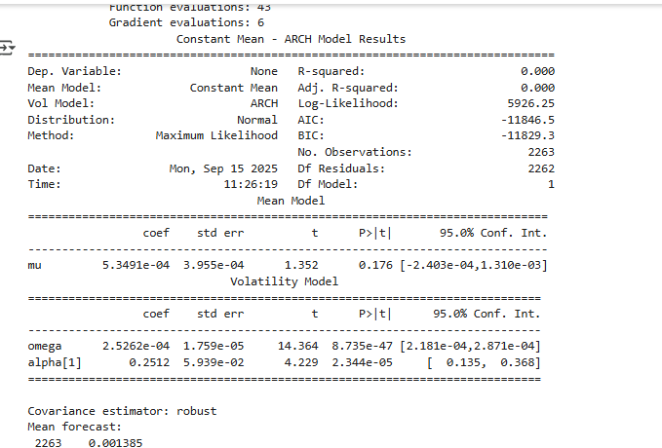

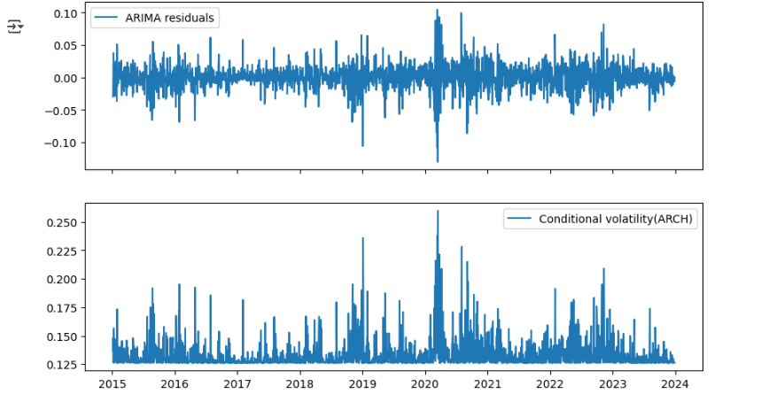

**Code:**

#example 2: arima+arch on exchange rates of us dollars

import pandas as pd

from statsmodels.tsa.stattools import adfuller

from statsmodels.tsa.arima.model import ARIMA

from arch import arch_model

import matplotlib.pyplot as plt

#step 1: Load some exchange rate data

data=pd.read_csv('EURUSD_daily.csv')

data['Date'] = pd.to_datetime(data['Date'])

data = data.set_index('Date')

close=data['Close'].dropna()

#step 2: compute return

returns=np.log(close).diff().dropna()

#step 3: stationary check

adf=adfuller(returns)

print("ADF p-value:",adf[1])

#step 4: fit arima on return

model_arima=ARIMA(returns,order=(1,0,1))

res_arima=model_arima.fit()

print(res_arima.summary())

#step 5:ARCH(1) on residuals

am=arch_model(res_arima.resid,vol='ARCH',p=1,o=0,q=0,dist='t')

#use t distribution

res_arch=am.fit(update_freq=5)

print(res_arch.summary())

#Step6: forecast

steps=10

mean_fore=res_arima.get_forecast(steps=steps)

vol_fore=res_arch.forecast(horizon=steps)

print("Forecasted return:\n",mean_fore.predicted_mean.tail(steps))

print("Forecasted variance:\n",vol_fore.variance.tail(steps))

**Output:**

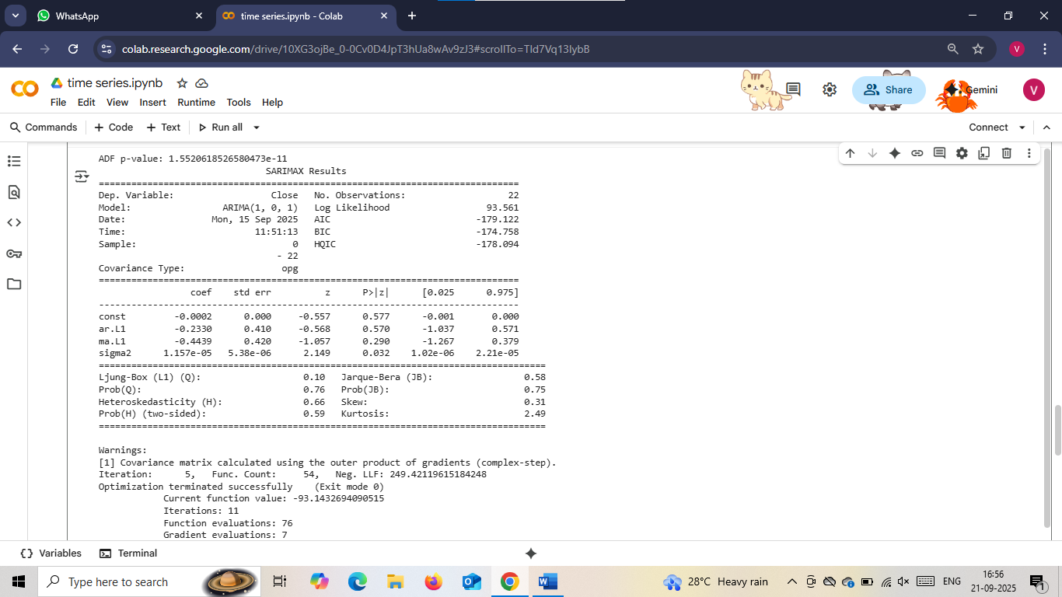

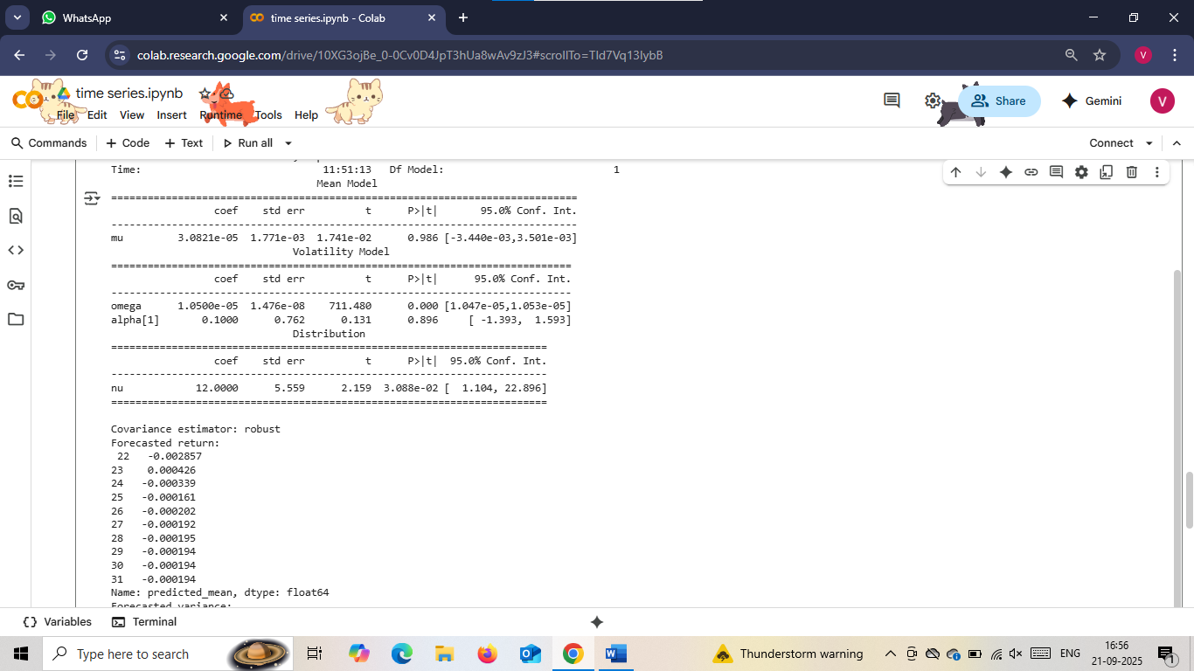

**Code:**

#program2 innovation from arma(2,1) (real GDP)

from statsmodels.datasets import macrodata

from statsmodels.tsa.arima.model import ARIMA

#load gdp data

macro=macrodata.load_pandas().data

gdp=macro['realgdp']

#fit arma(2,1)

model=ARIMA(gdp,order=(2,0,1)).fit()

innovations=model.resid

print("\=== Program 2 Output ===")

print(model.summary())

print("\nFirst 10 innvoations:\n",innovations.head(10))

**Output:**

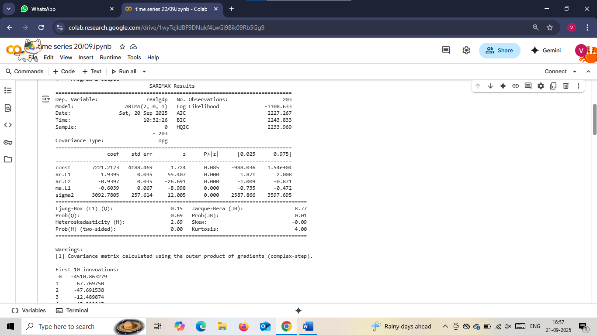

**Code:**

#Program 3: innovations from ARIMA(1,1,1)(CPI inflation)

import numpy as np

#compute quarterly inflation

cpi=macro['cpi']

inflation=np.log(cpi).diff().dropna()

model=ARIMA(inflation,order=(1,1,1)).fit()

innovations=model.resid

print("\n\n=== Program 3 Output ===")

print(model.summary())

print("\nFirst 10 innvoations:\n",innovations.head(10))

**Output:**

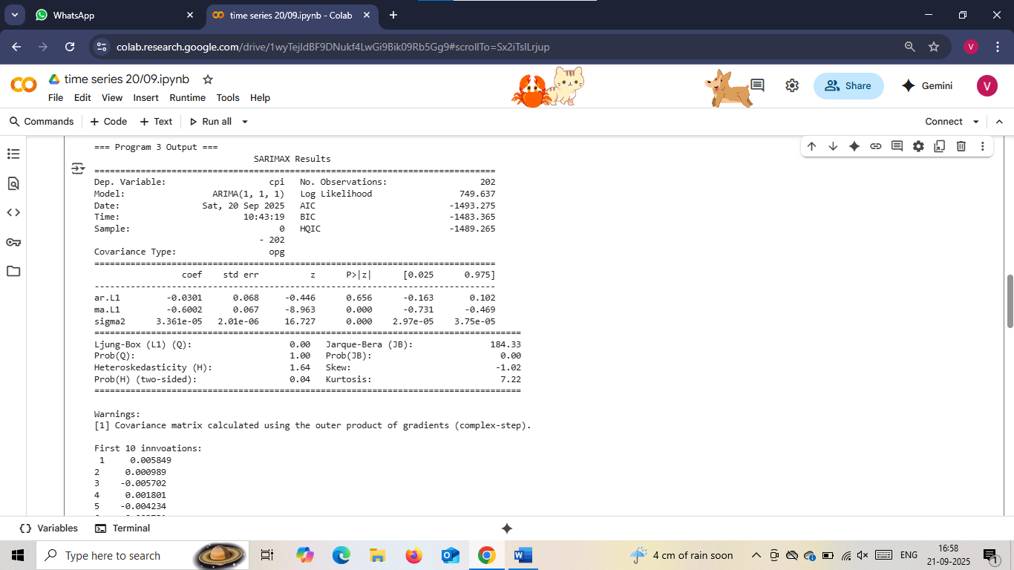

**Code:**

from statsmodels.datasets import get_rdataset

from statsmodels.tsa.arima.model import ARIMA

#load airline data

airline_data = get_rdataset("AirPassengers").data['value']

#fit arima(1,1,1)

model = ARIMA(airline_data, order=(1, 1, 1)).fit()

innovations=model.resid

print("\n\n=== Program 4 Output ===")

print(model.summary())

print("\nFirst 10 innvoations:\n",innovations.head(10))

**Output:**

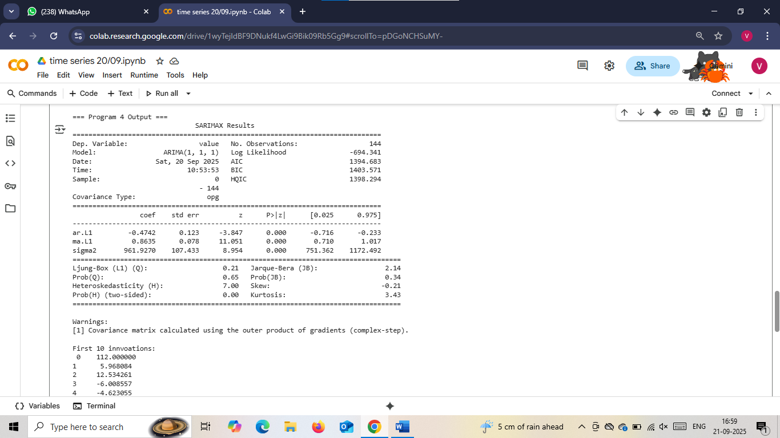

**Code:**

#program 5 :Ljung box test on innovations

from statsmodels.stats.diagnostic import acorr_ljungbox

lb_test = acorr_ljungbox(innovations,lags=[10],return_df=True)

print("\n\n=== Program 5 Output ===")

print(lb_test)

**Output:**

